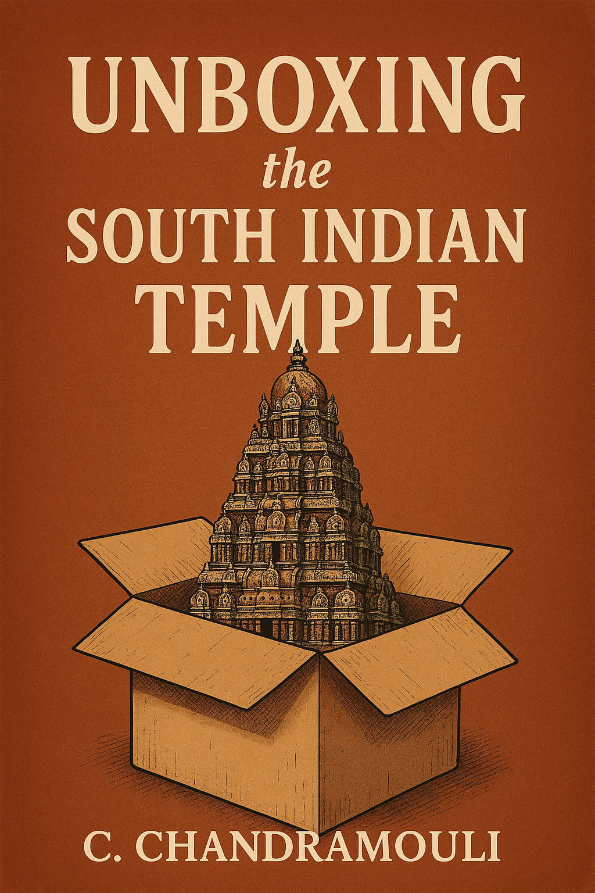

“Dedicated to Madhura, who never asked because she strongly believed; to Amritha, Arjun and Athreya, who asked but did not get answers and to Ayush and the little one (s) who will ask and hopefully get answers!”
Contents
Preface 6
Introduction 8
Chapter 2: 11
Gopurams — The Towers That Touched the Sky 11
Chapter 3: 22
Walking in Circles to Reach the Centre — The Prakāra 22
Chapter 4: 29
Fortresses of Faith — How Temples Were Protected 29
Chapter 5 37
Mandapas — Where Kings Ruled Under the Eyes of the Gods 37
Chapter 6: 47
Temple Festivals as Political Theatre 47
Chapter 7 66
The Calendar of Temple Festivals: Royal Patronage and Political Control 66
Chapter 8 73
Vahanas: Divine Mounts and Their Symbolism 73
Chapter 9 83
Temple Tanks – Eco-Conservation in Sacred Spaces 83
Chapter 10 91
Temple Trees and Groves: The Ancient Sanctuaries of Nature 91
Chapter 11 101
When God Took Form: A Story About Idols and the Divine 101
Chapter 12 117
Dhwaja Sthambam and Bali Peetam: Guardians of the Sacred Threshold 117
Chapter 13 125
Pujas in the Temple: A Day in the Life of the Divine 125
Chapter 14 134
Priests: Many Traditions 134
Vedic Priests 137
Chapter 15 143
The Secret Manuals of the Gods: What Are Temple Agamas? 143
Chapter 16 161
Annadanam – Most Sacred of Offerings 161
Chapter 17 169
Whispers in the Stone: A Sthala Puranam Discovery 169
Chapter 18 179
India: Sacred Geography 179
Chapter 19 188
Sacred Geography of South India 188

Preface
“A temple is not just built. It is remembered.”
Growing up in South India, temple visits were a part of life. Like many others, I walked beneath towering gopurams, waited quietly for darshan, watched the flicker of the deepa arati, and accepted the prasadam with cupped hands. But behind all the rituals and rhythms, I carried questions — simple, sincere, and unanswered.
- Why is the gopuram so tall?
- What lies behind the mandapams and prakāras we rush past?
- Why does every temple have a tank or a sacred tree?
- Who decided the temple's layout?
- Who sings inside the sanctum?
- And how did the gods come to stay in stone?
Temples weren’t built to be quiet monuments. They were made to move, breathe, and sing. In fact, every temple is a living organism — with a pulse that matches the rhythms of the cosmos, a heart that beats with devotion, and a memory that holds poetry, politics, prayer, and power — all in one breath. This book is my attempt to make that living presence visible, accessible, and meaningful — especially for young readers.
It is not a scholarly tome, nor a mythological index. It is a walk. A slow, curious walk through a temple — sometimes circling the prakāras, sometimes pausing before a mandapa, sometimes sitting quietly by the tank, or listening to the Odhuvar sing verses that once flowed from the lips of saints.
Over the course of this journey, we will meet:
- Architects who carved stone into sky-touching towers
- Kings and queens who used temples to build power and unity
- Poet-saints who sang their gods into the soil
- Priests, painters, sculptors, and singers who brought ritual to life
- Trees and tanks that held ecological wisdom
- And gods — not far away, but close, human, listening.
You will learn about the Gopurams that touched the sky, the vahanas that carried the gods through towns, the Pujas that marked every hour of the day, and the Agamas that instructed how gods should be awakened, bathed, dressed, and fed.
You’ll walk alongside the Alvars and Nayanmars, whose voices still echo in sacred verses, and visit Padal Petra Sthalams and Divya Desams — not just temples, but songs made solid in stone. You’ll see how devotion mapped the land, giving rise to a sacred geography where myth and memory merge. This book is for every curious mind that has ever asked — Why is this here? Who built this? What does it mean?
“Unboxing the South Indian Temple” is written in a narrative style and guided by lived experience and research, this is a guide not just to temple architecture, but to temple life — its rituals, symbols, stories, and silences. It is aimed at young adults who probably have the same questions and to parents like me, who have no answers to their curious posers.
I invite you not just to read, but to walk, pause, wonder, and listen. Because a temple is not just a structure. It is a story. And that story is waiting for you.
— C. Chandramouli

Introduction
Take a moment, close your eyes and imagine, you are walking barefoot across ancient stone — warm from the sun, cool in the shadows. The scent of jasmine and burning camphor hangs in the air. Somewhere in the distance, a conch sounds. The temple gopuram rises before you like a mountain carved with gods. Not silent, not still, but alive. You are not just entering a building. You are entering a rhythm. A world, a memory, a mystery! In this moment, you are part of something that began over a thousand years ago — and hasn’t stopped since.
Most of us have visited temples. Some as tradition. Some as tourists. Some just to pray for good marks in exams. But how many of us have really paused to ask — What am I walking into?
What is this space trying to tell me? Because a temple — especially in South India — isn’t just an old structure with ancient rituals. It is layered with meaning. Every part of it, from the tall gopuram at the entrance to the tiniest shrine in the corner, has a reason, a rhythm, and a story.
This book is an invitation to discover those stories. To peel back the layers. To understand why temples look the way they do, how they function, what rituals unfold inside them, and what history they carry in silence.
What Will You Discover Inside?
You’ll begin at the gates — the gopurams — and walk inward through prakāras, past mandapas, under painted ceilings and over carved floors. You’ll learn about temple tanks, sacred trees, and bronze idols — not as objects, but as presences.
You will meet kings who built temples, queens who donated lands, and poet-saints who sang until the gods seemed to appear. You will learn about temple festivals, divine vahanas, and the agamas, ancient manuals that instructed how gods should be woken, fed, dressed, and put to bed.
You will pause with a priest who whispers your name into a flower during an archana. You’ll listen to an Odhuvar sing hymns composed over 1,200 years ago — verses that transformed ordinary places into sacred spaces. Finally, you will explore how bhakti — the deep, emotional devotion of the Nayanmars and Alvars — turned language into prayer, and geography into sanctity.
Why This Book and Why Now?
Because the South Indian temple is not just part of the past. It is alive, even if we’ve forgotten how to listen to it. Every time a bell rings, a flame is waved, or a chant echoes, something ancient is being remembered. And yet, many young people today — perhaps even you — feel distant from that world. You’ve seen temples. You’ve walked through them. But have you ever really seen what they are trying to show you? This book hopes to open that door. Not with big theories. Not with complex philosophy. But with a storyteller’s voice, a curious eye, and a steady hand that says: Come. Let’s walk together.
You don’t need to be religious. You don’t need to know Sanskrit. You just need to be curious. If you have ever asked, “Why is this here?”
“What does this mean?” “What happened here before I came?” Then this book is for you.
Each chapter in this book ends with three gentle doorways — the Glossary, Activity, and Reflection. These are not just summaries or add-ons. They are invitations. The Glossary helps you understand key terms — not just as definitions, but as living ideas that shaped temples, rituals, and beliefs. The Activity invites you to do something — observe, draw, explore, or ask questions in the world around you. It’s a way to turn learning into experience. The Reflection is a quiet space — to pause, wonder, and connect. Here, you’ll find open-ended prompts that help you think more deeply about what you’ve read, felt, or remembered.
You don’t have to rush through them. Take your time. Let the glossary be your guide, the activity your adventure, and the reflection your moment of stillness.
Because learning about temples is not just about the past — it’s also about how we carry that sacredness into our present.
Let’s begin — not with a chapter, but with a step.
Because in a South Indian temple, even a single step can be sacred.
And every corner holds a secret — waiting to be heard. Welcome. You are inside now!

Chapter 2:

Gopurams — The Towers That Touched the Sky
“Like Mount Meru rising from the earth, this temple shall stand for all time, where the Lord of the Cosmos resides in divine splendour.”
— Chola Inscription at Brihadisvara Temple
The temple town was still far away, but its presence was already being felt. On the horizon stood a towering form—rising like a sacred mountain, sharp against the sky. The driver slowed down, pointing toward it. Immediately, passengers in the vehicle reacted. Some folded their hands in reverence. Others whispered silent prayers. All eyes turned upward.
There it was—the gopuram—colossal, majestic, teeming with sculpted life. Even from a distance, its purpose was clear: to call, to beckon, to anchor the spirit in awe. As we approached, its details came alive. Thousands of carved figures—gods, goddesses, demons, dancers, animals, and celestial beings—looked down from its sculpted tiers, as if watching over the world below. Stepping through the towering archway at its base was like entering a different reality—one where time slowed down, and the sacred began to breathe.
From Humble Beginnings to Sky-Piercing Towers
Temples didn’t always look like this. In the early centuries, they were small, intimate spaces—stone sanctums or even wooden structures that quietly housed the deity. The entrance was a simple doorway; the main feature was the vimana, the short tower above the garbhagriha, shaped like a stepped pyramid.
In these early temples—like the Shore Temple at Mamallapuram—gopurams were barely noticeable. All attention was directed inward, toward the deity’s sanctum.
But faith evolves and so does art and architecture. By the time the Chola dynasty came to power (9th–13th century CE), the vimana had become grand and imposing. The Brihadisvara Temple in Thanjavur, with its 66-meter vimana, stood taller than anything else in India at the time. It was not hollow—it was solid stone, capped by a single granite block weighing 80 tons!
Yet, as time went on, something shifted. The gopuram—once a minor feature—began to grow. Taller, broader, more ornate. By the Vijayanagara period (14th–17th century CE), the gopuram had overtaken the vimana in size, importance, and symbolism.
The Twin Towers: Vimana and Gopuram
South Indian temples evolved into vast complexes, almost like sacred cities. Two structures became central to their design: the vimana, marking the heart of the divine, and the gopuram, announcing the sacred from afar.
Originally, the vimana was always the tallest structure—this reflected the central idea that the deity in the sanctum was the most important part of the temple. But during the later periods, especially under the Vijayanagara and Nayaka dynasties, temples expanded into massive compounds with high enclosing walls. To match their scale, the gopuram had to grow—not just in size, but in symbolic power.
- The vimana remained the spiritual axis—the place of quiet, inward reflection.
- The gopuram became the social and visual beacon—a bridge between the outer world and the inner sacred space.
Devotion Meets Dynasty: Rise of the Gopuram
“Let the gopuram rise above all, so that even from the farthest lands, men may know where the gods reside.”
— Vijayanagara Inscription
Temples were not just places of worship—they were displays of royal power. Kings competed not just in battlefields but in temple towers. The Virupaksha Temple at Hampi boasts one of the earliest grand gopurams, standing at 50 meters. Later, the Srirangam Temple in Tamil Nadu saw the construction of the Rajagopuram, the tallest in India, rising to 72 meters—taller than a 20-storey building!
These towers weren’t just tall—they were talking towers. Through carvings, they told stories from Hindu epics, legends of saints, and cosmic myths. Devotees who couldn’t read sacred texts could still see the stories carved into stone.
Symbolism of Gopurams and Vimanas
While their grandeur is impossible to miss, the gopuram and vimana are not just feats of architecture—they are profound symbols, carrying spiritual meaning embedded into every tier, niche, and sculpted figure.
The vimana, directly above the deity’s sanctum, represents Mount Meru, the mythical mountain that stands at the centre of the cosmos in Hindu, Buddhist, and Jain traditions. It marks the holiest part of the temple and symbolizes the still, silent heart of the universe—where divinity resides.
The gopuram, on the other hand, is the gateway between two worlds—the material and the spiritual. When a devotee steps through its archway, they symbolically leave behind the chaos of worldly life and enter a sacred space.
The ascending tiers of the gopuram, often filled with divine figures, guardians, celestial beings, and mythological scenes, guide the eye—and the spirit—upwards, reminding us of the path from the earthly to the divine. The kalasha, the sacred finial at the top, represents moksha—liberation and spiritual fulfilment.
Sacred Engineering: Science Behind the Splendour
These soaring structures weren’t just beautiful—they were engineered with astonishing precision. Without cranes, concrete, or computers, ancient builders created towers that have withstood earthquakes, storms, and centuries of time.
Gopurams are built using a technique known as pyramidal load distribution. Their wide base tapers gradually toward the top, which helps evenly spread weight and redirect seismic shockwaves. The trapezoidal shape is not decorative—it’s functional, making gopurams some of the most earthquake-resistant structures in history.
The outer walls are covered in thousands of sculpted figures. These aren’t just decoration—they help break the force of strong winds, creating pressure pockets that prevent structural collapse.
The Kalasha: Cosmic Antenna, Survival Vault
At the very top of the vimana—and sometimes the gopuram—sits the kalasha, a pot-like finial often made of copper or gold. While it gleams like a decorative crown, its functions are far more profound.
- As a lightning conductor, the kalasha protects the temple during storms.
- As a spiritual resonator, it radiates the vibrations of chants and rituals throughout the complex.
- And most astonishingly, the kalasha has historically functioned as a seed vault—filled with pulses, grains, and medicinal herbs, stored high above the ground. In times of famine or flood, these seeds could restore life.
Why the Kalasha is renewed every twelve years
The kalasha is ritually removed and reconsecrated every twelve years. This is not arbitrary—it’s deeply aligned with both cosmic and practical cycles:
- Jupiter’s orbit around the Sun (12 years) marks a sacred renewal period in Vedic cosmology.
- Seed viability for many grains and herbs is roughly 12 years—after which they can no longer germinate effectively.
- Metal fatigue from weathering and oxidation makes 12 years an ideal maintenance cycle for the structure.
The renewal, called Kumbhabhishekam, realigns the temple with cosmic energy, refreshes its seed reserves, and reinforces its structural integrity.

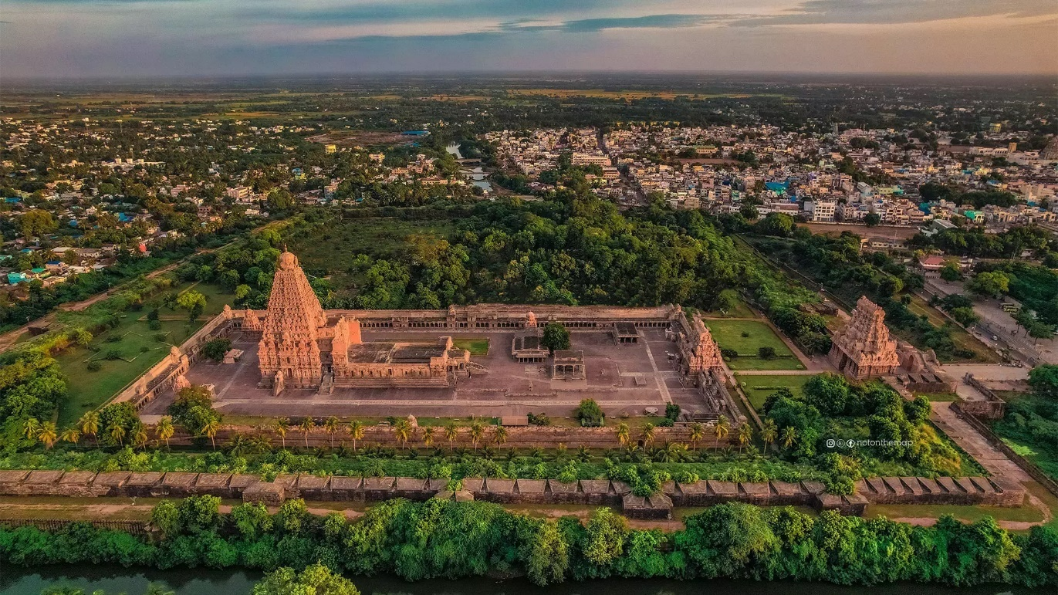
Photo Courtesy: tamilnadutourism.tn.gov.in/photos
The Evolution of Gopurams Across Dynasties
Period | Gopuram Features | Example Temple
Pre-Pallava | None or very small | Sangam-era shrines (lost to time)
Pallava | Modest stone gopurams | Kailasanatha Temple, Kanchipuram
Chola | Vimanas dominant, gopurams emerging | Brihadisvara, Thanjavur
Pandya / Hoysala | Taller gateways, rich sculpture | Early Meenakshi Temple
Vijayanagara | Huge, tiered gopurams, city-like temples | Virupaksha Temple, Hampi
Nayaka & Later | Colourful, stucco-covered, monumental | Meenakshi Temple, Srirangam
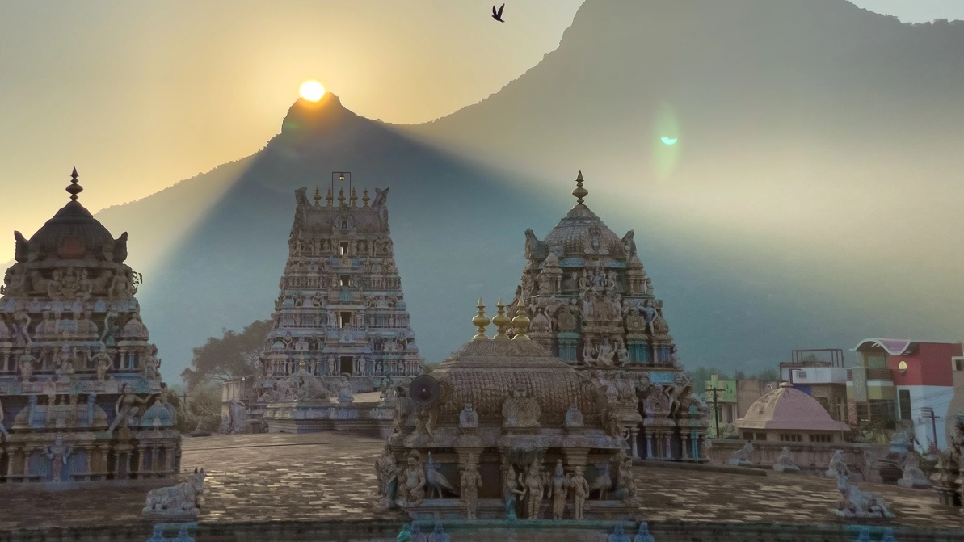
Gopuram and Vimanas at the Adi Annamalai Temple
Photo Courtesy: tamilnadutourism.tn.gov.in/photos
Types of Gopurams and Vimanas
Gopurams
- Kudu Gopuram: Small, curved gateways in early Dravidian temples
- Salakara Gopuram: Rectangular, pillar-supported Pallava styles
- Kutina Gopuram: Tiered towers from Vijayanagara temples
- Rajagopuram: Grandest gate tower, usually the main entrance
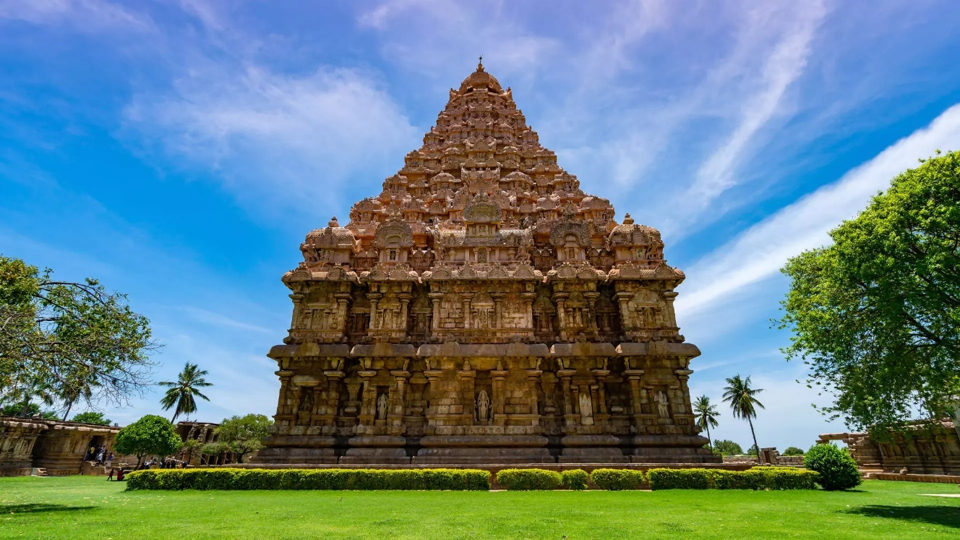
Gangaikonda Cholapuram
Photo Courtesy: tamilnadutourism.tn.gov.in/photos
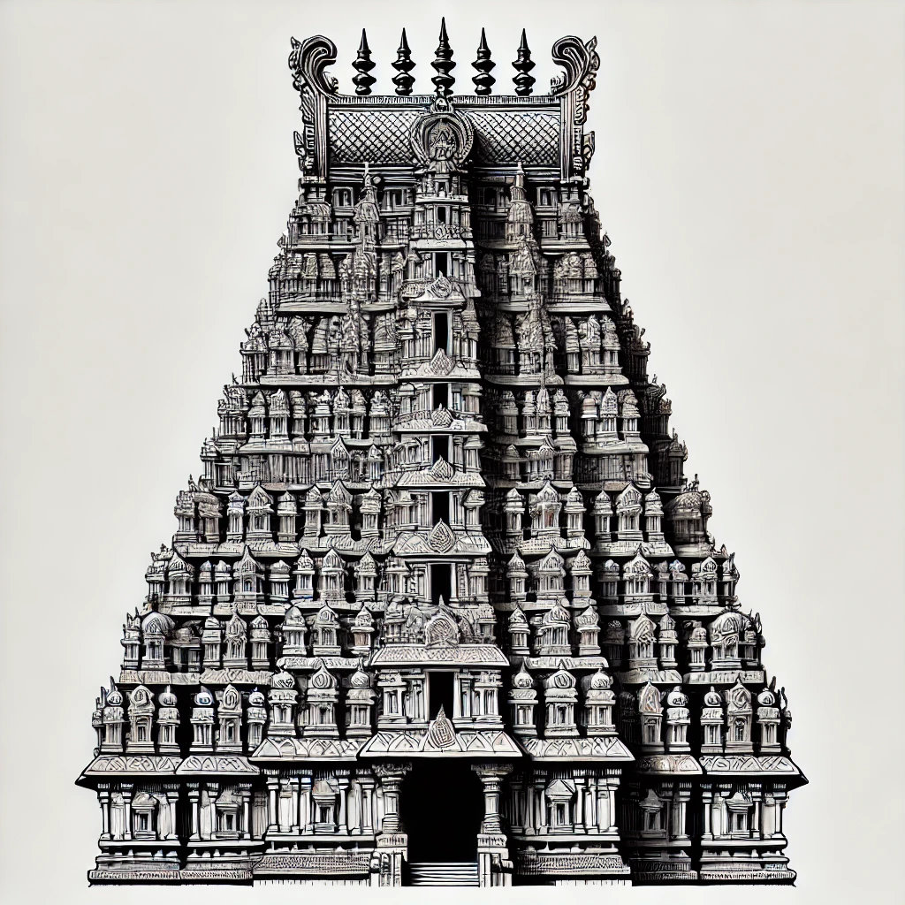
Vimanas
- Dravidian Vimana: Stepped pyramid (e.g., Thanjavur)
- Nagara Vimana: Curved tower (e.g., Khajuraho)
- Vesara Vimana: A hybrid style (e.g., Chennakesava Temple, Belur)
The Gopuram in Tamil Nadu’s State Emblem
When Tamil Nadu adopted its state emblem in 1949, it chose a gopuram as its central symbol—flanked by lions and inscriptions in Tamil and English. Designed by artist R. Krishna Rao, the emblem isn’t a replica of any single temple tower. Though many believe it to be the Srivilliputhur Andal Temple, it's actually a stylized composite, representing the essence of Dravidian architecture and Tamil cultural pride.
The gopuram and vimana are not just structures. They are symbols, scientific wonders, and spiritual beacons. The gopuram draws the devotee in, bridging the outer world and the sacred. The vimana lifts the gaze upward, anchoring the divine in stone. Together, they tell a story of a civilization that saw no divide between science and spirituality, art and engineering, heaven and earth.
So, the next time you pass a gopuram rising in the distance, don’t just admire its size. Let it call you in. Because beyond its towering gates lies not just a temple—but a universe waiting to be discovered.
Glossary
- Gopuram – A monumental entrance tower of South Indian temples, usually richly decorated and rising above the main gateway.
- Vimana – The sacred tower directly above the sanctum (garbha griha) in a temple, often pyramid-shaped in Dravidian architecture.
- Kalasha – The finial or pot-like structure at the top of a vimana or gopuram, symbolizing spiritual completion and moksha.
- Garbha Griha – Literally "womb chamber"; the innermost sanctum of a temple where the main deity is enshrined.
- Rajagopuram – The main and usually tallest gopuram in a temple complex, often found at the eastern entrance.
- Pyramidal Load Distribution – An architectural technique that spreads weight evenly through a wide base and narrowing top, used in temple towers to enhance structural stability.
- Kumbhabhishekam – A grand consecration ceremony performed to renew the energy of a temple, including the reinstallation or rejuvenation of the kalasha, typically done every 12 years.
- Mount Meru – A sacred mountain in Hindu, Jain, and Buddhist cosmology, believed to be the centre of the universe; symbolized by the vimana.
- Moksha – Liberation from the cycle of birth and rebirth; the ultimate spiritual goal in Hinduism.
- Stucco – A plaster-like material used to mold colorful figures on gopurams, especially during the Nayaka period.
Reflection & Activity Corner: Unbox the Temple Tower!
Observe and Sketch
Next time you visit a temple, do a gopuram–vimana comparison:
- Can you identify the vimana and gopuram?
- Which one is taller?
- What kinds of figures or carvings do you see?
- Are they made of stone or painted stucco?
Try sketching a simple outline of both:
- Label the garbha griha, vimana, gopuram, and kalasha.
- If possible, note down any stories or scenes you notice in the carvings.
Thought Prompt
Why do you think ancient architects put so much effort into making the entrance tower so grand? What would it feel like to enter a space through something so majestic? Write a few lines imagining yourself walking through a gopuram into the temple’s sacred world.
Fun Challenge
Create your own gopuram design! Use paper or building blocks to create a mini tower with 3–5 levels. Try to include small figures, tiers, and even a kalasha on top. What stories would your tower tell?

Chapter 3:

Walking in Circles to Reach the Centre — The Prakāra
“You, the divine, are the centre. And I move around you in reverence.”
The gopuram towers behind you like a mythical mountain. Music floats through the air—the deep throb of the thavil, the winding notes of the nadaswaram. The scent of sandalwood mingles with murmured mantras and the quiet shuffling of bare feet against ancient stone.
Before you lies a wide, curving corridor that wraps around the heart of the temple. It doesn’t lead you directly to the deity. Instead, it invites you to walk—slowly, purposefully—with the divine always at your centre. This is the prakāra.
A sacred corridor, yes—but also a time capsule, a visual scripture, and a stone manuscript etched with the hopes, victories, and proclamations of kings, queens, merchants, and devotees.
The Prakāra: A Pathway with Purpose
The prakāra (also spelled prakāram) is the circumambulatory path that encircles the sanctum. In South Indian temples, devotees perform pradakṣiṇā here—walking clockwise with the deity always to their right. Each step is a physical and spiritual act, a quiet unfolding of the self.
Some temples, like those at Chidambaram or Thanjavur, have one or two prākāras. Others, like Srirangam, contain seven concentric corridors—each more majestic, each drawing the devotee closer, not just to the deity, but to stillness itself.
Historical Echoes in Stone
The walls of the prākāra are not silent.
“I, Rājarāja, the protector of the world, have gifted land to this sacred temple so that the sound of the Vedas shall never cease, and the lamps shall always burn in devotion.”
— Chola Inscription at Brihadīśvara Temple, Thanjavur
As you walk, you pass inscriptions—beautiful, curling lines in Tamil or Sanskrit, carved into the very body of the temple. They record land grants, royal decrees, donations, and victories. They whisper the ambitions of kings and the gratitude of patrons.
One prakāra wall in Srirangam, dating to the 12th century CE, boasts of:
“Manabharanadeva, Somakula-tilaka, Paramabhattaraka, Chōlakulāntaka… gifted two garlands to Lord Ranganātha, through Kittidevan and Pattamahādevī.” These aren’t just ornamental—they are documents of empire, carved for eternity.
Layers of Time: How the Prakāra Evolved
Originally, early temples were built amidst sacred groves, where people naturally moved in circular paths around trees and shrines. But by the time of the Pallavas (6th–8th century CE), rock-cut temples like those in Kanchipuram featured narrow, enclosed prākāras—spaces for focused devotion.
The Cholas (9th–13th century CE) made the prakāra wider, ceremonial. The Vijayanagara kings built city-like temples with five, even seven prākāras. The Nayakas adorned them with sculpted pillars, musical halls, and festival platforms.
Each era left its mark in stone. Each inscription layered the walls with more than just history—it layered them with memory.
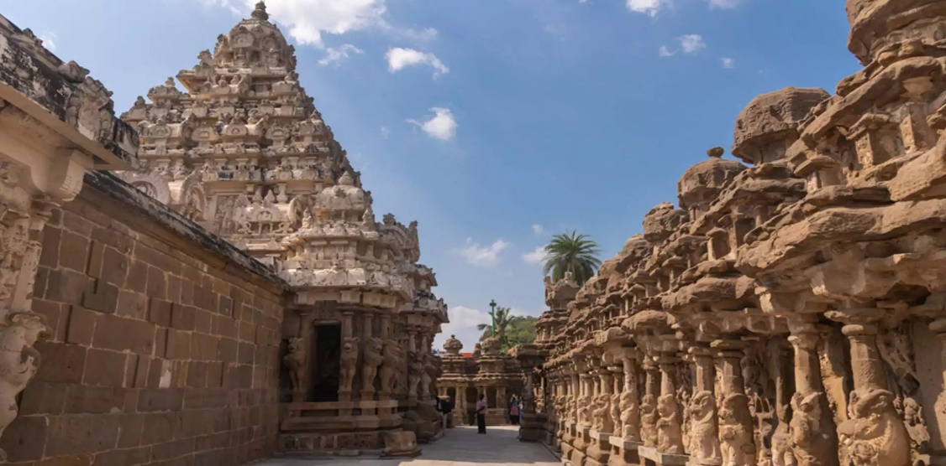
Richly adorned Prakara at the Kailasanatha temple, Kanchipuram
Photo Courtesy: tamilnadutourism.tn.gov.in/photos
Walking in Circles: The Inner Logic of the Prakāra
Why circles? Why not walk directly into the sanctum? Because the prakāra teaches us:
- To slow down, in a world that rushes
- To centre our thoughts
- To honour the journey, not just the goal
Every round is a meditation. A shedding of distraction. A return to essence. As one walks through these corridors, it becomes less about reaching the deity and more about finding your own sacred stillness.
The Sacred Path and the Warrior-King
For kings, these corridors were not just spiritual—they were stages of political theatre.
“The mighty Narasimhavarman, destroyer of Vatapi, has inscribed his glory in stone, ensuring that none shall forget his conquest over the treacherous foes.”
— Pallava Inscription, Kanchipuram, circa 700–725 CE
At Kailāsanātha Temple in Kanchipuram, inscriptions etched into the prākāra walls record wars, alliances, and even feudatory rebellions. These were statements of supremacy, carefully constructed to reinforce divine right.
Temples as Political Battlegrounds
Temples were political arenas. Their prākāras weren’t just walked—they were contested.
- Chalukya inscriptions claim they sacked Chola cities.
- Chola inscriptions retaliate, recording their victory and rebuilding of temples.
- Vijayanagara inscriptions glorify the king’s divine mission to protect dharma.
- Nayaka inscriptions in Madurai record the temple’s destruction by Malik Kafur—and its triumphant restoration:
“For every stone that was taken, we lay ten in its place; for every flame extinguished, a thousand lamps shall burn in the house of the goddess.”
Women, Merchants, and Forgotten Builders
In these inscriptions, it’s not only kings who speak.
- Queen Lokamahādevī, wife of Vikramāditya II, is credited with building the Virupākṣa Temple.
- Rashtrakuta queen Revakanimadi funded temples, appearing in multiple inscriptions.
- Devadāsis (temple dancers) donated their wages and owned property.
- Merchant guilds funded gopurams and halls in return for royal favour or spiritual merit.
In Kodungallur, Chera inscriptions reference Arab, Jewish, and Christian traders—showing how temples stood at the crossroads of faith, politics, and commerce.
“Rāma Kulasekhara, ruler of the Chera land, grants land to the temple, so that the gods may bless the ships that sail from our shores.”
Inscription as Survival Story
Not all inscriptions celebrate glory. Some mourn loss and celebrate resilience.
“The land weeps for the fall of the great city, but those who serve the gods shall raise the sacred shrines once more.”
— Post-Talikota Inscription, Hampi
After the 1565 Battle of Talikota, Hampi was sacked. But Virupākṣa Temple’s inscriptions document restoration by merchants and local chieftains. Even when empires fell, the faithful rebuilt.
Glossary
- Prakāra / Prakāram – The sacred corridor(s) that encircle the sanctum, used for pradakṣiṇā.
- Pradakṣiṇā – Circumambulation performed in a clockwise direction around a sacred object or space.
- Garbha Gṛaham – The innermost sanctum of the temple, housing the deity.
- Nādaswaram – A South Indian wind instrument, often played during temple rituals.
- Thavil – A barrel-shaped drum, played alongside the nādaswaram.
- Vāhana – The vehicle or mount of a deity, used during temple processions.
- Dharma – Righteous duty; moral or religious order.
- Devadāsi – A female temple performer, historically associated with sacred dance and ritual service.
Reflection & Activity Corner: Secrets in Stone
Decode a Temple Wall
Look closely at an old temple wall the next time you visit. Can you see:
- Lettering etched into stone?
- Names or dates?
- Carvings that seem to tell a story?
Take a picture or sketch one. Research its meaning or imagine what it might say.
Write Your Own Inscription
Imagine you're a queen, merchant, or poet living a thousand years ago. Write a short inscription you would want carved into the temple wall.
- What would you be remembered for?
- What offering would you make?
Map the Circles
Draw a simple plan of a temple’s prākāras.
Label each layer—what happens there?
- Are there sculptures?
- Is there a mandapa?
- Where does the deity travel during festivals?

Chapter 4:

Fortresses of Faith — How Temples Were Protected
“By the command of the king, a thousand warriors shall stand guard at the temple, ensuring that none with ill intent may enter.”
— Vijayanagara inscription, 15th century CE
You’re now standing in the outermost prakāra, gazing up at towering walls. They rise like mountains, casting deep shadows across the courtyard. These are not merely boundaries—they are bastions, fortresses, built not just to shelter stone deities but to protect empires of belief.
In South India, temples were not only sacred spaces—they were centres of power, wealth, and politics. Their granaries brimmed with gold. Their halls echoed with decrees. Their walls guarded the most prized possession of all: divine legitimacy.
To defend these sacred strongholds, kings deployed more than devotion. They built granite walls, stationed elite guards, and even forged alliances with enemies. Behind every carving and corridor lay a system designed to endure war, rebellion, and time itself.
Temples as Fortresses
Think of the massive stone walls of Brihadīśvara in Thanjavur, the concentric enclosures of Srirangam, or the citadel-like layout of Virupākṣa Temple in Hampi. These temples were designed with defensive architecture—thick walls, towering gateways, elevated platforms, and underground vaults.
At Halebidu, the Hoysaleśvara Temple stood on an elevated site with fortified walls. During times of invasion, Virupākṣa Temple at Hampi stored weapons, food, and treasures in underground vaults. Srirangam had tunnels believed to be used for evacuating idols during attacks.
Temples were more than spiritual sanctuaries—they were military assets.
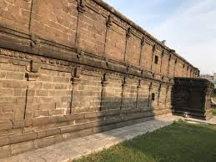
Temple Wall at Draksharama Temple
Royal Decrees as Shields
“Let no king, nor prince, nor general dare to lay hands upon this sacred temple, lest the wrath of the gods be upon him.”
— Chola inscription, Brihadīśvara Temple
Legal protection often matched physical defence. Many temples were declared inviolable zones—sacred lands that could not be taxed, looted, or attacked, even during war.
“Though we march against our foes, the sacred land of Rāmeśvaram shall remain undisturbed, for it belongs not to kings but to the gods.”
- In Madurai, Meenākṣī Temple inscriptions describe tax-free land grants, ensuring economic security.
- In Chidambaram, inscriptions note that criminals who sought refuge in the temple could not be harmed—a form of sanctuary law.
- Pandya records reveal that temple workers were exempt from military service, allowing rituals to continue unbroken, even in wartime.
Temples, in essence, were legal fortresses, guarded not just by stone and sword, but by royal command.
Diplomacy and Divine Agreements
In times when armies couldn’t protect, rulers turned to alliances. Some inscriptions hint that even during conflict, rival kings agreed to spare certain temples. Why? Because to attack a temple wasn’t just political—it was cosmic treason.
Temples also formed bonds with powerful trade guilds like the Ayyavole 500 and Maṇigrāmam. These groups donated land and gold in exchange for protection and trade privileges. In Kerala, Jewish, Arab, and Chinese traders gave generously to temples, weaving international diplomacy into divine networks.
The Sacred Warriors: Temple Guards & Monks
“We, the Velaikkarars, shall protect this temple as long as our swords are sharp and our lives remain. If we fail, we shall not return alive.”
-Chola Inscription
Temples were protected by elite defenders—men who combined warrior skill with spiritual duty. They weren’t just soldiers. They were guardians of dharma.

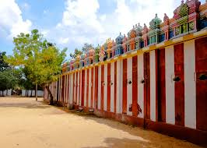
Velaikkarars: The Chola Temple Warriors
Hand-picked by kings, the Velaikkarars guarded temples day and night. Inscriptions at Brihadīśvara Temple speak of how Rājarāja Chola assigned these warriors to major temples:
- They guarded temple treasuries
- They escorted processions and royal offerings
- Some even died in battle, refusing to surrender their temples
The Kāval System: Vijayanagara’s Temple Guards
“By the grace of the gods, the temple shall remain inviolate, as long as the king's guards stand firm at its gates.”
-Vijayanagara Inscription
The Vijayanagara kings implemented the kāval system, assigning local chieftains and warrior clans to protect temples. These guards:
- Patrolled temple lands
- Prevented looting during invasions
- Maintained law and order on temple premises
Krishnadevarāya stationed permanent guards at Srirangam after it was attacked, and merchants helped fund their wages—an early model of public-private partnership in temple defence!
Warrior-Monks: Saffron-Clad Defenders
“We are not kings, nor are we conquerors; yet we shall raise our arms in the defence of the gods, for the temple is our battlefield, and faith is our sword.”
Some defenders weren’t kings or soldiers—they were monks.
- Shaiva Kāpālikas and Kālāmukhas wielded staves and swords to protect Śiva temples.
- Vaiṣṇava monks in Srirangam formed human shields to save idols during invasions.
- Some trained in martial arts like kalarippayattu, blending faith with ferocity.
These warrior-monks were not conquerors—they fought only to defend.
Salais: Sacred Academies of Strategy and Scripture
“From these sacred halls emerge the keepers of dharma—wise in scripture, skilled in combat, and devoted to the gods.”
Salais were monastic universities—temple schools where students studied the Vedas, temple ritual, and combat training. Inscriptions at Tiruvottriyur, Chidambaram, Thiruvalla, and Thiruvananthapuram mention such institutions, supported by Chola, Pandya, and Chera kings.
- Trained both priests and warrior-monks
- Had their own economic systems
- Some students took vows to “live and die” for the temple
Kandalur Salai: The Forgotten Fortress
“At Kandalur, the wise learn the scriptures, the strong wield the sword, and the faithful guard the sacred lands of the gods.”
Among all salais, Kandalur Salai stands apart—a sacred citadel in medieval Kerala, feared even by kings.
- Trained naval warriors and monk-commanders
- Operated as an independent military-spiritual state
- Protected temples and trade routes
But in the 10th century CE, Rājarāja Chola I attacked and destroyed Kandalur Salai.
“He who conquered Kandalur Salai, breaking its defences and humbling its warriors, now stands as the supreme lord of the southern lands.”
Its fall marked the decline of Chera naval power and Chola dominance over Kerala’s temples. Though Kandalur’s site is debated, its legacy remains—in temple records, warrior traditions, and whispers of a time when monks bore arms in defence of the gods.
Glossary
- Velaikkarars – Elite Chola temple guards sworn to protect the deity and temple with their lives
- Kāval system – A Vijayanagara-era model of regional temple security managed by chieftains
- Salai – A monastic university where priests and warrior-monks were trained in both scripture and combat
- Dharma – Sacred duty; moral and spiritual law
- Kalarippayattu – A martial art from Kerala practiced by warrior-monks and defenders
- Kāpālikas / Kālāmukha – Ascetic sects of Shaivism trained in spiritual and martial disciplines
- Vratya – Ascetic warrior-priests trained in salais during Chola rule
- Nāyaka – Local governor or commander, especially during Vijayanagara period
Reflection & Activity Corner: Temple Defence Logbook
Draw a Fortress-Temple
Sketch your version of a fortified temple. Add:
- Thick walls
- A watchtower
- A hidden tunnel
- A temple guard post
Label the roles of each structure!
Write a Temple Guard’s Oath
Imagine you’re a Velaikkarar. Write the vow you would take before the deity.
What would you protect? What would you never allow?
Decode a Defensive Inscriptions
Find and translate (or imagine) a temple inscription that warns enemies, records a guard’s oath, or praises a warrior-monk’s sacrifice.
Example:
“We guard the god not with fear, but with faith—and the wrath of heaven shall fall on those who breach this gate.”

Chapter 5

Mandapas — Where Kings Ruled Under the Eyes of the Gods
“In the great maṇḍapa of Ranganātha, under the gaze of the Lord, the kings of the land bring their offerings and pledge their loyalty.”
— Vijayanagara inscription, 14th century CE, Srirangam
You step through the towering gopuram, leaving behind the bustling courtyard of devotees and festival processions. As your feet touch the cool stone, you enter a space unlike any other—a vast, open hall filled with rows upon rows of carved pillars. The light slants in through lattice windows, dappling the floor in golden shapes. Each pillar is alive with stories: divine dancers frozen mid-spin, kings offering homage, warriors standing guard.
You are in the maṇḍapa—the grand pillared hall at the very heart of temple life. This was no ordinary corridor. This was a theatre of power, learning, healing, politics, performance, and devotion—a hall where kings ruled, deities danced, treaties were forged, and communities gathered under the divine gaze. In these sacred halls, the echoes of bhajans, mantra recitations, and royal proclamations merged into a single, harmonious rhythm—blurring the lines between palace and shrine, between statecraft and sanctity.
Mandapas as Thrones of Divine Rule
Imagine a Chola king, cloaked in silks, seated in the maṇḍapa of Brihadīśvara Temple in Thanjavur. Around him are his ministers, commanders, and temple trustees. A priest approaches with prasādam—the sacred offering of the deity. The king receives it first, for he rules by the will of the gods.
“Rājarāja, ruler of the cosmos, offers his wealth to the Lord, and in return, the Lord grants him victory over all lands.”
This is not just faith—it is ritualised statecraft. By receiving the prasādam first, the king affirms that his power flows not from conquest alone, but from divine sanction.
At Meenākṣī Temple, Madurai, kings held court in the maṇḍapas, issuing tax exemptions and royal grants under the watchful gaze of the goddess. One inscription proclaims:
“By the grace of Meenākṣī, the righteous king grants wealth to those who sing her praises, ensuring prosperity for the land.”
In these halls, divine order and earthly governance became one. In some cases, the maṇḍapas served as courtrooms, where legal disputes were settled under the eyes of the deity. Witnesses were sworn in before the sanctum, and royal judgments were recorded in temple inscriptions, adding moral weight to civic decisions.
Mandapas as Halls of Diplomacy
During temple festivals, maṇḍapas turned into diplomatic stages, where kings met vassals, merchants, and foreign emissaries. In Srirangam’s famed Thousand Pillared Maṇḍapa, local rulers reaffirmed their loyalty to the Vijayanagara Empire:
“In the great maṇḍapa of Ranganātha, under the gaze of the Lord, the kings of the land bring their offerings and pledge their loyalty.”
At Virūpākṣa Temple in Hampi, emissaries from Persia and Portugal were received in temple halls. A Portuguese traveller, Domingo Paes, witnessed Emperor Krishnadevarāya seated on a golden throne, as priests chanted Sanskrit hymns. The message was clear: this king ruled with the gods behind him.
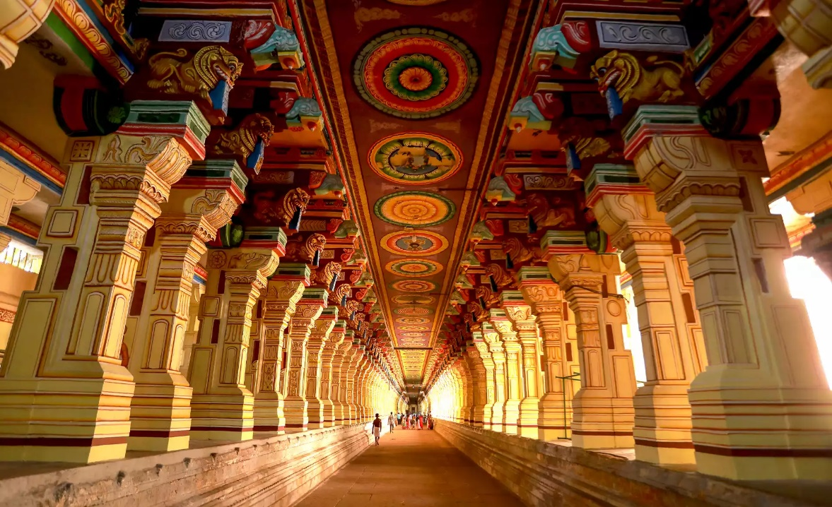
Pillared Mandapa at the Ranganathaswamy Temple
Photo Courtesy: tamilnadutourism.tn.gov.in/photos
Mandapas as Sacred Theatres
The walls of these halls were more than stone—they were textbooks in relief. Many Ranga Maṇḍapas displayed sculpted panels of scenes from the Mahābhārata, Rāmāyaṇa, and local legends, serving as both decoration and education. Come spring, during temple festivals, maṇḍapas transformed into sacred performance spaces. Dancers took to the stage, temple musicians filled the air with melody, and the gods themselves were honoured through drama. At Chidambaram, the Ranga Maṇḍapa celebrated Śiva’s Ananda Tāṇḍava, his cosmic dance.
“For the eternal dance of the Lord, the king grants gold and land, so that the music shall never cease.”
In Madurai’s Podhu Maṇḍapa, the Nayakas staged epic dramas like Rāmāyaṇa and Kumārasambhavam, cleverly blending mythology with political messaging, legitimising their rule in a Tamil cultural landscape.
Mandapas as Economic Hubs
Temples weren’t just spiritual—they were economic engines. In Tiruvārur, merchant guilds like Maṇigrāmam and Ayyavole 500 met in the maṇḍapas to negotiate taxes, trade routes, and temple endowments.
“By the grace of Thyāgarāja, the merchants of the land gather, bringing wealth to the temple and prosperity to the kingdom.”
Here, temples served as banks, boardrooms, and courts, safeguarding wealth and ensuring prosperity. These gatherings weren’t just financial—they were ritualised transactions, with every contract sanctified by temple offerings and witnessed by the deity. The trust placed in the temple ensured that deals struck in the maṇḍapa were honoured like sacred vows.
Mandapas as Military Outposts
Even the distribution of land to soldiers and temple guards was sometimes conducted in maṇḍapas, linking military service directly with divine protection. These halls bore witness to solemn oaths, where warriors pledged to uphold dharma with sword and soul. In times of war, maṇḍapas became war rooms. At Achyutarāya Temple, Hampi, warriors took oaths before battle, their swords blessed beneath stone ceilings:
“By the will of the Lord, the warriors march forth, swords blessed in the sacred maṇḍapa, victory assured by dharma.”
After victories, generals offered their weapons at the maṇḍapa in gratitude, turning battle into devotion.
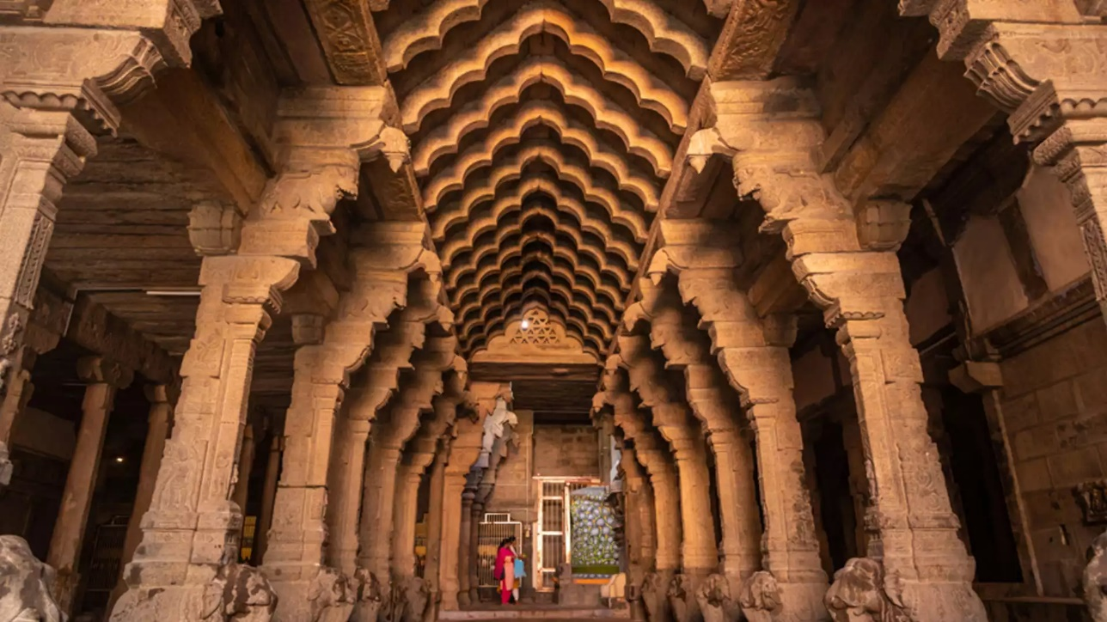
Mandapa at the Kasi Viswanatha Temple
Photo Courtesy: tamilnadutourism.tn.gov.in/photos
Mandapas as Schools and Healing Halls
Inside Vyākaraṇa Maṇḍapas, young scholars learnt Sanskrit grammar under the watch of revered teachers. An inscription at Brihadīśvara Temple records:
“To ensure learning never ends, the king grants gold and land to the scholars of the temple.”
Aushadha Maṇḍapas served as healing halls, where vaidyas treated patients with herbs and oils. Ekāmbaresvara Temple in Kanchipuram records:
“A royal gift sustains the temple’s healers, who serve the sick with plants, prayer, and sacred waters.”
The Ranganathaswamy Temple in Srirangam had inscriptions indicating the operation of an Arokiya Salai (hospital) within the temple premises. A notable inscription records that 1,100 coins were allocated to purchase land for this hospital, which was situated to the north of the "Edutha Kai Azhagiya Nayanar" gopuram. This facility provided medical care to devotees and the local community, highlighting the temple's role in public health and welfare.
Some students even lived in quarters adjoining the maṇḍapas, supported by temple-endowed food grants. A few inscriptions refer to these scholars as "brahmachārins who lived by the light of the temple lamp."
Ranga & Vasanta Mandapas: Where Gods Celebrated
During Dolotsavam in Srirangam’s Vasanta Maṇḍapa, Lord Ranganātha was placed on a swing amidst garlands, music, and joy.
“In the Vasanta maṇḍapa, the Lord swings in gold and pearl, as the kingdom rejoices in the rhythm of spring.”
These halls hosted celestial weddings and seasonal rites, tying the cycles of nature, myth, and society together.
Architectural Evolution and Patronage
The architectural grandeur of mandapas evolved significantly under various dynasties. The Vijayanagara kings, followed by their vassals, the Madurai and Thanjavur Nayaks, played a pivotal role in rebuilding and expanding temples like Srirangam in the 15th and 16th centuries. Much of the temple structures seen today are attributed to their patronage during this period. Some of the earliest and grandest mandapas are seen in the following temples:
- Ajanta & Ellora: The earliest mandapas (2nd century BCE–8th century CE) were rock-cut sanctuaries—simple, sacred shelters.
- Pallava Era: Kailāsanātha Temple at Kanchipuram introduced elaborate mandapas with rich carvings.
- Cholas & Hoysalas: Expanded mandapas into centres of politics, learning, and ritual.
- Vijayanagara & Nayakas: Built monumental halls like Vittala Temple’s Ranga Maṇḍapa, famed for its musical pillars.
Legacy of the Mandapa
“In the shade of the maṇḍapa, the emperor speaks, and all listen, for his word is as eternal as the gods who dwell here.”
— Vijayanagara inscription, Hampi
The temple walls of South Indian temples, particularly in Srirangam, are adorned with numerous inscriptions that serve as vital historical records. These inscriptions, numbering over 800 and spanning from the 9th to the 16th centuries, document various aspects such as temple grants, gifts from rulers and nobles, and details of temple management. They are written in multiple languages, including Tamil, Sanskrit, Kannada, Telugu, Marathi, and Oriya, reflecting the diverse cultural interactions of the time.
If walls could talk, the maṇḍapa would not whisper—it would resound with centuries of music, diplomacy, devotion, and law. It was not just the soul of the temple; it was the soul of the civilisation. From sanctuaries to stages, from classrooms to courthouses, the mandapa was the heart of the temple—a space where divinity and humanity met in stone. Even today, as festivals unfold and lamps flicker, the mandapa continues to echo with footsteps of kings, voices of poets, and whispers of gods.
Glossary
- Maṇḍapa – A pillared hall within a temple used for rituals, performances, court sessions, or public gatherings. A pillared hall or pavilion in Indian temples used for various purposes, including rituals, gatherings, and performances
- Vasanta Maṇḍapa – A seasonal or festival pavilion, especially used during spring festivals
- Vyākaraṇa Maṇḍapa – Grammar or learning hall used for teaching sacred texts
- Aushadha Maṇḍapa – Healing-hall for Ayurvedic medicine and treatment
- Utsava Mūrti – Festival deity brought out in processions during temple events
- Devadāsi – Female temple dancer dedicated to ritual and sacred performance
- Vaidya – Traditional physician practicing Ayurveda
- Dharma – Cosmic order, moral law, and righteous duty in Indian philosophy
- Prasadam: Sacred food offered to a deity and then distributed to devotees as a blessing.
- Devadasi: A woman dedicated to the service of a temple deity, often performing classical dance and music as part of religious rituals.
- Arokiya Salai: A term referring to a hospital or healthcare centre, often associated with temples in historical contexts.
- Utsava Murti: A processional deity used during temple festivals and ceremonies, distinct from the main idol in the sanctum.
- Pancharatra Agama: One of the principal scriptures guiding the rituals and temple constructions in Vaishnavism, believed to be revealed by Lord Vishnu over five nights.
Activity:
Reflect on the multifaceted roles of mandapas in South Indian temples. Consider how these spaces functioned not only as centres for religious activities but also as hubs for education, healthcare, arts, and governance. How does this integrated approach compare to modern community centres? Discuss the potential benefits and challenges of such multifunctional spaces in contemporary society.
Reflection & Activity Corner: Step into the Pillared Past
Mandapa Explorer
Next time you visit a temple, walk into a maṇḍapa. Count the pillars. Look up—are there stories carved into the ceiling? What activities might have taken place here?
Sketch a part of the maṇḍapa and label where:
- A king might have sat
- A dancer might have performed
- A healer might have treated patients
Write Your Mandapa Moment
Imagine you are:
- A scholar giving a lecture
- A dancer rehearsing for a festival
- A warrior taking an oath before battle
Write a short first-person diary entry about your day in the maṇḍapa.
Recreate a Festival Scene
Using clay, paper, or drawing tools, recreate a maṇḍapa decorated for a festival. Add:
- The deity on a swing
- Musicians
- Priests and dancers
- Flower garlands and lamps

Chapter 6:

Temple Festivals as Political Theatre
“In the sacred halls of the temple, warriors, kings, and merchants stand together, bound by the divine order of the gods and the power of the emperor.”
— Vijayanagara inscription
As you walk past one of the maṇḍapas, a glorious sight catches your eye. The distant strain of nādaswaram and thavil, that you heard when you entered the temple, has now become strident. A few devotees whisper chants under their breath, while others let out loud cheers in praise of the deity. The fragrance of fresh jasmine and sandalwood thickens the atmosphere—you can feel it: something is about to happen.
At the centre of the maṇḍapa, beneath an ornately carved wooden canopy, the utsava mūrti waits. Not the main deity—who remains in the garbha gṛha, the sanctum—but the processional form, the one who steps out into the world, the one who meets the people. The utsava mūrti is dressed like royalty. The bronze form gleams, polished until it glows like molten gold in the dim temple light. Draped in silk of the deepest maroon and emerald green, edged with zari that catches the flicker of oil lamps, the deity seems less like an idol and more like a living presence. A crown of gold rests on the head, surrounded by fresh garlands of mullai, kanakambaram, and tulsi. From the chest hangs a long, looping mālai (garland), interwoven with fragrant flowers and shimmering coins. Tiny bells on the ankles glint as priests make final adjustments. Behind the idol, temple attendants hold up a velvet parasol, embroidered with the temple’s symbol. On either side, lamp bearers stand ready. Fans made of peacock feathers gently stir the air. You can hear the low rustle of silk, the faint clink of gold, the quiet gasp of an old devotee seeing their god like this—up close, radiant, human, and divine.
Before the idol departs, there’s a final ārati—a circle of flame drawn before the deity’s face, casting dramatic shadows on the finely sculpted features. The priest chants, the conch blows, and the dīpam glows in every eye watching. No temple elephant today. No fireworks. No crowd pressing against the barricades. This isn’t one of the great annual festivals; it’s a minor utsavam, a quiet celebration—perhaps tied to a nakṣatra or tithi, maybe the commemoration of a saint’s visit, or the deity’s symbolic journey through the streets.
The pallakku bearers step in. A murmur passes through the gathering as the priests nod, giving the go-ahead. With a united heave, the pallakku lifts from the maṇḍapa floor. The bells tied to its corners begin to jingle. The utsava mūrti now sits elevated, eyes forward, ready to leave the maṇḍapa and touch the world. As the mūrti passes through the maṇḍapa pillars, the stone seems to glow. The procession begins—and the festival is alive.
Royal Patronage: The King as the Supreme Devotee
“The temple chariot rolls through the streets, and the people rejoice, for the king and the gods walk together, bringing fortune to the land.”
— Vijayanagara inscription
Travel through time to medieval India, where temple festivals were more than religious celebrations; they were carefully designed political spectacles that reinforced royal authority, secured economic control, and ensured public loyalty. Imagine the grandeur of a temple festival—elephants draped in silk and gold, priests carrying sacred idols in elaborate processions, the deafening sound of drums and conch shells, and thousands of devotees gathered to witness the divine spectacle. But beyond the devotion and rituals, these festivals were a stage for kings to assert their rule. From the Cholas and Pandyas to the Vijayanagara rulers, kings used temple festivals to strengthen alliances, project military power, mobilize economic resources, and reinforce their divine legitimacy.
In medieval South India, a ruler was not just a king; he was the chief servant of the gods. His ability to rule was closely linked to his patronage of temples and participation in religious rituals. Temple festivals provided an opportunity for the king to publicly exhibit his devotion, ensuring that his rule was seen as divinely sanctioned. Kings often walked barefoot during festival processions—a symbolic act of humility before the gods—while also ensuring that they remained the centre of public attention. Royal donations of gold, land, and livestock to temples were made during these festivals, reinforcing the king’s generosity and divine favour.
Inscriptions from the Brihadīśvara Temple in Thanjavur record how Rājarāja Chola personally led festival processions, ensuring that his presence was associated with Śiva’s divine blessings. Similarly, Pandya inscriptions describe how their kings funded elaborate chariot processions, strengthening their image as protectors of dharma. These were not just religious gestures; they were highly choreographed political performances that reinforced the idea that the king ruled not by mere force, but by divine approval.
Temple festivals were also important political gatherings. They brought together kings, feudatory chieftains, military leaders, merchants, and religious institutions, serving as an ideal platform for the king to consolidate his power. Feudal lords were required to attend these festivals, reaffirming their loyalty to the king in a sacred space. Rulers used these gatherings to negotiate alliances, showcase military strength, and settle disputes. Some festivals featured martial processions and warrior contests, designed to remind both allies and enemies of the king’s military prowess.
Records from Srirangam Temple mention that Vijayanagara rulers invited local chieftains to temple festivals, ensuring that they remained under the empire’s control. Inscriptions from Hampi describe how temple festivals featured military parades, emphasizing the empire’s strength. These festivals ensured that no feudatory could act independently; they had to publicly recognize the king’s authority in a setting that merged political loyalty with divine approval.
Economic Power Through Rituals: Temple Festivals and Tax Collection
“By the grace of the gods, merchants bring their wealth to the temple, and the king, protector of dharma, ensures prosperity for all.”
— Pandya Inscription
Temple festivals were also significant economic events that generated massive revenue through donations, trade, and taxes. Rulers strategically linked taxation with festivals, ensuring that wealth flowed into temple treasuries, which were often controlled by the state. Special festival markets were set up near temples, where traders had to pay taxes to operate. Some rulers even imposed mandatory donations from merchants and landowners, a practice known as ulavaṟ panam, ensuring a continuous flow of revenue.
Records from Tirupati Temple indicate that Vijayanagara rulers taxed festival vendors and used the proceeds to fund temple rituals. Chidambaram inscriptions mention tax exemptions for traders who contributed to temple festivals, securing their loyalty to the king. Pandya inscriptions list special festival levies imposed on merchants and landowners, highlighting how closely temple festivals were tied to state finances. These festivals were economic engines that reinforced royal authority while keeping temples at the heart of the kingdom’s financial network.
Temple festivals allowed kings to control public perception by demonstrating their power in an awe-inspiring and sacred setting. Grand chariot festivals, where deities were paraded through the streets, reinforced the idea of a unified kingdom under one god and one ruler. Some festivals included symbolic acts of submission, where feudatories or even defeated rivals were required to participate in religious rituals, acknowledging the king’s supremacy in front of the masses.
To further cement their image as divine rulers, kings funded music, dance, and theatrical performances during festivals. The Vijayanagara inscriptions describe how kings ensured their presence at temple festivals to reinforce their image as divine protectors. Kumbhabhiṣekam temple records mention mass donations and public feasts organized by rulers, strengthening public loyalty. Pandya inscriptions describe how festival parades included banners depicting the king’s military victories, subtly reminding people of his strength. The spectacle of the temple chariot rolling through the streets was not just an act of devotion but an unmistakable symbol of the king’s authority. By controlling public perception through festivals, kings ensured loyalty, stability, and admiration—all without having to wage war.
Rathas, Vahanas, and Processions: The Power of Divine Journeys
“As the king rules the land, so does the Lord rule the heavens. The chariot rolls forth, and all shall bow before the divine sovereign.”
— (Chola Inscription at Bṛihadīśvara Temple, 11th century CE)
You witnessed a minor utsavam as you were exploring the maṇḍapas. Now imagine a major festival—a ratha utsavam or ratha yatra. As the temple gates swing open, a deafening conch blast echoes through the streets. The air is thick with the scent of jasmine and camphor. A massive chariot, adorned with gold, silk, and towering parasols, begins its slow, majestic movement. Thousands of devotees—peasants, merchants, nobles, and warriors—raise their voices in prayer as the deity emerges, carried aloft in a radiant pallakku or seated upon a grand ratha (chariot).
This is no ordinary religious ritual. This is the moment when gods rule like kings. Temple processions, whether on chariots (rathas) or pallakkus, were acts with political overtones, carefully designed to reinforce the sovereignty of the deity, the divine legitimacy of kings, and the integration of all social classes into a shared sacred order. These grand processions functioned as political tools, integrating the divine and the earthly realms, ensuring that gods, kings, and subjects remained in perfect cosmic harmony. As we have already seen in South Indian temple traditions, deities are not just celestial beings—they are rulers. Their temples are their palaces (deva ālayam/koyil), their priests act as ministers, and their processions mirror royal visits to their subjects. Just as kings rode on elephants or chariots during royal visits, deities were placed on giant wooden chariots, towering above the crowds to remind the people that the god was their sovereign. Deities were also carried on ornate pallakkus, often escorted by temple guards (daṇḍa nayakās or velaikkarars) and musicians, just like a king traveling through his dominion. Just as emperors were shaded by golden umbrellas and waved with fly-whisks, deities were adorned with the same symbols of kingship.
A similar example is seen in Puri’s Jagannātha ratha yatra, where the deities are taken out in colossal chariots, mirroring a royal procession. According to temple traditions, this is not just a festival but an assertion of Jagannātha’s rule over the land. Even the Gajapāti King of Odisha (historically the ruler of the region) performs the chhera pahāra ritual (sweeping the chariot), symbolizing that he is merely a servant of the god-king. The king’s authority is legitimized by his devotion to the deity, and the temple remains the true seat of power.
Rathas (chariots) played a central role in temple festivals, serving as the divine vehicles upon which deities travelled through their kingdom. These towering, intricately carved structures—sometimes over 90 feet tall—were pulled by thousands of devotees, symbolizing the cosmic and earthly sovereignty of the deity. The connection between divine and royal power was unmistakable. Just as a king rode through his lands in a grand procession, the temple deity was carried through the city, reinforcing the idea that both were rulers of their respective realms.
Kings often walked behind the chariots barefoot, a symbolic act of humility, while also ensuring that they remained central to the procession. Temple guards, cavalry, and elephants often accompanied these processions, merging religious devotion with military spectacle.
The Thiruvarur Chariot Festival, one of the most significant in Tamil Nadu, is an example of the grandeur associated with these events. The Azhi Ther, a colossal chariot standing 96 feet tall and weighing over 300 tons, is one of the largest temple chariots in India. The festival, referenced in the hymns of Tamil saint-poets like Āppar and Sambandar, was historically sponsored by ruling dynasties to assert their dominance over the region. Even in modern times, political figures such as M. Karunanidhi of the Dravida Munnetra Kazhagam (DMK) played a role in reviving the festival, illustrating how temple celebrations continue to hold political significance.
How the Nayakas Used the Alagar Procession to Win the Countryside
“By the grace of the gods, Alagar himself comes down from the hills to bless the people, and the kingdom prospers under the watchful eyes of Meenakshi and her brother.”
— Vijayanagara/Nayaka Inscription
The Chithirai thiruvizha of Madurai is one of the grandest temple festivals in Tamil Nadu, celebrated with unmatched devotion and grandeur. At its heart lies the divine wedding of Goddess Meenakshi and Lord Sundareswarar, a spectacle that transforms the city into a massive stage for devotion, tradition, and political symbolism. However, the festival we know today was not always the same. It was the Nayaka rulers of Madurai (16th–18th century CE) who altered its structure by introducing the Alāgar (Vishnu) procession—a brilliant political move that helped them secure the loyalty of the rural population of the Madurai kingdom.
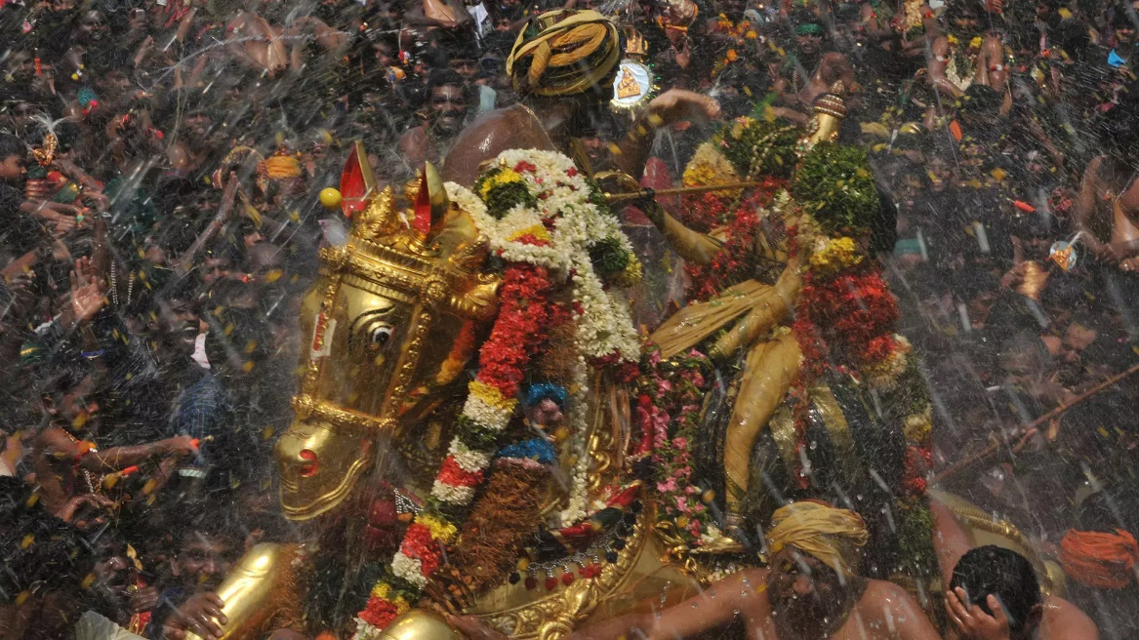
Madurai Chithirai Festival
Photo Courtesy: https://www.tamilnadutourism.tn.gov.in/photos
The festival, in its original form, was celebrated during the Pandya dynasty’s reign, focusing entirely on the wedding of Goddess Meenakshi and Lord Sundareswarar. The festival lasted for ten days, culminating in the celestial wedding at the Meenākṣī Temple. It was a Shaiva-centric festival, reinforcing the Pandya kings’ devotion to Lord Śiva. The royal family played a major role, with the king symbolically acting as Meenākṣī’s brother, giving her away in marriage. The event consolidated the city of Madurai as the religious and administrative heart of the kingdom. For centuries, this festival cemented the Pandya rulers’ legitimacy, tying their rule to Madurai’s divine presence.
But when the Pandyas declined and the Nayakas took over, things began to change. When the Nayakas of Madurai came to power under Viśvānatha Nayaka (16th century CE), they faced a significant challenge. The Nayakas were Telugu-speaking rulers appointed as governors under the Vijayanagara Empire. They needed to prove their legitimacy to the Tamil people. While they controlled Madurai, the rural regions remained culturally and politically disconnected from their rule. The countryside was filled with Vishnu-worshipping (Vaishnava) communities, particularly in the Alāgar Hills region, who did not fully connect with the Shaiva-dominated Meenākṣī festival. To win the hearts of the rural people and integrate them into the political and religious landscape of Madurai, the Nayakas made a bold move—they changed the structure of the Chithirai Festival itself.
The Nayakas expanded the Chithirai festival by introducing the Alāgar Vaigai Eluntharulal (Alāgar Procession to the Vaigai River). This new addition brought Lord Alāgar (Vishnu), the presiding deity of Alāgar Kovil, into the festival celebrations. Alāgar, the elder brother of Meenākṣī, was now included in the festival’s narrative. According to the new tradition, Alāgar starts his journey from Alāgar Kovil to attend Meenākṣī’s wedding in Madurai. However, by the time he reaches the city, the wedding is already over, so he stops at the Vaigai River, where he blesses the people before returning to his temple. It gave rural Vaishnavites a direct connection to the festival, making them feel included in Madurai’s religious traditions. It brought people from the countryside into the city, reinforcing Nayaka control over rural populations. It balanced both Shaiva and Vaishnava traditions, reducing sectarian divisions in the region. It turned the Vaigai River into a sacred site, reinforcing the Nayaka king’s ability to control both land and water resources. Thus, the festival was no longer just a royal Shaiva celebration—it had become a unifying event, connecting city and countryside, Śiva and Vishnu, urban rulers and rural subjects.
Even today, the Alāgar Procession remains a major highlight of the Chithirai Festival, drawing thousands of devotees. The event is marked by Alāgar’s journey from Alāgar Kovil, passing through rural villages before reaching Madurai; the dramatic moment when Alāgar "misses" his sister’s wedding and stops at the Vaigai River; a grand water ritual (theerthavari) at the Vaigai River, where Alāgar blesses the people; and finally, the return of Alāgar to his hilltop temple, completing the divine cycle. Through a single festival, the Nayakas transformed their rule from that of foreign governors to beloved Tamil rulers, using faith, tradition, and spectacle to win the loyalty of their people.
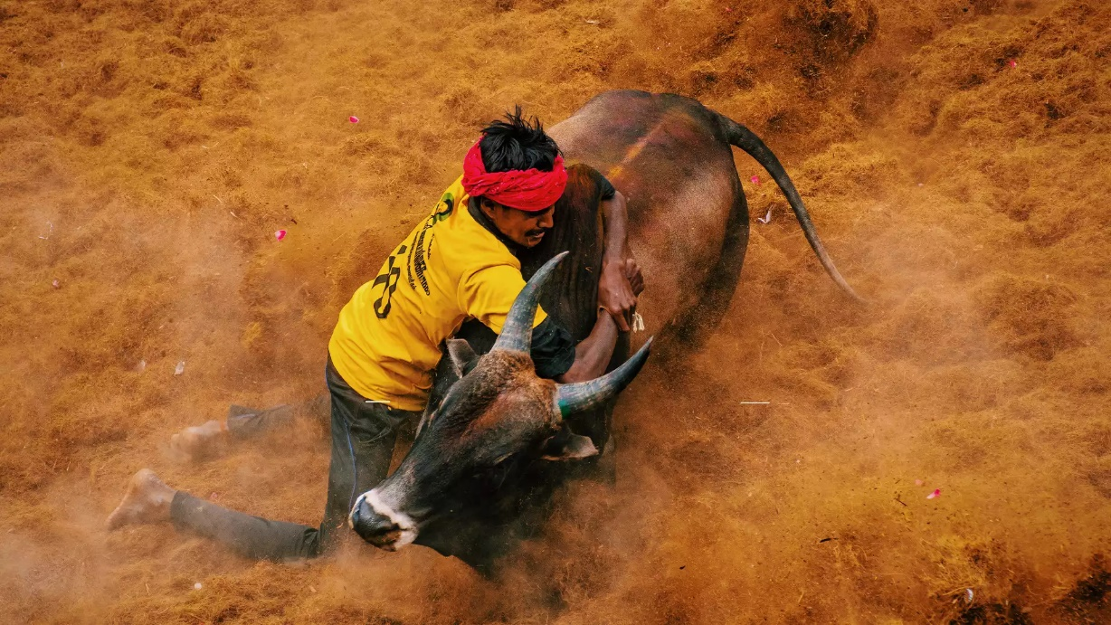
Jallikattu – An event organized at various places in Tamil Nadu
Photo Courtesy: https://www.tamilnadutourism.tn.gov.in/photos
The Chidambaram Festival: Elevating Shaivism Over Vaishnavism
“By the grace of Natarāja, the Chola king rules justly, and his empire flourishes as the gods dance in joy.”
— Chola Inscription at Chidambaram Temple
The Cholas were staunch Saivites, and they sought to establish Shaiva supremacy over Vaishnavism. One of their key strategies was reshaping the Chidambaram temple festival to focus entirely on Lord Śiva (Natarāja), sidelining Vishnu-worshipping communities. Before the Cholas, Chidambaram was a shared space for both Śaivas and Vaiṣṇavas. Rājarāja Chola expanded the festival around Natarāja, emphasizing Śiva as the supreme deity. Kulothunga Chola II removed references to Vishnu from the temple’s rituals and linked royal authority to Śiva’s cosmic dance. The Chidambaram Dikshitar priests (traditional custodians of the temple) were given land and royal grants, ensuring they promoted the Chola-approved version of the festival. This strengthened the king’s position as the divine representative of Śiva. This strategy was so successful that Chidambaram remains one of the most important Śaiva centres to this day.
The Vijayanagara Empire and the Srirangam Vaikunta Ekadasi
“The righteous king, by the favour of Ranganātha, restores what was lost and ensures that dharma prevails over adharma.”
— Vijayanagara Inscription at Srirangam
The Vijayanagara Empire, a Hindu kingdom resisting Islamic invasions, used temple festivals to restore and reclaim sacred sites that had been attacked or occupied by the Delhi Sultanate. One of the most important examples was the revival of the Vaikunta Ekadasi festival in Srirangam. After Malik Kafur’s invasion (1311 CE), Srirangam suffered destruction, and its festivals were disrupted. Vijayanagara kings funded the reconstruction of the temple and revived the annual Vaikunta Ekadasi festival, attracting pilgrims from across South India. The festival now included military parades showcasing the empire’s strength, reinforcing the idea that the empire was the temple’s defender. Kings participated in the festival by offering gold, elephants, and land grants, symbolizing their role as protectors of Vishnu’s sacred abode. This move reclaimed Srirangam’s status as a Hindu stronghold after Islamic invasions. It portrayed the Vijayanagara kings as divine warriors protecting temples from foreign rule. It served to integrate Vaiṣṇava traditions into state politics, securing support from Vishnu-worshipping communities.
Inclusion and Integration
“As the chariot rolls through the streets, all are equal in the eyes of the Lord, for He visits the homes of the rich and the poor alike.”
While the temple sanctum was restricted to certain groups (castes), processions took the gods outside the temple walls, allowing all social classes—including marginalized communities—to participate in temple life. Many castes that were denied access to the temple sanctum could worship and interact with the deity in public spaces. In fact, some castes were given specific duties, such as pulling the chariot ropes, preparing floral decorations, or playing temple drums, integrating them into temple traditions. The deity’s journey outside the temple reinforced that god belonged to all, not just the elite priestly class.
Rulers actively participated in temple processions to demonstrate their devotion and establish themselves as divine representatives on earth. The kings used processions for political messaging by donating golden chariots and temple jewellery, ensuring their names were linked to the prosperity of the festival. Some kings walked barefoot before the chariot, signalling their humility before the gods and reinforcing their piety. Royal guards, elephants, and cavalry often accompanied the chariot, creating a display of both spiritual and military strength.
“The king walks behind the Lord’s chariot, for the ruler of men bows before the ruler of the cosmos.”
The Vijayanagara Empire expanded temple festivals as grand state-sponsored events. Kings funded processions at Tirupati, Hampi, and Srirangam, ensuring that temples remained under royal control and that pilgrims associated the empire with divine blessings. These were also occasions where feudatories and local rulers reaffirmed their loyalty by attending the festivals. The underlying political message was that the emperor was not just a ruler—he was a divine servant and protector of dharma. Thus, temple processions were statements of power, sovereignty, and social order. They reinforced the idea of the deity as a king and served to integrate all social classes into temple life. Ultimately, they linked royal authority with divine favour.
The Eternal Connection Between Festivals and Political Power
“Let the fire burn bright on the holy hill, a sign that the king’s rule is strong and just under the gaze of Lord Śiva.”
— Chola Inscription
Temple festivals followed a meticulously organized calendar, ensuring that royal patronage was a constant presence in the lives of the people. The Chithirai festival in Madurai, sponsored by the Pandyas, celebrated the wedding of Meenākṣī and Sundareswarar, reinforcing the king’s role as the divine protector of the city. The Kārthigai Dīpam festival at Arunachaleshwara Temple, where a giant fire was lit atop the hill, was funded by Chola rulers as a symbol of divine kingship. As one inscription asserts, the Vijayanagara rulers made grand donations to Tirupati during Purattāsi Saturdays, ensuring their status as defenders of dharma.
Even today, temple festivals in South India continue to operate on medieval economic and political principles. The Tirumala Tirupati Devasthanam (TTD), one of the richest temple trusts in the world, functions much like a medieval temple treasury, using revenue from land donations, business contributions, and festival-specific taxation to sustain religious activities. The Madurai Chithirai Festival, Tirupati Brahmotsavas, and Puri Rath Yatra still generate enormous economic activity, just as they did under the Chola and Vijayanagara rulers.
The Crafting and Restoration of Temple Chariots (Ther) in South India
“As the chariot rolls, so does time; as the god moves, so do the fates of men.”
— (Chola inscription, Tiruvarur, 12th century CE)
Temple chariots, known as Ther in Tamil, Ratha or Radham in Malayalam, are an integral part of South Indian temple festivals. These massive, intricately carved wooden structures carry deities through the streets during rathotsava (chariot festivals), symbolizing the cosmic journey of gods among their devotees. The construction and restoration of these chariots are centuries-old traditions, carried out by specialized craftsmen who carve, assemble, and maintain these moving temples using ancient techniques. Despite modernization, temple chariots are still built and restored in traditional ways, preserving the art of chariot-making across generations.
The Spiritual and Symbolic Meaning of Temple Chariots
“With every hand that pulls, the burden of life is lifted; with every step the chariot takes, the world is blessed.”
Temple chariots symbolize the Universe as a Moving Temple—the chariot represents the cosmos, carrying the deity through space and time. As kings once rode in grand processions, deities travel in chariots to remind people of divine authority. Devotees pulling the chariot signify karma (effort) in seeking spiritual liberation. The deity’s movement represents the cyclical nature of life and cosmic order (dharma).
Though most temples have their own versions of Ther, some impressive ones are at:
- Tiruvarur Thyagaraja Temple – The largest in Tamil Nadu, nearly 96 feet tall.
- Thiruvarangam (Srirangam) Temple – One of the grandest Vishnu chariots.
- Kanchipuram Varadaraja Perumal Temple – Notable for its intricate carvings.
Building a temple chariot is a highly specialized art, requiring months or even years of craftsmanship. The process involves traditional measurement systems, specific wood selection, and intricate carvings: a) Choosing the Wood: Sacred woods such as Vengai (Indian Kino), Neem, Sal, and Jackfruit are used. The wood is seasoned for months to prevent cracking and ensure durability. In modern times, metal and fibre-reinforced wood are sometimes used to replace aging wooden parts.
b) Assembling the Chariot Frame: The base of the chariot (Adipadi) is assembled using interlocking wooden beams. A central pillar, known as Brahmasthambha, is erected to balance the structure. No nails are used—only wooden pegs and interlocking joinery, a technique perfected by Vishwakarma artisans.
c) Carving and Decorating the Chariot: Intricate wooden reliefs depicting gods, mythological scenes, and celestial beings are hand-carved. Sculptures of lions, elephants, Garuda, and Yali (mythical beasts) adorn the wheels and sides. The deity’s vahana (divine mount) is prominently displayed at the front.
d) Fabric and Metalwork: The chariot is covered with richly embroidered cloth canopies in red, blue, and gold. Silver and brass ornaments, bells, and mirrors are added for visual grandeur. Large wooden wheels with metal rims are fitted to support movement.
e) Final Assembly and Blessing Rituals: The chariot is assembled near the temple and purified with Vedic rituals before use. Final inspections are done by temple priests and sthapathis (architects).
While kings may no longer rule the land, temple rathotsava remain powerful symbols of political, economic, and spiritual authority. The gods still ride in chariots, and the people still gather in thousands, reinforcing a tradition that has outlived dynasties, survived empires, and continues to shape the cultural and political landscape of South India..
Glossary
Term | Definition
Utsava Mūrti | The processional (festival) form of the deity used in temple processions.
Pallakku | A palanquin used to carry the deity during minor festivals.
Ratha / Ther | A temple chariot used in major festival processions; an ornate, often enormous wooden structure.
Ulavaṟ Panam | A type of festival levy or tax imposed on merchants and landowners to support temple rituals.
Chhera Pahara | The ritual sweeping of the chariot, symbolizing humility before the divine.
Azhi Ther | A colossal temple chariot at Thiruvarur, one of the largest in India.
Chithirai Thiruvizha | The annual spring festival in Madurai celebrating the wedding of Meenākṣī and Sundareswarar.
Alāgar | A form of Vishnu, often depicted as the elder brother of Meenākṣī, featured in temple festivals in Madurai.
Theerthavari | A sacred water ritual performed during temple festivals, often at a river or tank.
Brahmasthambha | The central pillar in a temple chariot that supports and balances the structure.
Dharma | Cosmic order, moral law, and righteous duty in Indian philosophy.
Adipadi | The base or foundation of the temple chariot, assembled from interlocking wooden beams.
Sthapathi | An architect or master builder, especially in temple construction.
Vishwakarma | A divine architect in Hindu mythology, whose skills are emulated by traditional temple artisans.
Activity & Reflection Corner
Design a Festival Poster
- Task: Create a hand-drawn or digital poster announcing a grand temple festival.
- Include: The deity on a chariot, details of the procession (such as the pallakku and ratha), royal participation, musical instruments, and vibrant festival elements.
- Objective: Capture the grandeur and political symbolism of temple festivals.
Historical News Flash
- Task: Imagine you are a reporter in medieval South India covering the festival.
- Write: A short news report (200–300 words) that includes quotes from temple priests, royal representatives, and common devotees.
- Objective: Reflect on how temple festivals served as both religious spectacles and political platforms.
Debate: Festival Devotion or Political Spectacle?
- Task: In groups, debate whether temple festivals were primarily acts of devotion or strategic political events.
- Points to Consider: Royal patronage, economic impact, military displays, and social integration.
- Objective: Use historical evidence from the inscriptions and narratives to support your arguments.

Chapter 7

The Calendar of Temple Festivals: Royal Patronage and Political Control
"By the order of the righteous king, let the temple shine in festival lights, and let the gods be pleased by the devotion of the people."
— Vijayanagara Inscription
Introduction
Temple festivals in South India have long been grand spectacles of devotion, culture, and economic activity. Among these, the Ratha (chariot) festival stands out for its magnificence. However, due to its elaborate nature, it is typically held once a year. To ensure continuous veneration of deities, temples adhere to meticulously organized festival calendars, featuring monthly and annual celebrations. These events were often state-sponsored, funded by kings, merchant guilds, and temple endowments. Royal grants, documented in inscriptions, financed processions, chariot festivals, special pujas, music, dance performances, and massive public feasts. Such royal associations with temple festivals reinforced divine legitimacy, secured loyalty from temple institutions, and strengthened economic ties with traders and local communities. Each month in the Hindu lunisolar calendar was marked by special temple rituals and minor festivals, with kings and local rulers providing funding for specific ceremonies.
Monthly Festivals and Royal Patronage
The alignment of Tamil and Hindu months with corresponding festivals and their royal patrons is illustrated below:
Tamil Month | Hindu Month | Festival Name | Royal Patronage
Chithirai (April-May) | Chaitra | Chithirai Thiruvizha | Sponsored by Pandyas for Meenakshi Temple; grand wedding of Meenakshi & Sundareswarar.
Vaikasi (May-June) | Vaishakha | Vaikasi Visakam | Funded by Cholas for Murugan temples; celebrated Murugan’s birth.
Aani (June-July) | Jyestha | Aani Thirumanjanam | Chidambaram temple’s special abhishekam for Nataraja, with grants from Chola kings.
Aadi (July-August) | Ashadha | Aadi Pooram | Royally funded in temples dedicated to Andal, honouring divine feminine power.
Aavani (August-September) | Shravana | Aavani Moolam | Krishna festivals supported by Vijayanagara kings at Udupi and Srirangam.
Purattasi (September-October) | Bhadrapada | Purattasi Saturdays | Festival in Tirupati, where Vijayanagara kings made significant gold donations.
Aippasi (October-November) | Ashwin | Aippasi Annabhishekam | Food donation in Shiva temples, funded by Nayaka rulers.
Karthigai (November-December) | Kartik | Karthigai Deepam | Royally sponsored lamp-lighting festival at Arunachaleshwara Temple.
Margazhi (December-January) | Margashirsha | Margazhi Utsavam | Tamil Vaishnavite temples received royal endowments for reciting the Tiruppavai hymns.
Thai (January-February) | Pausha | Thai Poosam | Murugan festival with processions and royal donations.
Masi (February-March) | Magha | Masi Magam | Great sea-bathing festival in Tamil Nadu, where Chola kings made offerings.
Panguni (March-April) | Phalguna | Panguni Uthiram | Royal sponsorship for divine weddings, especially at Srirangam and Madurai.
Note: The above table aligns Tamil months with their corresponding Hindu months and highlights the associated festivals along with their royal patrons.
Chola inscriptions at Chidambaram mention that Rajaraja Chola I granted gold and lands for Aani Thirumanjanam. Pandya records at Meenakshi Temple state that their kings financed the Chithirai festival, making it the grandest in Madurai. Vijayanagara inscriptions at Tirupati highlight Purattasi Saturdays as the peak of royal donations, with Krishnadevaraya personally gifting gold ornaments.
Temple Festivals and the Festival Economy
"Let the temple shine with a hundred lamps, let the chariots roll, and let the kingdom rejoice, for the king has ensured that the festival of the gods never ceases."
— Chola inscription
Imagine chariots taller than houses rolling through the streets, thousands of oil lamps illuminating temple walls, merchants setting up grand bazaars, and musicians, dancers, and priests performing elaborate rituals. The entire city pulsates with life, as if the temple itself has become the capital of the kingdom. These grand festivals were state-sponsored spectacles, carefully managed by rulers to assert their power, generate wealth, and integrate people from all social and economic backgrounds into temple-centred governance. Kings strategically funded temple festivals, controlled their economic structures, and ensured that temples remained the heart of political and financial power.
Mechanisms of Royal Support:
- Direct Royal Grants (Dana & Ubhayam): Kings and queens personally donated gold, silver, jewels, and land to temples to finance festivals.
- Festival-Specific Taxation (Utsava Viniyogam): Special taxes were levied on merchants, artisans, and agricultural lands to fund festival expenditures.
- Compulsory Donations from Feudatories & Local Chiefs: Vassal kings and regional chieftains were required to fund processions, chariot-building, and public feasts.
- State-Controlled Temple Treasury (Devaradiya Treasury): Many rulers ensured that a portion of tax revenue was permanently allocated to temple festivals, preventing financial shortages.
Inscriptions at Thanjavur, Kanchipuram, Udupi, Tirupati, and Rameswaram Temples, dating from the Chola, Pallava, Nayaka, and Vijayanagara periods (10th–17th Century CE), indicate that one of the most effective ways kings ensured long-term festival funding was by granting lands to temples, known as Devadana or Utsava-Devadana
Glossary
Term | Meaning
Ratha | Chariot used in temple festivals to carry the Utsava Murti (processional deity).
Utsava Murti | The festival or processional idol of a deity, distinct from the main idol housed in the sanctum (garbha griha).
Devadana Lands | Land grants given to temples by kings or wealthy patrons, with the revenue used for temple maintenance and festivals.
Tiruvizha | Tamil term for temple festival or fair, often associated with seasonal, economic, and religious activities.
Dana | Alms or donations (gold, land, livestock) made to temples by kings, queens, or lay devotees.
Ubhayam | A type of sponsorship for specific rituals, where a donor funds the cost of conducting a festival or puja.
Utsava Viniyogam | A special levy or tax imposed for the purpose of funding temple festivals.
Annadanam | Sacred tradition of offering free food to pilgrims and the poor during temple festivals.
Theerthavari | Ritual bathing in holy rivers or tanks during temple festivals, symbolizing purification and blessings.
Navadhanya | The nine sacred grains offered during Navaratri and other agrarian festivals.
Chithirai Thiruvizha | Grand festival held in Madurai to celebrate the wedding of Meenakshi and Sundareswarar.
Karthigai Deepam | Tamil festival of lights celebrated by lighting large oil lamps, symbolizing divine energy and cosmic light.
Maasi Magam | Festival involving sea processions of deities and ritual bathing, especially in coastal temples.
Tirunamattukkani | Tax-exempt temple lands, often given by royal decree to ensure uninterrupted temple activities and worker salaries.
Manigramam/ Ayyavole 500 | Powerful merchant guilds in medieval South India that funded temples and gained trade privileges.
Margazhi Utsavam | Devotional celebration in the Tamil month of Margazhi, involving early morning hymns, music, and dance in Vaishnavite temples.
Activity: Map the Festival Economy
Objective:
To understand how temple festivals functioned as both sacred and economic events in medieval South India.
Instructions:
- Festival Mapping (Group Activity):
Choose one temple festival (e.g., Chithirai Festival, Brahmotsavam at Tirupati, or Karthigai Deepam). Map its timeline, rituals, and economic actors involved (weavers, merchants, priests, farmers, etc.). Use charts or role-play as different stakeholders (king, merchant, farmer, priest).
- Inscription Decoding (Individual Task):
Provide students with short translated excerpts from real temple inscriptions (e.g., from Chidambaram or Thanjavur). Ask them to decode who donated what, and for what purpose. Discuss the political motives behind these donations.
- Festival Economics Chart (Homework):
Create a data table showing how temple festivals impacted:
  - Textile industry (silk, cotton)
  - Agriculture (food grain supply, dairy, sugarcane)
  - Livestock trade (bulls, elephants)
  - Temple employment (priests, dancers, musicians)
  - Donations and taxes
- Creative Writing Prompt (Reflection):
Imagine you are a weaver from Kanchipuram or a rice farmer near Madurai preparing for an upcoming festival. Write a short diary entry explaining your preparations, hopes, and offerings to the temple.

Chapter 8

Vahanas: Divine Mounts and Their Symbolism
"As the Lord rides forth, so do the heavens move; as the mount carries the divine, so does the temple carry the world’s blessings."
(Chola inscription, Thiruvarur, 12th century CE)
Remember the utsavam we witnessed earlier on? The deity was seated on a pallakku (palanquin). As you meandered through the mandapams, I’m sure you wouldn’t have missed the Vahanas, some plated in metal, while others in colourful wood. Now picture the grand sight of Lord Vishnu riding Garuda, Goddess Durga seated majestically on a lion, or Lord Shiva carried in a silver Nandi as thousands chant in devotion, a scene common in South Indian Temples.
Deities do not always remain inside their sanctums. They emerge in grand processions, riding elaborate Vahanas (divine mounts) that symbolize their cosmic power and presence among their devotees. Vahanas are not just vehicles; they are extensions of the deities themselves, each carrying a deeper philosophical and political meaning. Their presence in temple processions transforms the sacred space of the temple into a moving spectacle, reinforcing divine authority and royal symbolism. In Hindu temple traditions, a Vahana is a sacred mount or vehicle of a deity, used in rituals and processions. Deities are often enshrined in chariots, palanquins, or animal-shaped mounts during temple festivals, making them visible to the public. Different Vahanas are used on different days of festivals, each carrying a specific meaning. Vahanas reflect the power, virtues, and role of the deity.
During the Brahmotsavam at Tirupati different Vahanas are used for carrying Lord Venkateswara each day:
- Pedda Sesha (cosmic serpent)
- Garuda
- Hanumantha
- Chandra Prabha Vahana (Moon Vahana
Every Vahana carries deep symbolic meaning, reflecting their divine role in the universe.
Deity | Vahana | Symbolic Meaning | Temple Processions
Shiva | Nandi (Bull) | Strength, Dharma, Patience | Karthigai Deepam, Mahashivaratri
Vishnu | Garuda (Eagle) | Speed, Power, Protection | Vaikunta Ekadasi, Garuda Sevai
Durga | Lion | Courage, Fearlessness | Navaratri, Theppotsavam
Ganesha | Mooshika (Mouse) | Humility, Control over Desire | Vinayaka Chaturthi
Murugan | Peacock | Victory, Wisdom | Thaipusam, Skanda Sashti
Lakshmi | Elephant (Gaja) | Royalty, Abundance | Gaja Vahana Seva
Saraswati | Swan (Hamsa) | Purity, Knowledge | Saraswati Pooja, Navaratri

At Chidambaram Nataraja Temple, Lord Shiva is carried on Nandi during Mahashivaratri. This signifies Shiva’s mastery over Dharma (cosmic order). The bull is a symbol of patience and fertility, connecting temple worship with agricultural prosperity. In Chola times, Nandi was a royal emblem, linking the king’s power to Shiva’s divine rule. Chola rulers saw themselves as "Shiva’s Nandi", bringing justice and dharma to the land. Vijayanagara Kings patronized Garuda Seva – They reinforced Vaishnavism as state policy, making Garuda a royal emblem. Nayaka rulers used grand processions with Vahanas to assert legitimacy in newly conquered territories. "As Garuda lifts Vishnu, so does the emperor lift dharma; as Nandi carries Shiva, so does the king uphold justice. "Garuda was used as a battle emblem by Vijayanagara rulers, asserting Vaishnavite supremacy. Garuda Vahana processions at Srirangam and Tirupati were funded by the Vijayanagara state, ensuring the king’s name was always linked to divine power.
The Enduring Legacy of Vahanas in Temple Rituals
"For the gods to ride, the hands of artisans must toil; for the festival to shine, the weaver must weave, the carpenter must carve."
Temple Vahanas are not just mounts for the gods—they are carriers of faith, symbols of royal power, and engines of economic life. They ensure that the deity remains accessible to devotees through processions. Different aspects of divine power are represented through different mounts. Kings and rulers align themselves with divine authority. Artisans and craftsmen continue to thrive through temple-based industries.
Throughout history, Vahana carvings—depictions of the divine mounts of deities—have played a crucial role in temple architecture, processions, and sculptural traditions. These carvings are found on temple pillars, gopurams (tower facades), mandapams (halls), and chariot bases, symbolizing the power and attributes of the deities they carry. Over time, Vahana depictions evolved from simple representations to elaborate, highly detailed sculptures, integrating regional artistic styles, royal patronage, and changing religious traditions.
Even today, traditional artisans continue to craft wooden, bronze, and stone Vahanas for temple processions, ensuring that these age-old traditions remain alive. Cities like Kumbakonam, Swamimalai, Mamallapuram, Puri, and Udupi remain centres of Vahana sculpture production.
Early Vahana Depictions: Simple Stone Reliefs in Rock-Cut Temples
"The bull stands firm, the lord watches over the land, and the temple echoes with his presence."
(Pallava inscription, Kanchipuram, 7th century CE)
The earliest Vahana carvings in South Indian temples appear in rock-cut caves and early stone temples. These depictions were often simplistic, symbolic, and integrated into niches and bas-reliefs rather than being freestanding processional sculptures. These were characterized by minimal ornamentation, focusing on naturalistic forms of animals like Nandi (bull), Garuda (eagle), and Hamsa (swan). They were carved as part of temple walls, usually beneath or beside the deity, with limited separation between deity and Vahana, with both carved in a single relief panel. Some examples are - Narasimha on Garuda at Badami Cave Temples (Chalukya, 6th century CE); Shiva on Nandi at Kailasanatha Temple, Kanchipuram (Pallava, 7th century CE). Over time, Vahana carvings became more prominent, moving from simple relief panels to fully sculpted figures integrated into temple pillars and mandapams.
The Chola era marked a major evolution in Vahana craftsmanship, with depictions becoming more detailed, dynamic, and independent of temple walls. This period also saw the emergence of bronze processional Vahanas, crafted using the lost-wax method. Chola Vahana carvings were highly detailed stone Vahanas, often placed in temple corridors and mandapams. They introduced freestanding stone and metal Vahanas, allowing them to be used in processions. This period also saw integration of mythological themes, such as Garuda with folded hands carrying Vishnu (Chidambaram, 11th century CE); Rishabha Vahana (Shiva on Nandi) with elaborate jewellery and dynamic postures (Thanjavur, 12th century CE); Simha Vahana (Lion) with intricate manes and expressive eyes (Darasuram, 13th century CE). As a Chola inscription avers, "The mount bears the lord, the temple bears the people, and the land flourishes under the divine gaze." (Chola inscription, Brihadisvara Temple, 12th century CE)
During the Vijayanagara and Nayaka periods: ornate and gigantic Vahanas emerged. Vahana sculptures became more dynamic, expressive, and massive in scale. These eras also introduced wooden Vahanas used in grand temple processions. These were marked with highly ornamental floral, geometric, and figurative carvings. Larger-than-life wooden processional mounts, often gilded with gold or silver plating were produced. Examples of famous Vahana sculptures from this period include the massive Garuda Vahana at Tirupati (15th century CE); the grand Simha Vahana at Madurai Meenakshi Temple and the multi-headed Rishabha Vahana at Srirangam (17th century CE). "As the deity moves, so does time itself; as the mount strides, so do the faithful follow." (Vijayanagara inscription, Hampi, 15th century CE)
Despite modernization, traditional artisans in Tamil Nadu, Karnataka, Odisha, and Andhra Pradesh continue the age-old practice of carving Vahanas for temples across India. Key Vahana making industry flourishes today at:
- Swamimalai (Tamil Nadu) – This centre is famous for lost-wax bronze casting, producing bronze Garuda, Nandi, and Simha Vahanas.
- Kumbakonam (Tamil Nadu) – Wooden Vahana carvings, used in temple chariot processions across Tamil Nadu.
- Mamallapuram (Tamil Nadu) – Specializes in granite Vahanas, sculpted for major South Indian temples.
- Puri (Odisha) – Renowned for Ratha Vahanas (chariots), including those used in Jagannath Puri Rath Yatra.
- Udupi (Karnataka) – Crafts silver and wooden Vahanas for local Krishna and Shiva temples.
From rock-cut temples to grand bronze icons, from temple walls to massive wooden chariots, Vahana carvings have continuously evolved while preserving their sacred and cultural significance. Even today, these divine mounts continue to be made with devotion and craftsmanship, ensuring that temple traditions remain as grand as they were centuries ago. Ancient styles survive in Swamimalai bronzes, Kumbakonam woodwork, and Puri chariot making. Modern artisans still uphold Chola, Vijayanagara, and Nayaka artistic traditions. Temples continue commissioning Vahanas for festivals and processions. Even today, as deities ride their mounts, history moves forward—one festival, one chariot, one carving at a time.
Glossary
Term | Meaning
Vahana | The divine mount or vehicle of a deity, symbolizing their powers and virtues; used in temple rituals and processions.
Pallakku | A palanquin used to carry the deity during temple processions.
Mandapam | Pillared hall in a temple, often used for rituals, processions, and seating Vahanas during festivals.
Nandi | The sacred bull and Vahana of Shiva, symbolizing strength, patience, and dharma.
Garuda | The eagle mount of Vishnu, representing speed, power, and martial valor; also a royal emblem for Vaishnavite kings.
Mooshika | The mouse mount of Ganesha, symbolizing humility and control over ego and desire.
Simha Vahana | Lion mount of Goddess Durga, embodying fearlessness, justice, and cosmic power.
Rishabha Vahana | A variant of Nandi, often elaborately sculpted in Chola temples.
Pedda Sesha | The cosmic serpent used as a Vahana during Brahmotsavam for Lord Venkateswara.
Chandra Prabha Vahana | Moon-themed mount used in processions, symbolizing calmness, lunar energy, and reflection.
Theppotsavam | Float festival where deities are carried on Vahanas and floated on temple tanks.
Lost-wax technique | Ancient method of casting metal (especially bronze) idols and mounts, perfected by Chola artisans.
Swamimalai | Tamil Nadu town renowned for its bronze Vahana casting industry.
Kumbakonam | Temple town famous for wooden Vahana carving and processional mounts.
Bas-relief | A form of shallow carving where figures project slightly from the background, often used in early Vahana depictions.
Gaja Vahana | Elephant mount of Goddess Lakshmi, representing prosperity and royal grace.
Activity: Tracing the Divine Journey – Exploring Vahanas in Art, Symbolism, and Ritual
Objective:
To analyse how Vahanas reflect both divine symbolism and political authority, and how their depiction has evolved through time.
Part 1: Match the Deity to the Vahana
Deity | Vahana | Symbolic Trait
Durga |  | Courage
Ganesha |  | Control of desire
Vishnu |  | Protection and speed
Saraswati |  | Knowledge and purity
Task: Fill in the missing Vahanas and explain how each represents the deity's divine function.
Part 2: Map the Artistic Styles
Select one of the following periods:
- Pallava (Kanchipuram)
- Chola (Thanjavur, Darasuram)
- Vijayanagara (Hampi)
- Nayaka (Madurai)
Task: Draw or source an image of a Vahana from your chosen period. Annotate key features: material, style, symbolism, and regional influence. What does this Vahana tell us about the king’s political or religious agenda?
Part 3: Creative Role-Play
Scenario: You are an artisan in Swamimalai or Kumbakonam during the Chola period. You have been commissioned to build a bronze Nandi Vahana.
Task: Write a letter to the temple priest explaining:
- What materials and techniques you will use
- What symbolism must be carved into the Vahana
- How the king’s name or royal seal will be included
Part 4: Timeline and Evolution
Task: Create a timeline tracing the evolution of Vahana representations:
- Early rock-cut temples
- Chola bronze and stone freestanding mounts
- Vijayanagara and Nayaka wooden Vahanas
- Modern Vahana carving centres
Use images, quotes from inscriptions, and temple examples to illustrate your timeline.

Chapter 9

Temple Tanks – Eco-Conservation in Sacred Spaces

"Let the waters of the heavens be gathered so that the land may prosper, and let the temple stand as a guardian of both faith and life."
-Pallava inscription, Kailasanatha Temple
Let’s continue our journey. We are at the kulam (tank). The waters of the vast temple tank lay still, like a polished mirror reflecting the grandeur of the temple. At one end, the gopuram soared toward the sky, its towering silhouette stretching endlessly into the heavens. At the other, the vimana, crowned with a gleaming kalasha, stood in silent majesty above the sanctum. Their reflections shimmered on the water’s surface, creating a vision so perfect it seemed almost otherworldly. At first glance, the temple tank appeared to be nothing more than a serene pond—a place for quiet prayers, feeding fish, and ritual cleansing. As we soon discovered, however, it was far more than just a tranquil body of water. Beneath its surface lay a story of ancient engineering, sacred tradition, and a civilization’s deep understanding of water conservation, woven seamlessly into the spiritual and social fabric of the temple.
Temple tanks were one of the most advanced water management systems of their time. The Pallavas, Cholas, Pandyas, and Cheras weren’t just great warriors and temple builders—they were pioneers in water conservation. Temple tanks were not just sacred pools for ritual bathing—they were carefully designed rainwater harvesting and groundwater recharge systems. Built with granite or laterite stone linings, they prevented water seepage and ensured long-term storage. These tanks:
- Collected rainwater during monsoons, reducing runoff and preventing floods.
- Recharged groundwater, ensuring a continuous water supply for drinking, agriculture, and temple rituals.
- Maintained humidity and temperature regulation, keeping temple environments cool even in scorching summers.
Inscriptions from different dynasties record extensive state-sponsored water conservation projects, showing that kings were not just temple builders but also ecologists and hydrologists in their own right.
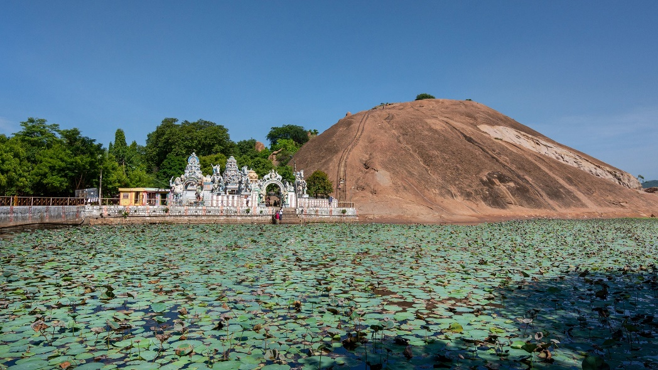
Temple Tank at Samanar Hills
Photo Courtesy: https://www.tamilnadutourism.tn.gov.in/photos
The Pallavas: Early Innovators of Water Management
The Pallavas (4th–9th century CE), who ruled from Kanchipuram, were among the first South Indian rulers to integrate rainwater harvesting into temple architecture. At Mamallapuram, they carved rock-cut temple tanks, ensuring that even the coastal town had a steady water supply despite its proximity to the sea. The famous Shore Temple has vestiges of underground water channels that direct rainwater into a reservoir—an early example of rainwater harvesting.
The Pallavas also constructed irrigation lakes—one of the largest being the Chitramegha Tataka near Kanchipuram, ensuring year-round water availability. We will discuss the contribution of the Pallavas to irrigation structures later on
The Cholas: Masters of Hydraulic Engineering
"The waters of the sacred Ganga now embrace our land, so that the fields may bloom, the people may prosper, and the temple may thrive."
Chola Inscription, Gangaikonda Cholapuram
If the Pallavas introduced rainwater harvesting, the Cholas (9th–13th century CE) perfected it. They built massive temple tanks and irrigation lakes, making their empire one of the most agriculturally prosperous in the world. One of the greatest achievements of Rajaraja Chola I (985–1014 CE) was the construction of the Brihadisvara Temple tank in Thanjavur, designed to store rainwater for both religious and agricultural use. But it was Rajendra Chola I (1012–1044 CE) who undertook the most ambitious water conservation project—the construction of the Chola Gangam, an enormous artificial lake in which water from the Ganges, was poured after the ruler’s successful campaign to North India.
Chola Rainwater Harvesting Techniques
- Temple tanks connected to underground channels allowed excess water to flow into nearby fields.
- Stepwell structures ensured easy access to water while minimizing evaporation.
- Reservoir-based irrigation—large lakes such as the Veeranam Lake were built to sustain crops during dry seasons.
The Anaiyur Tank and Grand Anicut (Kallanai Dam), originally built by the Cholas, continue to irrigate thousands of acres of farmland even today!

Grand Anicut (Kallanai Dam)
The Pandyas: The Water Guardians of Madurai
"As the lotus blooms upon pure waters, so shall the city of Madurai thrive when the temple nourishes both soul and land."
-Pandya Inscription, Meenakshi Temple, Madurai
The Pandyas (6th–16th century CE), ruling from Madurai, built some of the most intricate rainwater harvesting systems in temple towns. The Golden Lotus Tank (Porthamarai Kulam) at the Meenakshi Temple is one of their finest achievements. The Pandyas built temple tanks in a series of descending levels, allowing rainwater to flow naturally from one level to the next, preventing overflow and wastage. These tanks also helped maintain humidity, reducing heat inside the temple complex.
They expanded irrigation networks by linking temple tanks to large-scale reservoirs, ensuring a continuous water supply even during droughts. The Vaigai River and Periyakulam Lake were major projects initiated by Pandya kings to sustain Madurai and surrounding regions.
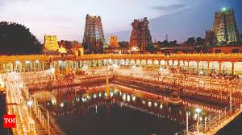
The Golden Lotus Tank (Porthamarai Kulam) at the Meenakshi Temple
Photo Courtesy: Times of India
The Cheras: Rainwater Harvesting in Kerala’s Temples
"The waters of the temple are the waters of the land; let them be preserved, for they are the gift of the gods to the people."
-Chera Inscription, Padmanabhaswamy Temple
The Chera dynasty (3rd century BCE – 12th century CE) ruled the lush, rain-rich lands of Kerala, where water management required flood control and conservation rather than scarcity management. The Padmatheertham Tank at Padmanabhaswamy Temple (Thiruvananthapuram), built by the Cheras, is one of the oldest rainwater harvesting structures in India. It was designed to:
- Collect excess monsoon rainwater and prevent flooding.
- Store water for temple rituals throughout the dry season.
- Recharge groundwater for drinking and irrigation.
The Cheras also constructed networked canals connecting temple tanks to rivers, ensuring a steady flow of water for both religious and secular use.
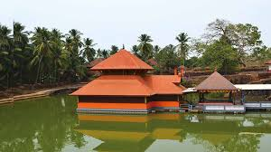
Ananthapuram Temple
Photo Courtesy: Kerala State Archaeology Department
Temple Tanks: Ancient Lessons for Modern Water Conservation
The Pallavas, Cholas, Pandyas, and Cheras left behind a legacy of water wisdom that remains relevant even today. Their rainwater harvesting techniques, groundwater recharge systems, and flood management methods were not just engineering marvels but sustainable solutions for thriving civilizations.
Unfortunately, many temple tanks have fallen into neglect due to urbanization and encroachment. However, there is a growing movement to restore and revive these ancient water systems. In Tamil Nadu, the Kudimaramathu Scheme has helped restore several temple tanks, proving that these historical structures can still serve modern needs.
Glossary
- Anicut: A dam constructed across a stream to maintain and regulate irrigation
- Kulam: Tamil term for a pond or tank, commonly referring to temple tanks used for religious and water conservation purposes
- Teppakulam: A temple tank used for float festivals, where deities are paraded on decorated rafts
Activity Corner
1. Explore Local Temple Tanks:
- Objective: Discover and document the current state of temple tanks in your vicinity
- Instructions:
  - Identify nearby temples with existing tanks.
  - Visit these sites and observe their condition.
  - Note aspects like water quality, cleanliness, and usage.
  - Engage with local communities to understand historical significance and current challenges.
- Outcome: Create a report or presentation highlighting the importance of these tanks and suggest conservation measures
2. Rainwater Harvesting Model:
- Objective:Design a simple model demonstrating the principles of rainwater harvesting inspired by ancient temple tanks
- Instructions:
  - Study the structure and function of traditional temple tanks.
  - Using materials like clay, plastic containers, and pipes, construct a miniature model showing how rainwater can be collected, stored, and used.
  - Explain the filtration process and how groundwater recharge occurs.
- Outcome: Present the model in community centres or schools to spread awareness about sustainable water management practices

Chapter 10

Temple Trees and Groves: The Ancient Sanctuaries of Nature
"The eternal witness to the goddess’s descent, standing firm as the river flows and the temple thrives."
-Pandya Inscription, Meenakshi Temple
In one corner of the temple courtyard, standing firm and timeless, is the sthala viruksham — the sacred temple tree. Its bark is rough, ancient. Its branches stretch upward like arms in prayer. Around its trunk, hundreds of tiny threads are tied — red, yellow, white — each carrying a whispered wish. And on its branches, low and swaying gently in the breeze, hang dozens of tiny wooden cradles — placed by couples praying for a child. Some are old and faded, some new and brightly painted. But each one holds a story. A hope, a longing.
Devotees walk around the tree, barefoot, heads slightly bowed, palms pressed together. Some chant softly. Some carry little pots of ghee or milk. Others simply tie another thread — a silent promise, a plea wrapped in trust. It’s not loud here. No grand rituals. No drums or conches. Just the soft rustle of leaves. The creak of cradles. The scent of incense. And the deep, unshakable feeling that something divine lives in this tree — something that listens.
Long before the first stones of temples were laid, before towering gopurams and intricate vimanas graced the land, the sacred spaces of worship were not built in stone—they thrived in the heart of ancient forests. These were the temple groves, vast and untouched, where sages meditated, where tribal communities revered nature, and where deities were believed to reside in the shade of colossal trees. The groves were not just places of worship but also natural sanctuaries, where faith, ecology, and conservation existed in perfect harmony.
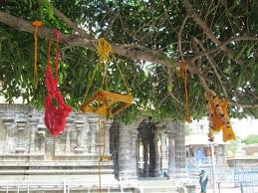
Sthala Viruksham, Annamalaiyar Temple
Photo Courtesy: Tamilnadu Tourism
Temples, as we know them today, came much later. When kings and artisans began carving shrines in stone, they built them within or around these groves, preserving the sacred trees and forests that had long been worshipped. Over time, these temple groves were formalized into Devara Kadus (sacred forests), Kavus (snake groves), and Nandavanams (temple gardens), forming the green heart of every temple town.
Walking through one of these temple groves today, one can still sense the ancient wisdom that shaped them. The air is cooler, filled with the scent of sandalwood and flowering creepers. The ground is soft, covered in fallen leaves that enrich the soil, feeding the trees that have stood for centuries. Most significant among the trees is the Sthala 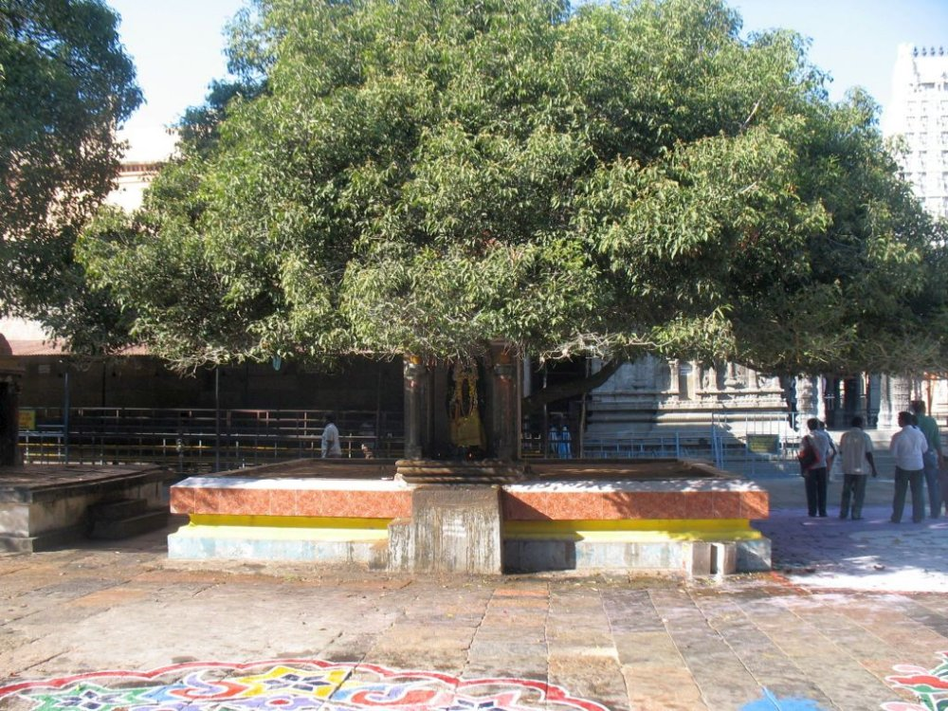
Sthala Viruksham, Annamalaiyar Temple
Photo Courtesy: Tamilnadu Tourism
Viruksham, the sacred tree of the temple, its roots older than the temple itself, its branches reaching toward the divine.
The Sthala Viruksham: The Original Deity of the Land
"By the will of the Chola kings, let no axe touch the sacred tree, for it stands as the guardian of the Lord’s presence."
  - Chola Inscription (10th century CE)
Before deities were enshrined in temples, they were believed to inhabit trees, rivers, and mountains. Among these, the Sthala Viruksham, or the sacred tree of the site, held a place of special reverence. These trees, chosen for their spiritual significance, medicinal properties, and ecological importance, became symbols of divine presence.
At the Madurai Meenakshi Temple, the Kadamba tree is the Sthala Viruksham. According to legend, Goddess Meenakshi was born beneath its shade. At Thiruvanaikaval’s Jambukeswarar Temple, the Naaval tree is revered, marking the spot where Goddess Parvati worshipped Lord Shiva.
Each temple had its own Sthala Viruksham, which was often preserved for centuries, even after the temple was expanded or rebuilt. Leaves, flowers, or fruits from these trees were used in rituals, Ayurvedic medicine, and temple prasadam, ensuring their continued importance in daily life.
Temple Groves: The World’s First Conservation Zones
"Let the temple groves remain untouched, for their roots call the rains, their shade cools the earth, and their waters nourish the land."
-Chola Inscription
Temple groves were more than just religious sanctuaries—they were ancient conservation projects designed to protect water, soil, air, and biodiversity.
1. Protecting Water and Climate: These forests acted as natural rain catchers, absorbing monsoon showers and replenishing temple tanks and underground wells. The roots of sacred trees, like Peepal and Neem, retained groundwater, ensuring a steady supply even in droughts.
2. Preserving Biodiversity: Temple groves sheltered rare medicinal plants, nesting birds, and small wildlife. Many temples maintained Nandavanams, flower gardens that provided fresh blooms for daily pujas, ensuring a self-sustaining ecosystem.
A Vijayanagara inscription (15th century CE) at the Virupaksa Temple in Hampi declares:
"Within these temple forests, let the deer roam free, let the birds find their nests, and let no man disturb the peace of the sacred trees."
3. Regulating the Seasons and Agriculture: In South India, temple groves were often linked to agricultural cycles. Farmers prayed to the Sthala Viruksham for good harvests, and trees like Tamarind, Mango, and Amla were planted near temples, ensuring year-round availability of fruits and shade for travellers.
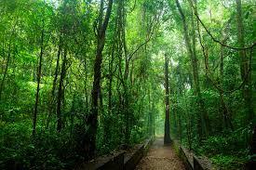
Iringole Kavu, Ernakulam
Photo Courtesy: Kerala Tourism

At the Srirangam Ranganathaswamy Temple, an inscription from the Chola era (12th century CE) instructs:
"Let the temple’s sacred lands be used to grow food, for as the trees nourish the earth, so shall the temple nourish its people."
The Decline and Revival of Temple Groves
Many ancient temple groves have been lost to urbanization, deforestation, and neglect, but efforts are now being made to restore and protect them.
- The Meenakshi Temple Trust has begun a project to replant the Kadamba trees of Madurai, ensuring their survival for future generations.
- In Kerala, conservationists are working to revive the last remaining Kavu groves, recognizing them as one of the oldest unbroken ecosystems in the world.
- The Kudimaramathu Scheme in Tamil Nadu is restoring temple tanks and groves as part of a larger water conservation movement.
A Maratha-era inscription (18th century CE) at the Brihadisvara Temple in Thanjavur urges temple-goers to protect their environment:
"To worship the Lord is to worship the earth. Let the trees remain standing, let the waters remain pure, and let none bring harm to the sacred groves."
Temple Groves: The Lost Wisdom of Ancient India
As we stepped away from the temple grove, a sense of awe settled over us. These weren’t just trees. They were living relics of a forgotten world, where humans and nature coexisted in harmony.
They were the first temples, the original places of worship before stone sanctuaries rose in their place. They were the first conservation zones, protecting water, wildlife, and climate for centuries. They were the first sources of medicine and agriculture, sustaining entire civilizations through wisdom passed down in inscriptions, rituals, and daily life.
As the ancient inscriptions tell us, to protect the temple tree and groves is to protect life itself. And perhaps, in reviving these sacred forests, we are not just restoring trees—we are reviving an ancient way of thinking, one where nature is not just a resource to be used, but a divine presence to be revered and protected. Not surprising that the pious seek the gift of life from these sacred trees by symbolically hanging cradles on its branches!
Glossary
Term | Meaning
Sthala Viruksham | The sacred tree of a temple, believed to predate the temple structure itself and often associated with myths and divine presence.
Devara Kadu | Literally "Forest of the Gods" — sacred groves found especially in Karnataka and parts of Tamil Nadu. These are protected forest patches where no trees can be cut.
Kavu | Sacred groves found in Kerala, often associated with serpent worship and ecological balance.
Nandavanam | Temple garden where flowers are grown exclusively for rituals and offerings.
Kadamba Tree | A flowering tree sacred in many South Indian temples, notably associated with Goddess Meenakshi.
Naaval Tree | Indian blackberry tree (Syzygium cumini), revered in several temples; known for its medicinal and sacred properties.
Cradle Offering | Ritual of tying a wooden cradle on the sacred tree to seek blessings for childbirth — symbolizing faith in the tree’s life-giving power.
Temple Grove | A cluster of trees surrounding or associated with a temple, preserved as sacred land and often rich in biodiversity.
Kudimaramathu Scheme | A Tamil Nadu government initiative that encourages local participation in the restoration of tanks, canals, and groves linked to temples.
Ayurvedic Plants | Medicinal herbs and trees grown in temple groves, used in traditional healing and rituals.
Activity Corner
Here are a few activities to help readers and learners engage with the themes of this chapter meaningfully 🌿
Activity 1: Find Your Local Sthala Viruksham
Objective: Explore and document sacred trees in temples near you.
Instructions:
- Visit a nearby temple and identify the Sthala Viruksham (sacred tree).
- Ask temple priests or elders about any stories, rituals, or beliefs associated with the tree.
- Document its type, age (approximate), and ecological importance.
- Photograph or sketch the tree.
- Share a short write-up or presentation with your school/community.
Outcome: Increased awareness of bio-cultural heritage and the importance of preserving sacred trees.
Activity 2: Build a Mini Nanda Vanam
Objective: Recreate a miniature temple garden to understand how temples supported ecosystems.
Instructions:
- Use pots or a patch of soil to grow native flowering plants like jasmine, hibiscus, tulsi, marigold, or kadamba.
- Label each plant with its name and temple significance.
- Water and care for your garden for a full month.
- Invite friends or classmates to visit and learn about temple garden traditions.
Outcome: Learn hands-on about temple ecology and sustainable gardening.
Activity 3: Map the Groves (Heritage + Biodiversity Project)
Objective: Create a heritage map of sacred groves in your region.
Instructions:
- Research local temple groves, Devara Kadus, or Kavus through field visits or online resources.
- Note the species of trees, wildlife, or rituals associated.
- Create a visual map (digital or hand-drawn) marking their locations and ecological importance.
- Present findings in your school or share with local conservation groups.
Outcome: Encourages heritage documentation and environmental awareness at the community level.
Reflective Writing Prompt
"The sacred grove was the first temple."
Write a short personal reflection or story imagining life in a time when people worshipped under trees rather than in buildings. How would that change your connection to nature and spirituality?

Chapter 11

When God Took Form: A Story About Idols and the Divine
You step past the last stone threshold, and suddenly — the world goes quiet. The coolness of the inner chamber wraps around you like a whisper. The garbha griha is small, silent, alive. The only light comes from a single flickering deepam, its flame casting shadows that dance on ancient granite walls. And then you see the deity. Not loud, not dazzling, just... still. Majestic, mysterious bathed in oil and sandal paste, adorned with fresh flowers and simple jewels.
The first time I stood in front of a temple idol, I didn’t know what I was supposed to feel. People around me folded their hands. Some whispered prayers. A few closed their eyes. And there I was — staring at this stone figure, dressed in silk, covered in flowers, glowing in the dim light of an oil lamp. It was beautiful. But also confusing. Was this... God? Or just a sculpture? I mean, how could something carved by human hands hold something so infinite?
My grandfather, anticipating the confusion, smiled and said, “You’re not wrong to ask that. Even great philosophers have asked the same.” He told me a story — not from the news, but from a place deeper than that. “Imagine trying to stare directly at the sun,” he said. “Too bright. Too intense. You can’t see it with your eyes. But hold up a mirror — and suddenly, you can see the light. That’s what a murti is. A way to see the unseeable. A mirror for the divine.”
Form for the Formless
In Indian thought, the idea isn’t that God lives only in a statue. The idea is that God is everywhere — in stars, in rivers, in you, in me. But that’s a lot to wrap one’s head around. So, we begin where we can see. Where we can touch. Where we can feel something. That’s why idols exist. They are starting points. They give form to the formless. They bring the infinite within reach. When you look into the eyes of a murti — whether it’s Ganesha, Shiva, Krishna, or Devi — you’re not looking at stone. You’re looking at a reminder: “Hey, the divine is close. Closer than you think.”
Every murti has a story - Durga rides a lion and destroys darkness; Krishna plays the flute and invites the heart to dance; Shiva sits in stillness, holding chaos and calm in perfect balance; And these stories aren’t just bedtime tales — they’re reflections of us. Some days, we need strength. Some days, peace. Some days, joy. The murti we stand before becomes a mirror of what we seek.
Idols as Companions
Over time, the murti becomes more than a symbol. It becomes a companion. You tell it your secrets. You cry in front of it without shame. You light a lamp when you’re lost. You offer flowers when you're grateful. You may not always know if someone’s listening — but you talk anyway. And slowly, something changes. Not in the idol. In you. Because this isn't about the stone coming alive. It's about you waking up.
Idols are not always necessary. Some people meditate on light. Some see God in nature. Some in silence. But for many — for millions — idols are how the journey begins. Not everyone can imagine the entire ocean. Sometimes, we start with just a drop. In Indian tradition, an idol is never just a statue. It is an ideal in physical form — a vision of who you could become. Every murti (idol) carries a mood, a story, and a dharma — a cosmic message. For instance:
- Ganesha: Big ears to listen more. A broken tusk to show that even the imperfect can be wise. A tiny mouse by his side — humility beside power.
- Durga: Ten arms holding weapons and lotus flowers. Calm face, fierce energy. She reminds you that you can be gentle and strong, all at once.
- Shiva: Ash-smeared yogi, still as a mountain. Destroyer of ego, lord of transformation. He asks, “Can you sit still in the middle of chaos?”
- Krishna: Flute in hand, smile on lips, mischievous and divine. He teaches joy, love, and the art of being playfully wise.
These forms aren’t just decorative. They’re designed to teach. Their posture, their expressions, their stories - all reflect a state of being you can strive toward. We often think idols are about who we worship. But they also shape how we live. They become moral compasses and models of courage, patience, creativity, silence, compassion. You look at Hanuman and remember loyalty and strength; You look at Saraswati and are reminded to value learning over loudness; You look at Lakshmi, and realize wealth isn't just money — it's beauty, balance, and generosity.
In yogic and Tantric traditions, there’s a beautiful practice: you don't just worship the deity — you become it. Through mantra, meditation, and visualization, you internalize the form:
- You imagine Ganesha’s calm intelligence inside your mind.
- You feel Durga’s power rise in your spine.
- You breathe with Shiva’s stillness.
This is not imagination. It’s embodiment.
Idols and Politics: When Power Wears a Divine Face
We are told that idols are sacred. That they live in temples, are worshipped with flowers and incense, and help us connect with something greater than ourselves. But idols don’t always stay in temples. Sometimes, they are carried through the streets; sometimes, they are raised on public platforms; sometimes, they are built taller than the tallest building; and sometimes… they’re broken. Not in moments of prayer — But in moments of politics.
Why Do Idols Matter in Politics?
Because idols represent more than belief. They represent identity. To many, an idol is not just a deity. It is:
- “Our god.”
- “Our community.”
- “Our story.”
And once something becomes “ours,” it becomes territory. And where there is territory — there is power. That’s where politics enters.
History Is Full of Political Idols
In ancient India, kings didn’t just rule from palaces — they ruled from temples.
- They built towering idols of Vishnu, Shiva, or Devi to show their spiritual legitimacy.
- In Chola temples, massive bronze idols became symbols of royal patronage — and divine right.
- In North India, temples and idols were built or rebuilt to mark victory, identity, and resistance.
When invaders came — whether from rival kingdoms or empires — idols were often the first to be targeted: Not just to destroy a religion, but to send a message: “Your god can’t protect you.” Later, when colonial powers took over, many idols were stolen — taken to museums, stripped of context, and displayed as exotic art. This, too, was a kind of politics — turning sacred symbols into trophies.
Idols in the Streets: Modern Politics
Today, idols continue to play political roles — often in highly visible ways:
- Massive public idol installations during festivals become expressions of regional pride, religious identity, and even vote banks.
- Debates over idol placement, temple construction, or idol immersion are not just cultural — they are deeply political.
- The destruction or preservation of an idol often sparks national outrage, protests, or even violence — because people aren’t just protecting a statue; they’re defending what it stands for.
In this way, idols can be weaponized — not in themselves, but through the emotions they carry.
The Double-Edged Power of Idols
The paradox is that idols are meant to connect people to the divine — to elevate the mind, inspire the heart, and dissolve the ego. However, in the wrong hands, they can be used to divide, to stir anger, and to fuel political agendas. We are in a world where:
- Faith and identity are deeply intertwined.
- Religion and politics often walk hand in hand — for better or worse.
- The same idol that inspires peace in one place might spark conflict in another.
Understanding the power of symbols — and how they are used — gives you the ability to see clearly, ask deeper questions, and stand for unity even when things get loud. It teaches you to respect devotion — but also to recognize manipulation. Ultimately, an idol is a symbol. It can reflect the best in us — or the worst. It can be used to build temples, or build walls. It can be placed on a pedestal, or held gently in your palm. In the end, the idol doesn’t choose how it’s used. We do. And when we choose to see it not as a weapon, but as a window, not as a flag, but as a form of love — then maybe, the idol will do what it was always meant to do: Not divide us, but bring us closer to something higher — and to each other.
The Science of Idol-Making: When Art Became Sacred Technology
We often think of science and spirituality as opposites. One deals with facts and formulas. The other, with faith and feelings. But in ancient India, the two were deeply intertwined — especially when it came to something you’ve probably seen all your life: Idols.
Those serene stone faces. The gleaming bronze arms of gods. The perfectly symmetrical features of Devi, the still silence of the Shiva lingam — they aren’t just “carvings.” They’re designed devices. Yes. Devices. Made using mathematics, metallurgy, geometry, astronomy, and energetic science — to become living vessels of the divine.
Before a single line is drawn or a hammer is lifted, the sculptor — or shilpi — must ask: What energy will this idol carry? Because in Indian tradition, the deity is not just a character. It is a frequency.
- Shiva = Stillness, destruction, deep transformation.
- Durga = Power, protection, maternal force.
- Vishnu = Preservation, balance, grace.
- Saraswati = Wisdom, purity, flow.
Each deity carries a vibration, a mood — and the idol must be crafted to hold and transmit that vibration. This isn’t just aesthetics. It’s energetic architecture.
The Math — Proportion is Power
Shilpa Shastra are ancient treatises that lay out exact mathematical rules for creating idols. Think of them as sacred engineering manuals.
These texts detail:
- How tall the idol should be
- How many eyes wide the nose must be
- How many fingers apart the ears should sit
- The angle of the head, the curve of the hips, the bend of the hands
Every murti is made using strict proportional systems like the Tala system, based on units of measurement derived from the human body.
The Alignment — Made for the Earth, Sun, and You
Ancient idol-making didn’t happen in isolation.
- Temples were aligned to celestial events — solstices, equinoxes, lunar phases.
- Idols were placed so that light would fall on them at certain times (e.g. the Chidambaram Nataraja or Konark Sun Temple).
- The face of the deity might point toward a river, a mountain, or a sacred direction (east for beginnings, north for wisdom, etc.)
Even the materials used were chosen based on astrological and geographical factors:
- Black stone from specific hills for Shiva lingams
- Panchaloha (five-metal alloy) for bronze murtis — a special blend of gold, silver, copper, iron, and lead, believed to balance energies
The idol was not placed randomly. It was wired into the Earth and the sky.
Prana Pratishtha — When the Idol Comes Alive
Once the idol is made, it’s not yet divine. Not until the ritual of Prāṇa Pratiṣṭhā — the “establishment of life force.” This is where science meets soul. Through mantras, mudras, yantras, and energy transmission by trained priests (or yogis), the idol is activated — like switching on a powerful, sacred circuit. From that point forward, it is not just stone or metal. It is a conscious presence. This is why idols are:
- Fed
- Bathed
- Woken up
- Put to bed
Because they are treated as living beings.
Resonance — The Murti as a Spiritual Amplifier
An idol is designed to absorb, store, and radiate energy.
- The material (like granite or Panchaloha) holds vibration.
- The shape channels that vibration.
- The mantras charge the space around it.
- The devotee’s emotion activates the loop.
It becomes a spiritual battery — charged with collective devotion and sacred intention.
What Does This Mean Today?
It means when you stand in front of an ancient idol, you're not looking at "just a statue."
You're standing before:
- A mathematical marvel
- A cosmic receiver
- A psychological tool
- And a spiritual presence — one that was built with more precision than most modern machines.
And it was done centuries — sometimes thousands of years — ago. With no AI, No 3D printer - Just human hands, sacred texts, and deep inner science.
The Lost-Wax Technique: Fire Brings the Divine to Life
In a dimly lit workshop, the air smells of beeswax, charcoal, and metal. A sculptor — barefoot, calm, and steady — shapes something in his hands. It’s not yet a god. Not yet sacred. But it’s becoming. This is the beginning of a process that has barely changed in over 2,000 years — the ancient and astonishing art of lost-wax casting. It’s called “lost wax” because, during the process, the wax disappears — lost to fire — but what remains is immortal.
The Wax Model — The First Form
It all starts with beeswax or a wax mixture, warmed and shaped by hand into a perfect replica of the idol-to-be. This isn’t just a rough draft. The wax model has every tiny detail. The artist knows this wax form will be destroyed, but it has to be perfect, because this is the only chance to get it right.
Clay Mould — The Protective Shell
Next, the wax model is carefully covered with layers of fine clay, forming a mould. This mould is dried in the sun, then baked in a furnace. And here’s where the magic and science happens: As the mould heats up, the wax melts and flows out, leaving behind a hollow space in the exact shape of the original sculpture. That’s why it’s called lost-wax — the wax is gone, but its memory remains in the clay. This hollow becomes the womb of the idol.
The Metal Pour — Liquid Soul
Now, a special alloy is prepared — usually Panchaloha:
- Gold
- Silver
- Copper
- Iron
- Lead (or zinc)
Each metal carries its own symbolic and energetic value, and together they create a material said to balance cosmic forces. Once the metal is melted to a glowing orange liquid, it is poured into the clay mould — filling the empty space left by the wax. This is a moment of transformation: Fire turns memory into matter and the molten metal takes the shape of the god.
Cooling & Revealing — The Idol Emerges
After the mould cools, it is broken open — carefully, reverently — to reveal the metal idol inside. But it’s not ready yet. It needs:
- Filing and polishing
- Stone inlay (for eyes or ornaments)
- Carving of finer details
- Ritual purification
This is where artisans pass it on to the priests — who perform prāṇa pratiṣṭhā, the invocation of life-force. Only then does the idol stop being a sculpture — and become a murti - a living form of the divine.
Why Is the Lost-Wax Method So Special?
- Each idol made this way is one of a kind. The mould is destroyed in the process.
- It captures unbelievable detail, even the texture of skin or the folds of cloth.
- The combination of art, chemistry, physics, geometry, and ritual makes it one of the most advanced traditional techniques in the world.
In fact, some of the greatest bronzes ever made — like the Chola-era Nataraja sculptures — were created using this exact method.
Variations of the lost-wax technique have been used by:
- Ancient Egyptians (for jewellery and statues)
- Greeks and Romans (for sculptures and weapons)
- West African cultures (notably the Benin bronzes)
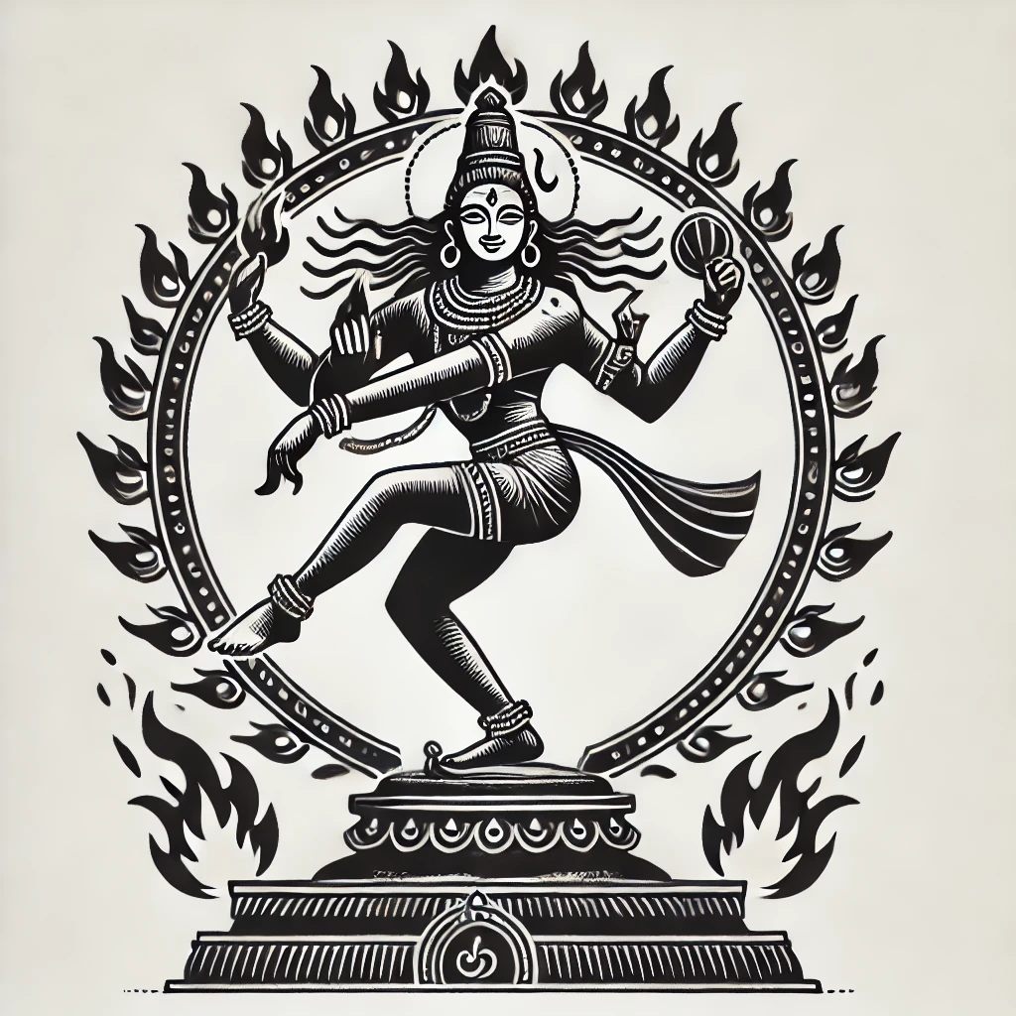
But in India, it became something else entirely: Not just technology, but theology. A sacred process that turned metal into meaning, craft into consciousness and art into avatar. In the end, the murti is not just stone or metal or wood. It is a mirror — showing us what we love, what we long for, and what we believe we can become. It is a doorway — leading us from distraction to devotion, from noise to stillness. It is a companion — silent, steady, always present. And when we fold our hands, light a lamp, and meet its gaze — we’re not just worshipping something sacred. We’re remembering that the sacred lives within us, too!
Glossary
Term | Meaning
Murti | A sacred idol or image that represents a deity in physical form. It is not merely a sculpture but a vessel for divine presence.
Garbha Griha | Literally “womb chamber”; the innermost sanctum of a temple where the deity is enshrined.
Prāṇa Pratiṣṭhā | The ritual of infusing life-energy (prāṇa) into a murti, transforming it into a living embodiment of the deity.
Panchaloha | A sacred five-metal alloy (gold, silver, copper, iron, and lead/zinc) used in making idols, believed to have spiritual and medicinal properties.
Shilpa Shastra | Ancient Indian texts that guide the art and science of sculpture, architecture, and idol-making through mathematical proportions and cosmic alignment.
Tala System | A measurement system used in Indian sculpture, where proportions of the human body are divided into specific units for artistic precision.
Lost-Wax Technique | An ancient method for casting metal idols by first creating a wax model, which is then melted away and replaced by molten metal.
Yantra | A geometric diagram used in ritual and meditation, believed to represent cosmic energies and aid in spiritual focus.
Mantra & Mudra | Sacred sounds (mantras) and symbolic hand gestures (mudras) used in rituals and meditation to channel spiritual power.
Idol Politics | The use of idols as tools of identity, power, or propaganda — where spiritual symbols take on social and political meaning.
Activity Corner
These activities are designed to deepen your personal connection with the ideas in this chapter — through art, reflection, and observation.
Activity 1: Design Your Own Murti
Objective: Understand the symbolic language of deity design.
Instructions:
- Pick a deity (or create your own symbolic figure).
- Research the attributes, symbols, and postures associated with that deity.
- Draw or sculpt a murti using clay, paper, or any craft material.
- Annotate your artwork with notes: What does each gesture, weapon, animal, or expression symbolize?
Outcome: Learn how Indian idols are carefully constructed to represent ideals, emotions, and values — not just appearances.
Activity 2: Build a Story Around a Murti
Objective: Explore the storytelling power of sacred images.
Instructions:
- Choose any murti you’ve seen in a temple or photo.
- Imagine what that deity might say if they could speak.
- Write a short dialogue or story from their perspective, addressing a devotee or describing the world they see from the sanctum.
- Share your writing in class or among friends.
Outcome: Practice empathy, creativity, and deeper understanding of devotional art.
Activity 3: Embody the Deity (Mindfulness Exercise)
Objective: Experience what it means to internalize divine qualities.
Instructions:
- Sit quietly and choose a deity — e.g., Ganesha for wisdom, Durga for strength, or Krishna for joy.
- Close your eyes and breathe deeply.
- Visualize the deity inside you.
  - Ganesha’s wisdom in your mind.
  - Durga’s power in your spine.
  - Shiva’s stillness in your breath.
- End the session with a short journal entry: How did it feel? What did you learn about yourself?
Outcome: Discover the yogic idea that divinity is not just external — but within.
Discussion Prompt
“Is an idol just a statue? Or does it become something more when we believe in it?”
Debate this in small groups. Explore how belief transforms objects, and whether science, symbolism, and spirituality can all coexist in sacred art.
Exploration: Temple Visit with a Purpose
Goal: Visit a local temple and observe:
- The murti’s features — what message does its face or posture convey?
- The materials — metal, stone, or wood?
- Any rituals around the idol — bathing, dressing, offerings?
Document your observations with sketches, photos (if allowed), and write a reflection: “What did this murti make me feel?”

Chapter 12

Dhwaja Sthambam and Bali Peetam: Guardians of the Sacred Threshold
Before you even step into a South Indian temple’s innermost sanctum, two powerful presences greet you. Not gods in stone or bronze or priests with lamps - two silent sentinels — standing in full view, yet often passed without a second glance: the Dhwaja Sthambam, or Kodi Maram — the temple flagstaff and the offering altar. While hurrying in, we missed them, but on the way out we prostrate reverentially before these two. To the untrained eye, they’re just part of the architecture, but to those who look closer, they’re thresholds.
Tall, gleaming, rooted in the earth, but pointing to the sky - the Dhwaja Sthambam is the temple’s flagstaff, usually made of wood, sheathed in shining brass or copper. It stands between the gopuram and the mandapam, right along the path toward the deity. During festivals, it’s wrapped in cloth and garlands. A flag flutters at the top, bearing the emblem of the deity — a trident, a discus, a vel, a lion. It's the temple's standard, declaring: “This is the house of the divine. This is the land of the sacred.”
Symbolically, the Dhwaja Sthambam is the spine of the temple — the energetic axis connecting earth and heaven. In some traditions, it is also seen as a symbol of ego, standing tall — reminding you to bow, to shed pride before entering the presence of the divine.
The Dhwaja Sthambam: More Than a Pillar
At first glance, the Dhwaja Sthambam looks like a tall, gleaming pole planted in front of the temple — usually just before the Bali Peetam and directly aligned with the sanctum sanctorum. But go a little deeper, and it becomes clear that this is not just a religious symbol. It’s also a marker of authority, legitimacy, and sovereignty.
In many historical contexts, the temple was the political heart of the region — not just a spiritual centre. Kings and ruling dynasties, built temples, maintained them, and stamped their legacy onto them. The Dhwaja Sthambam, standing tall and visible, often became a marker of the ruler’s patronage. Its installation was a royal act — sometimes celebrated with elaborate rituals, music, and community gatherings.
- The flag hoisted on the stambha during festivals often bore symbols associated with the ruling dynasty or the deity they were devoted to.
- By sponsoring the erection of a Dhwaja Sthambam, a king was publicly displaying his alignment with divine power — and, by extension, justifying his right to rule.
A tall Dhwaja Sthambam wasn't just about piety — it was a political statement: “I serve the gods. I protect dharma. I am worthy of your loyalty.” For a king, placing this vertical axis at the entrance of a temple he patronized was a visual reminder of his connection to cosmic order, or raja dharma.
- It marked the temple territory as a sacred and sovereign space.
- It reinforced the idea that the king was a servant of the deity, and thus a legitimate ruler of the land.
- It often stood within sight of the palace or royal quarters, creating a symbolic line between political and spiritual power.
During festivals, the flag raised on the Dhwaja Sthambam signalled the start of a procession — when the utsava murti (festival idol) would travel through the streets. In many ways, this was temple diplomacy at work:
- The god came out, blessed the town, and reminded everyone of who ruled both heaven and earth.
- The king's role in the festival — walking alongside the deity or offering the first lamp — symbolized his partnership with the divine.
- The flag signalled not just devotion, but a structured relationship between king, deity, and people.
In this way, the Dhwaja Sthambam became the starting point of a ritual theatre of power.
In later periods, especially under colonial rule or in multi-faith urban spaces, the presence or absence of a Dhwaja Sthambam could even become a politically sensitive issue. In some cases, the installation of a new flagstaff could:
- Spark conflict over temple rights
- Be viewed as an assertion of sectarian or community control
- Represent resistance or revival, especially in the wake of political suppression
Therefore, while it seems like just a piece of architecture, the Dhwaja Sthambam has always carried political weight — as a symbol of spiritual sovereignty, ritual legitimacy, and cultural dominance.
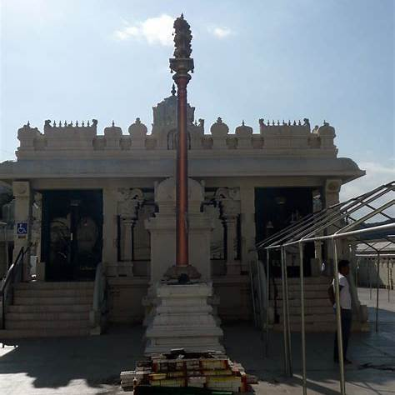
The Bali Peetam: The Silent Altar of Surrender
Just before the flagstaff, or sometimes right beside it, sits the Bali Peetam — a low stone platform, often unnoticed, but deeply important. This is where offerings are made — not to the main deity, but to all the unseen beings who protect the temple: The ganas, the yakshas, the guardians, the spirits of the land. Here, rice, flowers, ghee, and even blood offerings (in ancient times) were placed to honour those energies.
Spiritually, the Bali Peetam is where you symbolically leave your lower self behind — your anger, ego, jealousy, fear. You offer them up, consciously or not, before walking further in. You don’t carry your baggage into the sanctum. You leave it here, at the stone altar, beneath the open sky. Think of it like this: entering a temple is like entering the core of your own self.
- First, you pass through the towering gopuram — the outer world.
- Then, you stop at the Dhwaja Sthambam — where your identity pauses.
- Then, you reach the Bali Peetam — where your ego is offered.
- Only then, do you move forward — toward light, silence, the sanctum, the murti, and the mystery within.
Every part of the temple is intentional. Every structure is symbolic. So next time you enter a temple, pause between these two markers. Look up at the flagstaff. Look down at the altar. Realize that something is being asked of you — not in words, but in presence.
Glossary
Term | Meaning
Dhwaja Sthambam / Kodi Maram | The temple flagstaff, usually made of wood and plated with metal, erected in front of South Indian temples. It symbolizes the temple’s spiritual and political authority.
Bali Peetam | A low altar placed before the flagstaff, used for offering oblations to guardian spirits and symbolic surrender of the ego before entering the sanctum.
Gopuram | The towering gateway or monumental entrance of a South Indian temple, often richly decorated with sculptures.
Mandapam | A pillared hall in temples used for congregational gatherings, rituals, or processions.
Sanctum Sanctorum / Garbha Griha | The innermost chamber of the temple where the main deity (murti) resides; the most sacred space.
Utsava Murti | A movable metal idol of the main deity, used during festivals and processions.
Yakshas / Ganas | Guardian spirits and celestial beings in Hindu mythology who are believed to protect the temple premises.
Raja Dharma | The cosmic duty of kings — upholding justice, righteousness, and divine order in governance.
Ritual Theatre | A term used to describe temple festivals and processions where ritual, politics, and performance converge.
Spiritual Sovereignty | The idea that temples are autonomous spaces of divine authority, often intertwined with royal power in historical India.
Offering (Bali) | A ritual act of surrender or reverence, symbolized through the presentation of food, flowers, or symbolic substances at the Bali Peetam.
Activity Corner
1. Temple Entry Reflection
Next time you visit a temple:
- Pause before the Dhwaja Sthambam. Look at its height, material, and symbol at the top.
- Kneel or bow at the Bali Peetam. Take a moment to mentally "leave behind" your distractions or ego.
Question to reflect on:
What does it feel like to consciously mark your entry into a sacred space? Did it change the way you experienced the temple?
2. Creative Writing Prompt
Imagine the Dhwaja Sthambam as a character. Give it a voice.
Write a short monologue (150–200 words) starting with:
“I stand in silence as generations pass beneath me…”
Or try the Bali Peetam:
“I ask for nothing, yet receive your burdens…”
3. Sketch or Label the Sacred Path
Draw a simple layout of a South Indian temple (you can choose any you've visited or studied). Mark and label:
- Gopuram
- Dhwaja Sthambam
- Bali Peetam
- Garbha Griha (sanctum)
- Mandapam
Add annotations about what each symbolizes on the spiritual journey from entrance to inner sanctum.
4. Map It!
Research and mark three temples in South India known for:
- A tall or famous Dhwaja Sthambam
- Unique Bali Peetam rituals
- Historical records of royal patronage
Create a mini presentation (poster or slide) linking these elements to royal power and sacred architecture.
5. Group Discussion or Debate
“Is the Dhwaja Sthambam only a religious symbol, or is it also political?”
Divide into two groups. One argues for its spiritual symbolism, the other for its political significance. Use examples from history, architecture, or festivals.

Chapter 13

Pujas in the Temple: A Day in the Life of the Divine
If you’ve ever stood before a temple deity during deepa arati, as the camphor flame dances in the darkened sanctum, you’ve felt it — that moment when the divine seems alive. But have you ever wondered — how many times a day does this happen? Does the god rest? Eat? Wake up like we do? In a traditional South Indian temple, the deity — though made of stone or metal — is treated as a living presence. And like any living being, the deity has a daily routine. This is where the pujas come in.
Typically, there are six main pujas performed every day in most Agamic temples (those that follow temple ritual manuals like the Shaiva, Vaishnava, or Shakta Agamas).
- Ushathkala Puja – Before sunrise - Waking up the deity, offering water, lighting lamps.
- Kalasanthi Puja – Around 8 AM - Formal worship with abhisekam (ritual bathing), decoration, and food offering.
- Uchikala Puja – Midday - A second, more elaborate offering of food and flowers.
- Sayaraksha Puja – Around sunset - Evening worship, with lamps, incense, and gentle music.
- Irandamkala Puja – Late evening - A quiet, reflective offering with minimal noise.
- Arthajama Puja – Night, before temple closes - Final puja of the day — deity is “put to sleep” with lullabies and camphor.
Each puja is not just a ritual — it's part of a rhythm, a sacred daily routine that honours the deity as fully alive. Every puja represents a moment in the cosmic life cycle. It has been described as a a way of aligning the temple’s energy with the sun, the planet’s rhythm, and the human heart. It is meant to keep the prana (life force) of the murti active — through sound, light, fragrance, and touch. It is also a reminder that our daily life is sacred too — waking, eating, resting, sleeping — all can be acts of devotion. In some temples, especially during festivals or special occasions, there can be more than six pujas — each one timed to match the movement of the sun, moon, or celestial configurations.
The Experience for Devotees
If you have ever been at a temple during Kalasanthi or Sayaraksha, you will notice the following:
- Priests chant mantras from ancient scriptures
- Bells ring as camphor flames circle the deity
- Flowers are offered, and vibhuti or kumkum is placed on your forehead
- At the end, you receive prasadam — food blessed during the puja
Attending just one of these pujas is enough to feel a deep connection for some. For others, watching the full cycle through the day is like walking with the divine.
Archana: A Whispered Prayer with Your Name on It
You walk into the temple. It’s quiet, except for the soft echo of bells in the sanctum and the low chant of priests in the distance. The air smells of incense and fresh jasmine. You pause — not just to pray, but to be heard. So, you walk up to the priest, hands folded, and ask for an archana. He asks, “in whose name? You tell him your name, your birth star, your gotra. Suddenly, in the heart of this ancient temple, your story is folded into the ritual. The priest begins. He chants the 108 names of the deity — soft, rhythmic, ancient words — and with each name, he offers a flower or a grain of rice at the deity’s feet. At the end, he hands you prasadam — two-halves of a coconut, bananas, some vibhuti, maybe a tulsi leaf — small things, but filled with something more than just tradition. This isn’t a grand festival, there is no crowd, no spectacle, but in this quiet act, you feel seen.
Archana is a personal prayer offered at the temple. It’s your moment. Your name, your intention, your energy — woven into the worship. It’s different from the big temple pujas that happen multiple times a day — those are called the shat-kala pujas (the six-time pujas) explained earlier. They happen whether you’re there or not — like the heartbeat of the temple itself. Archana, however, is a personal prayer offered by an individual, sometimes to express gratitude, sometimes to ask for strength or send a prayer for someone you love. Maybe, just maybe, somewhere between the flower, the flame, and the name — the universe leans in and listens!
Abhiseka: A Personal Offering of Love, Not Just Ritual
It’s early morning. The temple is still half-asleep, but the sanctum glows faintly with the soft light of oil lamps. You’ve come quietly, with a small brass pot of milk and water in your hands, maybe a few tulasi leaves tucked into your palm. You're not here for a crowd, or a grand celebration. You’re here to offer something personal — a moment just between you and the divine. The priest takes your name, your star, your prayer. Then, gently, slowly, he begins the Abhiseka — the ritual bathing of the deity with water, oil, milk, curd, honey, sandal paste, vibhuti and other material. Each material is offered with devotion and accompanied by the chanting of mantras. This ritual is not just for cleansing — but for honouring the deity. It’s like you're bathing the divine with devotion, offering coolness, sweetness, nourishment, and purity.
Sometimes the deity is just a linga, or a small bronze image. Sometimes, it's a majestic murti in the sanctum. But either way, in that moment, you're not just a bystander. You are the host. The devotee. The one offering care. It’s a gesture of love, surrender, and connection.
Aspect | Kāla Pujas (Six Daily Pujas) | Abhiseka (Personal Offering)
Purpose | Daily rituals to maintain the energy of the deity | Devotee’s personal prayer or thanksgiving
Timing | Fixed times (sunrise, noon, evening, etc.) | Can be performed at various times, on request
Scale | Community-wide, part of temple’s daily schedule | Individual, name-based ritual
Focus | Alankaram, deepa arati, naivedya, etc. | Ritual bathing of the deity with water, milk, etc.
Intention | To uphold dharma and rhythm of temple life | To express devotion, make a vow, or mark a moment

Glossary
Term | Meaning
Puja | A ritual offering or worship performed to honour a deity.
Agamas | Ancient scriptures that serve as manuals for temple rituals, iconography, and construction.
Murti | The idol or form of the deity enshrined in the temple.
Prana (Prāṇa) | Life force or energy; pujas aim to keep this energy active in the murti.
Shat-kala Pujas | The six daily pujas performed at specific times, aligned with the sun’s movement.
Ushathkala | Early morning puja, performed before sunrise — the deity is “woken up.”
Kalasanthi | Morning puja with bathing (abhiseka), decoration, and food offering.
Uchikala | Midday puja, usually involving elaborate offerings and alankaram.
Sayaraksha | Evening puja with lamps, incense, and chants — marking the sunset.
Irandamkala | Late evening puja, more meditative and calm.
Arthajama | Night puja, when the deity is put to rest with lullabies and camphor.
Abhiseka (Abhishekam) | Ritual bathing of the deity with sacred substances like milk, honey, or water.
Archana | A personal prayer service where the devotee’s name is included in the chanting.
Prasadam | Blessed food or items distributed after a puja, considered sacred.
Vibhuti | Sacred ash, used especially in Shaiva temples.
Kumkum | Red powder used for applying tilak on the forehead, symbolizing blessings.
Tulasi (Tulsi) | Sacred basil leaf, often used in offerings to Vishnu or Krishna.
Deepa Arati | The ritual of waving lamps before the deity to invoke and celebrate divine presence.
Activity Corner
1. Create Your Own Temple Puja Schedule
Design a puja timetable for your own imaginary temple!
- Choose your deity
- Name your temple
- Design six daily pujas with names, times, and unique elements (special chants, music, food)
- Add a symbol or flag for your temple!
Present it as a decorative chart or mini poster.
2. Write a Personal Archana
Imagine walking into a quiet temple. What would you say in your personal prayer (archana)?
- Write a short prayer that includes:
  - Your name and intention
  - A few qualities of the deity
  - Something you’re thankful for or seeking
Read your prayer aloud with a soft background of bell or flute music (optional).
3. Roleplay: You Are the Priest!
In small groups:
- One student acts as the temple priest performing a mini puja (with a tray, water bowl, and flowers)
- Others act as devotees asking for an archana or offering abhisekam
- Narrate the steps of the ritual as you go: "Now I offer water... now I chant the name... now I give prasadam."
Optional: Record and present as a short “Day in the Life of a Deity” skit!
4. Puja vs. Abhiseka Comparison Chart
Fill in a Venn diagram or comparison table based on the following criteria:
- Who performs it?
- Who is it for?
- What materials are used?
- What time of day?
- Is it public or private?
Great for sharpening observational and analytical thinking!
Reflection Section: Daily Life as Devotion
“Waking. Eating. Resting. Sleeping. Each moment is sacred when offered with love.”
Take a moment to reflect on:
- What rituals do you follow daily — brushing teeth, lighting a lamp, praying before meals?
- How can you infuse mindfulness or devotion into them?
Journal Prompts:
- “My morning can become sacred when I…”
- “I feel closest to the divine when…”
- “If my heart were a temple, the ritual I’d perform most would be…”
Or simply reflect on:
What surprised you most about how deities are cared for in temples? Did anything feel deeply human or personal?
Final Thought:
In temple life, the divine is not distant. The murti sleeps, wakes, bathes, eats, and rests — just like you. The deeper message? You too are divine. Your life, your breath, your routine — all part of a sacred rhythm.
Worship is not just a ritual. It’s a relationship. And it begins with a whisper, a flower, a name… maybe yours.

Chapter 14

Priests: Many Traditions
Walk into a temple — and you are likely to see a priest dressed in clean white dhoti, a long tuft of hair tied neatly behind, chanting mantras as he waves a lamp before the deity. In a yajna, or a sacred Vedic fire ritual, you will see another kind of priest: seated before a homa kundam (fire altar). They’re both priests, but are not the same.
Temple Priests – Agama Tradition
These are the priests you see inside temples, especially in South India. They perform the daily pujas — the morning abhisheka, the afternoon alankaram, the evening deepa arati. They dress the deity, offer food (naivedyam), chant the 108 names, and maintain the ritual rhythm of the temple. Their rituals follow a set of ancient texts called the Agamas. We will discuss these Agamas later. Suffice to note here that Agama texts are detailed manuals — like instruction guides for temple worship. They tell the priest how to install the murti, how many times to perform puja, what offerings to make, how to conduct festivals, and more. Temple priests are caretakers of the deity — ensuring that the god or goddess is treated as a living presence. They may or may not have learned Vedic mantras in depth. Their training is more focused on ritual purity, temple procedures, Sanskrit prayers, and the rules laid down in the Agamas.
Vedic Ritual Priests – Yajna and Homam Experts
These are priests trained in the recitation of the Vedas. They specialize in yajnas, homas, upanayanams, shraddha ceremonies, marriages, and samskaras (rites of passage). They don't usually perform temple pujas. Instead, they:
- Recite mantras from the Rig, Yajur, Sama, and Atharva Vedas
- Memorize entire sections of scripture with perfect intonation
- Perform fire rituals with precise timing and symbolism
- Focus on cosmic order (ṛta) and invoking devas through fire
Vedic priests go through years of gurukula training, often starting as young boys. Accuracy in pronunciation is critical, because it is believed that mantra shakti (mantric power) depends on exact sound. These priests are the guardians of the Vedas, and through them, the ancient fire rituals continue to live.
Key Differences at a Glance
Aspect | Temple Priest (Agamic) | Vedic Ritual Priest
Main Role | Daily temple puja and deity worship | Fire rituals, Vedic ceremonies (yajnas, samskaras)
Textual Basis | Agamas, Tantras, Puranas | Vedas (Rig, Yajur, Sama, Atharva)
Training | Temple tradition, puja procedures, Agamic rules | Vedic recitation, memorization, fire ritual methods
Setting | Temple sanctum (garbha griha) | Fire altars, homes, public yajna spaces
Deity Focus | Worshipping a consecrated murti | Invoking gods into fire (agni)
Language Used | Sanskrit + local languages | Primarily Sanskrit (Vedic meter)
Mantras | Agamic slokas, stotras, nama-valis | Vedic suktas and chants

Temple Priests: One Role, Many Names
Not all temple priests are same. Their title often depends on the tradition they follow, the region they're from, and the lineage they belong to. Here are some of the common titles:
Sivacharya - Sivacharya is the name of priests of Shaiva temples, especially in Tamil Nadu. They are followers of Shaiva Agamas. Traditionally considered custodians of Shaiva temple worship since ancient times. They perform daily pujas, festivals, abhishekas, and Agamic rituals for Lord Shiva. In many major Shiva temples — like Chidambaram or Thiruvarur — the Sivacharyas are seen as ritual specialists of the highest order.
Bhattacharya - Bhattacharya is a name given to priests in Vaishnavite shrines. They are often trained in Sanskrit and Tamil texts, Puranas and Agamic worship. “Bhatta” = scholar or learned one; “Acharya” = teacher. They are sometimes referred to as Bhattar and follow the Pancharatra or Vaikhanasa Agamas. In temples like Srirangam, Kanchipuram, and Tirupati, you’ll find Bhattars serving as caretakers of the deity and rituals.

Vedic Priests
Vedic priests are those who specialize in yajnas, homams, samskaras, and Vedic recitation. Here, titles often reflect training level, specific roles, and textual expertise:
Adhyapaka - A teacher of Vedas. Often a senior scholar who trains young Brahmacharis in gurukulas.
Pandit - A learned scholar in Sanskrit, shastras, or ritual, not limited to priests — can be a scholar, astrologer, or purohit.
Purohita - A family priest who performs domestic rituals like weddings, upanayanams, grihapravesham, and shraddhas. Not always trained in full Vedic recitation, but well-versed in Grihya Sutras and samskaras
In a Yajna or any complex fire ritual, multiple priests take specific roles:
Title | Responsibility
Hotri | Recites Rig Veda hymns
Adhvaryu | Responsible for physical performance, from Yajur Veda
Udgatri | Sings Samaveda hymns, especially during Soma rituals
Brahma | Overseer and corrector — ensures no mistakes are made

These priests undergo long years of rigorous training, sometimes 10–15 years, to master pronunciation, rhythm, and ritual technique. Their titles don’t just indicate profession — they mark expertise in sacred sound and cosmic order.
Glossary
Term | Definition
Agama | Sacred scriptures that prescribe the methods of temple worship, construction, and rituals.
Temple Priest (Agamic) | Priests who perform temple-based worship (puja, abhisheka, alankaram) following the Agamas.
Vedic Ritual Priest | Priests trained in Vedic recitation and fire rituals like yajnas and samskaras.
Murti | The sacred image or idol of the deity enshrined in a temple.
Naivedyam | Food offered to the deity during puja.
Deepa Arati | Ritual waving of lit lamps in front of the deity.
Yajna | A Vedic fire ritual offered to the gods, involving chants and offerings into fire.
Homa | A smaller fire ritual, often domestic, part of samskaras (rites of passage).
Garbha Griha | The innermost sanctum of a temple where the main murti resides.
Sivacharya | Priests belonging to Shaiva temples, trained in Shaiva Agamas.
Bhattacharya / Bhattar | Priests in Vaishnavite temples, especially in Tamil Nadu.
Adhyapaka | A teacher of the Vedas; often trains young students (brahmacharis) in gurukulas.
Pandit | A learned person, often skilled in Sanskrit and religious scriptures.
Purohita | A family priest who performs domestic rituals such as weddings, upanayanams, and shraddhas.
Hotri | Priest who recites Rig Veda hymns during yajnas.
Adhvaryu | Priest who performs physical actions of the yajna, guided by Yajur Veda.
Udgatri | Priest who sings Samaveda hymns during Soma rituals.
Brahma (in yajna) | Chief supervisor of the ritual, who ensures everything is done correctly.
Mantra Shakti | The belief in the transformative and sacred power of correctly pronounced mantras.
Activity Corner
1. Priest Role-Play: Temple vs Vedic
Pair up and enact a ritual scene:
- One student plays a temple priest performing a daily puja.
- Another plays a Vedic priest preparing for a yajna.
Include actions like:
- Waving lamps or sprinkling water
- Chanting (you can create simple phrases like "Om Namah Shivaya" or "Swasthi Praja...")
Discuss afterward: What did each priest focus on? What tools or mantras did they use?
2. Priest Types Chart
Make a comparison chart between:
- Temple Priests (Agamic)
- Vedic Priests
- Purohitas
- Ritual specialists like Hotri, Adhvaryu, etc.
Include columns like:
- Texts followed
- Setting
- Language used
- Type of worship
- Community role
This helps clarify the differences in practice and training!
3. Design Your Ideal Temple Team
Imagine you're building a temple. Which types of priests would you include and why?
Write a short paragraph or create a temple “staff chart” showing:
- Who will do daily pujas?
- Who will teach scriptures?
- Who will perform special rituals?
Make it fun and creative — include titles, duties, and even a temple name!
4. Priest Traditions Research Project
Pick one tradition (Sivacharya, Bhattacharya, or a yajna priest) and create a poster or mini-presentation on:
- History
- Region
- Dress and customs
- Role in temple or family life
Optional: Interview a local priest (if possible) to get real-world insight!
Reflection Section: The Hands That Carry the Sacred
“The divine may reside in stone, but it is brought alive by human hands.”
Journal Prompts:
- What surprised you the most about the training and role of priests?
- Would you consider priesthood a form of service, power, or devotion — or all three?
- If you could ask one priest from history a question, what would it be?
Reflect on This:
Temple priests wake the deity, dress it, offer food, and lull it to sleep. Vedic priests chant verses from thousands of years ago with exact intonation. What does it take to carry such traditions forward? And who are the people — often quiet and behind the scenes — who do this day after day, for centuries?
Maybe next time you visit a temple, you’ll see them not just as priests, but as bridges — between us and the sacred, between past and presence.

Chapter 15

The Secret Manuals of the Gods: What Are Temple Agamas?
“Whether you light a lamp, whisper a mantra, or simply close your eyes in longing — you are walking a path laid down by the Agamas.”
It is evening time, the priests are performing rituals with perfect timing, moving as if they’ve rehearsed it for a thousand years. Many temples follow a standard process. What explains this? Well, behind all the lamps, chants, offerings, and architecture lies something like a divine rulebook — ancient handbooks that spell out exactly how temples should be built, how gods should be worshipped, and how rituals should unfold. These texts are called the Agamas — and they’re not just scriptures. They’re the operating system of Hindu temples.
What Exactly Are Agamas?
Agamas are ancient texts that deal with:
- Temple construction
- Rituals and puja methods
- Sculpture and iconography
- Philosophy and yoga
- Festivals and priestly duties
They are practical and spiritual guides that ensure temples don’t just look divine — they function like sacred energy machines. Different temples follow different Agamic traditions depending on which deity is central to the temple:
Shaiva Agamas
If the main deity is Shiva, the temple follows Shaiva Agamas. There are 28 major Shaiva Agamas. They are mostly in Sanskrit and focus on the worship of Shiva in lingam form; details about inner purity, yogic discipline, and temple energy flow.
28 Shaiva Agamas
No. | Agama | Summary / Focus Area
1 | Kāmika | Most widely used Agama in South Indian temples; details rituals, daily worship, and temple construction.
2 | Yogaja | Emphasizes yogic practices and meditative worship of Shiva.
3 | Chintya | Focuses on internal worship and contemplation (chintana).
4 | Kārana | Discusses cosmic principles and the creation of the universe.
5 | Ajita | Covers temple rituals and detailed methods of puja; used in many temple traditions.
6 | Deepta | Emphasizes light (deep) in worship and visualizations of divinity.
7 | Sūkshma | Deals with subtle (sūkshma) forms of Shiva and esoteric worship.
8 | Sahasra | Elaborates on the thousand aspects (sahasra) of Lord Shiva.
9 | Amsumat | Symbolic discussion of rays or effulgence (amsu) of Shiva.
10 | Supabheda | Details methods of spiritual awakening and breaking illusion.
11 | Vīra | Focuses on heroic devotion and strong mental discipline.
12 | Raurava | Describes fierce aspects of Shiva; also has ethical and ritualistic content.
13 | Mukhoṭṭara | Covers temple rituals and specific mantras for worship.
14 | Prodgīta | Emphasizes chanting and musical elements in rituals.
15 | Lalitā | Associated with grace and beauty in rituals and temple arts.
16 | Siddha | Offers paths to siddhi (spiritual perfection); combines yoga and ritual.
17 | Santāna | Focuses on continuity of life, lineage, and cosmic order.
18 | Nārasiṁha | Explores Shiva's protective forms.
19 | Sindhu | Relates to oceanic imagery, fluidity in worship, and meditative states.
20 | Suprabheda | Describes breaking through darkness and ignorance through devotion.
21 | Vajra | Symbolic of thunderbolt energy — discipline, clarity, and transformative power.
22 | Nisvāsa | Describes breath (prāṇa) and cosmic sound (nāda).
23 | Nityamukha | Deals with eternal (nitya) forms of Shiva and timeless rituals.
24 | Svāyambhuva | Focuses on the self-born aspect of Shiva and self-generated knowledge.
25 | Nidāna | Discusses cause and effect in spiritual evolution and karmic cycles.
26 | Vimala | "Pure" — promotes spiritual purification through disciplined rituals.
27 | Uttara | Serves as an 'upper' or concluding text, summarizing advanced practices.
28 | Kirana | Emphasizes Shiva’s rays or illuminative aspects; deals with spiritual light and inner realization.

Not all 28 Agamas are fully preserved. Some survive only in part or in commentary form. Temples typically follow one or two Agamas, depending on lineage or tradition — Kāmika, Ajita, and Karana are among the most widely practiced. These Agamas also inspire Shaiva Siddhanta — a powerful philosophical school especially alive in Tamil Nadu.
Vaishnava Agamas
If the temple is dedicated to Vishnu, it follows Vaishnava Agamas, mainly, Pancharatra (most widely followed) or Vaikhanasa (older). Vaishnava Agamas are the manuals for worshipping Vishnu — the divine preserver of the universe.
They cover everything from:
- Temple construction and layout
- Image (murti) making
- Daily worship and grand festivals
- Chanting, meditation, and bhakti (devotion)
- Philosophical ideas about God and the soul
“Every time a bell rings at a Vishnu temple, or a devotee offers tulsi leaves with a mantra — it’s likely being done just the way the Agamas taught over a thousand years ago.” There are two schools of Vaishnava Agamas:
Tradition | Based on | Used by
Pancharatra Agamas | Scriptures revealed by Narayana | Most Vaishnava temples
Vaikhanasa Agamas | Originated from Sage Vikhanasa | Some ancient temples

Pancharatra Agamas
The word Pancharatra means "five nights" — referring to the five-fold knowledge given by Vishnu over five nights to the sages. It focuses on Vishnu as the Supreme Being (Parabrahman). It includes detailed rituals for, daily worship (nitya puja), festival celebrations and temple administration. This is used by Sri Vaishnavas (followers of Ramanuja) and is very popular in Tamil Nadu, Karnataka, and Andhra Pradesh. It introduces the worship of four divine forms (Vyuhas) of Vishnu:
- Vāsudeva
- Sankarshana
- Pradyumna
- Aniruddha
Vaikhanasa Agamas are older and more Vedic in tone. This tradition was founded by the sage Vikhanasa. It is more conservative, with simpler rituals and is based heavily on Vedic tradition and fire rituals. It emphasizes Narayana as the supreme deity and focuses on inner purity, daily discipline, and personal devotion. Priests in this tradition are known as Vaikhanasas, a hereditary priestly community.
Vaishnava Agamas
Category | Pancharatra Agamas | Vaikhanasa Agamas
Origin | Revealed by Vishnu to sages over 5 nights | Sage Vikhanasa (mind-born of Brahma)
Philosophy | Vishnu is Supreme, in five manifestations | Narayana is Supreme, worship via Vedas
Texts | Over 200 agamas, including Ahirbudhnya, Padma Tantra, Lakshmi Tantra | Vaikhanasa Kalpasutra, Archanakalpa
Ritual Style | Elaborate, festival-rich, image-centric | Simpler, Vedic-based, daily-focused
Temple Usage | Srirangam, Kanchipuram, Melkote | Tirupati, ancient Andhra temples
Priesthood | Sri Vaishnava (trained) | Hereditary Vaikhanasa families
Murti Worship | Focus on Vyuhas and multiple deities | Main deity only; no subsidiary shrines

The Vaishnava Agamas are living traditions — not just ancient texts, but living rhythms that shape how Vishnu is worshipped every single day, from grand temples to small homes. Whether it's the rich festivals of Pancharatra or the simple, focused devotion of Vaikhanasa, both remind us of one truth: In every ritual, the divine is present. In every offering, love becomes sacred.
Shakta Agamas (Tantras): The Sacred Path of the Goddess
There’s a different kind of energy when you enter a temple dedicated to Devi — whether it’s Meenakshi, Durga, Kali, or Lalita. It’s fierce and tender at the same time. It doesn’t just ask for devotion — it asks for transformation. And behind the lamps and chants, there is a hidden current: the power of the Tantras.
These are not usual temple texts. They are bold, mystical, and sometimes even secretive — offering not just rituals, but inner alchemy. Unlike the Shaiva or Vaishnava Agamas, the texts guiding Devi worship are generally called Tantras — which literally means “loom” or “weave.” Why? Because they weave together:
- Mantras (sacred sounds)
- Yantras (sacred geometry)
- Mudras (hand gestures)
- Philosophy, ritual, yoga, and meditation
The Tantras are maps of both the cosmos and the self — showing how the two are deeply connected. They form the scriptural foundation of Shakta worship, especially in traditions like:
- Sri Vidya (Lalita Tripura Sundari)
- Kali Tantra (worship of the fierce feminine)
- Durga and Navaratri traditions
- Tantric Shaivism and Kashmir Shaivism (overlapping with Shakta)
Unlike texts that focus only on external rituals, the Shakta Agamas go deep into the inner world. Its core Themes:
- The Divine Feminine (Shakti) is the source of all creation — not secondary to Shiva, but equal or even supreme.
- Worship is both ritualistic and esoteric — aimed at awakening kundalini, purifying the mind, and achieving liberation through energy.
- The body is sacred, not to be rejected but transformed.
- Mantras, yantras, and meditation are tools to align with the goddess's inner presence.
Key Practices Include:
Element | Purpose
Mantra | Activates divine vibration (e.g., Aim Hreem Kleem)
Yantra | Geometric diagram that concentrates energy (e.g., Sri Chakra)
Mudra | Gesture to channel prana (life force)
Nyasa | Ritual placement of mantras on the body
Kundalini Yoga | Awakening dormant spiritual energy through the chakras

Why Are Some Shakta Agamas “Secret”?
Not all Tantras are chanted openly like Vedas.
- Some are transmitted orally from guru to disciple
- Many contain coded language, symbolism, and rituals that require initiation (diksha)
- Misuse or misunderstanding of certain texts can be harmful — hence the emphasis on guidance and discipline
Tantra is not about magic tricks or shortcuts. It’s about mastery — of the self, the senses, and spiritual energy.
Famous Shakta Agama Texts / Tantras
Text Name | Focus
Rudra Yamala Tantra | Shiva–Shakti unity, rituals, mantras
Kularnava Tantra | Foundation of Kaula path, guru-disciple relation
Devi Bhagavata Purana | Devotional and philosophical; elevates Shakti as Supreme
Tripura Rahasya | Philosophical; Sri Vidya tradition
Kalika Purana | Worship of Kali and Kamakhya; ritual and mythology
Lalita Sahasranama | 1,000 names of Goddess Lalita; recited in Sri Vidya

Worshipping the Goddess through the Shakta Agamas isn’t just about lighting lamps and singing hymns. It’s about:
- Waking up your power
- Facing your fears
- Balancing your mind and body
- Seeing the divine in the everyday
Agamas are the unseen instructions that turn bricks into breath, stones into stories, and rituals into real experiences of the sacred. They are not dusty old rulebooks. They’re living traditions — the DNA of temple worship, ritual, philosophy, and spiritual science — passed through generations, guiding how millions connect with the divine.
The Pre-Agamic World (Before 1500 BCE)
Long before temples, humans gathered around sacred trees, rivers, stones, and fire. In Indus Valley Civilization, clay figurines of mother goddesses suggest early goddess worship. In this age, Nature wasn't worshipped as separate from God — it was God. These early rituals were intuitive and community-based, not yet structured as in later Agamic traditions. The idea of energy in everything — a core Agamic belief — was already forming.
Vedic Foundations (1500–500 BCE)
As the Vedas were composed, the spotlight turned to cosmic sacrifice, fire rituals (yajnas), and hymns to deities like Agni, Varuna, and Indra. While temples didn’t exist yet, the seeds of Agamic thought — especially ideas of divine order (ṛta), mantras, and ritual exactness — began here. Shakti (feminine energy) was present, though subtle. Shrines to Vishnu and Rudra (early Shiva) appeared as the idea of personal deities gained traction. But the Vedas were mainly priest-centric and elitist — not meant for everyone.
The Agamic Revelation (500 BCE – 600 CE)
The Agamas arose — in multiple streams:
Tradition | Scriptures | Deity Focus
Shaiva Agamas | 28 main Agamas | Shiva as the Supreme
Vaishnava Agamas | Pancharatra & Vaikhanasa | Vishnu as Parabrahman
Shakta Agamas | Called Tantras | Devi/Shakti as the Supreme Energy

These weren’t "new religions." They were spiritual upgrades — practical, direct, and deeply personal. Unlike the Vedas, you didn’t need to be born into a priestly class to participate. You could experience the divine through temples, images (murti), meditation, mantra, and bhakti. The body wasn’t rejected — it was sacred. Life itself became worship.
Temples now followed precise Agamic rules for - building the shrine; placing the idol; chanting, bathing, and worshipping the deity; aligning the cosmos, community, and consciousness etc. Agamas were spiritual handbooks for real life.
Temple Culture Flourishes (600–1200 CE)
This period saw a temple boom all over India — and Agamas were the engine behind it. Shaiva temples in Thanjavur, Chidambaram, and Kanchipuram followed the Kāmika and Ajita Agamas. Vaishnava temples like Srirangam followed the Pancharatra system. Shakta temples like Kamakhya and Meenakshi integrated Tantric rituals. Temples became living schools of devotion, culture, art, architecture, and even science.
Agamic texts were not just religious — they covered:
- Iconography
- Sacred geometry
- Ritual psychology
- Community structure
- Dance, music, and festival design
Bhakti Movement (600–1700 CE): Devotion Over Doctrine
As Agamas formed the structure, the Bhakti movement brought in the soul. Bhakti Saints, Shaiva Nayanmars (Appar, Sundarar, Manikkavachakar); Vaishnava Alvars (Andal, Nammalvar); Shakta poets and mystics (Lal Ded, Ramprasad Sen) emphasized on aspects like:
- You don’t need elite training to love God.
- You don’t need complex rituals to feel divine presence.
- Your tears, songs, and longing are enough.
Bhakti’s Impact on the Agamas
- Popularized Agamic rituals by merging them with emotional devotion.
- Made temple worship accessible to the masses.
- Inspired festivals, processions, and open singing in temple prakaras.
- Temples became bhakti hotspots, not just ritual centres.
The Agamas gave the form, the Bhakti movement gave it fire.
From Suppression to Revival (1700–Present)
During colonial times, Agamic traditions were often dismissed as superstition. Many tantric texts were hidden or forgotten. Bhakti survived through songs and oral traditions. But the 20th and 21st centuries saw academic revival of Agamic studies. There was global interest in yoga, tantra, mantra, and temple architecture. There was simultaneously, resurgence of temple festivals, even in the diaspora
The Evolution of Agamas
Period | Key Developments
Pre-Vedic | Nature worship, Goddess and fertility cults
Vedic | Rituals for gods, early hymns to Rudra and Vishnu
Classical (500 BCE–600 CE) | Emergence of Agamas as temple handbooks
Temple Age (600–1200 CE) | Integration of Agamas into temple building, art, and ritual
Bhakti Movement (600–1700 CE) | Heart-centred devotion transforms Agamic practice
Modern Revival | Agamas studied, practiced, and adapted worldwide

Glossary
Term | Meaning
Puja | A ritual of worship involving offerings of flowers, food, incense, and prayers to a deity.
Agama | Ancient scriptures that lay down temple rituals, architecture, iconography, and philosophical systems, specific to Shaiva, Vaishnava, or Shakta traditions.
Murti | A sacred image or idol of a deity, believed to be imbued with divine presence after consecration.
Abhiseka | Ritual bathing of a deity with sacred substances such as milk, water, sandalwood paste, or honey.
Archana | A personal prayer where the priest chants the names of the deity, invoking blessings for an individual by name.
Naivedyam | Food offerings made to the deity during puja, later distributed as prasadam to devotees.
Deepa Arati | A ritual involving waving of camphor or oil lamps before the deity, symbolizing removal of darkness.
Prasadam | Blessed food or items given to devotees after being offered to the deity.
Shat-kala Puja | The six daily time-bound pujas performed in traditional temples.
Ushathkala, Kalasanthi, Uchikala, Sayaraksha, Irandamkala, Arthajama | The six daily worship times from dawn to nightfall.
Vibhuti / Kumkum | Sacred ash and red powder applied on the forehead as a mark of blessing and devotion.
Activity Corner
1. My Personal Puja Journal
- Attend or watch one full puja (online or in person).
- Note the steps: What did the priest do first? What was offered? What sounds, smells, and colours did you observe?
- Reflect on: How did it make you feel? What part stood out the most?
Prompt: “During the deepa arati, I felt...”
2. Design a Puja Clock
Create a visual puja schedule based on the six traditional daily pujas. For each time slot:
- Draw a symbolic image (sunrise, lamp, flower, moon, etc.)
- Describe what happens during that puja.
- Add a line of poetry or mantra for each.
Use vibrant colours to show the transition from dawn to night.
3. Archana Role-Play
- In groups of 2, act out a scene where one person is a devotee and the other is the temple priest.
- The devotee requests an Archana, stating their name, birth star, or wish.
- The “priest” chants a few deity names (you can use Om, Namah Shivaya or similar).
- After the “offering,” share how it felt to receive or perform a personal prayer.
This helps understand the intimacy and simplicity of a quiet ritual.
4. Make Your Own Naivedyam
- With guidance from a teacher or parent, prepare a simple offering dish like sweet pongal, fruits, or coconut rice.
- Light a lamp, offer it in silence or with a mantra.
- Share with others as prasadam.
Reflect: What does it mean to offer something with devotion?
5. Sacred Soundscape
Create an audio collage using:
- Temple bells
- Vedic chanting
- Conch blowing
- Camphor crackling
- Devotees singing
Present it in class to recreate the sound world of a temple puja.
Reflection Section: Puja as a Mirror
“We don’t just worship the divine. We align with it.”
Ask yourself:
- What is my daily rhythm like? Can I bring a little sacredness into waking, eating, resting?
- Have I ever paused and offered a moment of gratitude — even in silence — for something ordinary?
- What would a personal “puja” look like in my own life?
Try This:
- Light a lamp or candle at home each evening for a week.
- Sit for 2 minutes in silence.
- Close with a word of gratitude — for the day, your body, or something simple.
Even the smallest acts, when done with devotion, become a form of puja.

Chapter 16

Annadanam – Most Sacred of Offerings
"Let no pilgrim go hungry, let the granaries be full, and let the land know the king is just."
(Chola inscription, Thanjavur, 12th century CE)
The sun hangs low above the temple gopuram, its light softening into gold as the afternoon breeze carries the scent of sambar and ghee across the courtyard. Near the outer hall, rows of plantain leaves are being laid out with quiet precision. Volunteers move quickly, barefoot, hands moving in rhythm — placing water, salt, a spoon of pickle. The leaf rustles softly under each touch. A bell rings from the kitchen. The prasadam is ready. Steam rises from huge brass vessels as ladles dip in — drawing out piping hot rice. The cooks, work like clockwork. There’s no shouting. Just a sense of orderly urgency — because this is not just food. This is annadanam — the gift of food, the most sacred of offerings. Slowly, people begin to take their places: old men with walking sticks, women with babies on their hips, schoolchildren in uniform, wandering pilgrims with dust on their feet. No one is turned away. Everyone is fed. This is an everyday scene from temples across South India.
Throughout South Indian history, mass feeding in temples (Annadanam) and the distribution of Prasadam (sanctified food) have been more than just acts of devotion. They have served as powerful political tools. Kings, rulers, and temple administrators have used temple food distribution to reinforce their legitimacy, assert control over subjects, integrate diverse communities, and maintain economic stability.
By offering free food to the masses, rulers ensured their popularity, strengthened temple economies, and upheld their divine status as protectors of Dharma. Whether it was the Cholas funding grand temple kitchens, Vijayanagara emperors feeding thousands daily, or modern governments continuing Annadanam programs, mass feeding has remained an essential part of political strategy and governance.
Annadanam has been politically Important as it was a potent symbol of the Ruler’s generosity. Kings were expected to nourish their subjects, just as gods provide for their devotees. It served as a reinforcement of social hierarchy as controlled food distribution strengthened the king’s patronage over temples and communities. It served an economic agenda as Temple feeding programs stabilized grain prices, supported agriculture, and prevented famine-related uprisings. It functioned as an effective tool for inclusion and promotion of state loyalty. Feeding different caste groups brought rural populations under royal influence. New rulers often offered mass feeding in occupied lands to gain the loyalty of the people.
At Srirangam Ranganathaswamy Temple, thousands were fed daily using grains donated by Chola kings and later Vijayanagara emperors. By feeding the people, the king reinforced his role as the guardian of the divine order.
Cholas (9th–13th century CE)
"The temple feeds the land, the land feeds the temple; the king ensures the divine cycle never stops."
Chola Inscription
The Cholas established large-scale temple kitchens that functioned as economic and political institutions. The grains, ghee, and pulses used in temple food came from state-controlled agricultural lands, ensuring that temple wealth remained under royal control. Kings gave vast land grants (Devadana lands) to ensure constant grain supply for feeding programs. Thousands of pilgrims, temple workers, and monks were fed at royal temples. Temples also stored surplus grain and prevented food shortages during droughts and wars. Warriors and guards received prasadam, strengthening their loyalty to the temple and king.
The Brihadisvara Temple housed a grand kitchen where free meals were served daily. Brahmanas, temple servants, and warriors were fed, reinforcing social and military order. Temple lands produced paddy, pulses, and dairy, sustaining the local economy. Thus, temple kitchens became instruments of state power, reinforcing the king’s role as a divine provider.
Vijayanagara Empire: Annadanam and the Expansion of Temple Power
"The king who feeds is the king who rules; the god who eats is the god who blesses."
Vijayanagara Inscription
The Vijayanagara rulers (14th–17th century CE) expanded temple mass feeding programs to an unprecedented scale, using food distribution to strengthen their control over religious institutions and subjects. The empire financed free meals for thousands in major temples like Tirupati and Srirangam. Royal Endowments were endowed for Temple Kitchens, Grain storage and feeding centres, which were directly controlled by the state. Feudatory rulers were required to fund local temple feeding programs, ensuring loyalty. Feeding programs were expanded in Vishnu and Shiva temples, reinforcing religious authority.
Tirupati’s grand Annadanam program was heavily funded by Vijayanagara kings, linking them to Vishnu’s divine rule. Land grants to temple kitchens ensured steady revenue for feeding pilgrims. The empire’s expansion into Tamil Nadu and Andhra Pradesh saw increased Annadanam, winning the loyalty of local populations.
Nayaka Maratha Rule
"All who eat at the temple are children of the gods; all who serve the temple are servants of the state."
During the Nayaka and Maratha rule, temple food distribution was used to integrate newly conquered communities into the social order. Mass feeding events were expanded to include diverse castes and communities. Feasts were organized for newly settled traders, artisans, and weavers, ensuring their loyalty to the temple and state. Maratha rulers of Thanjavur introduced Maharashtrian dishes into prasadam offerings, reinforcing their cultural influence.
Temple Feeding in Modern India: A Legacy of Political Strategy
"The ruler who feeds is the ruler who is remembered."
Even today, temple feeding programs remain politically relevant. Tirupati, Srirangam, and Guruvayur continue massive Annadanam programs. State governments fund temple kitchens, continuing ancient traditions of food-based governance. Political leaders often associate with temple feeding programs to gain public goodwill. Thus, Annadanam and Prasadam distribution have historically reinforced the power of rulers, stabilized economies, and maintained social order. Through Annadanam, kings and temple administrators. This has served to strengthen their legitimacy as divine rulers; maintained economic control over land and grain production; integrated conquered communities into temple-based social structures and ensured political stability by preventing famine and social unrest.
Glossary
Term | Definition
Annadanam | The sacred act of offering free food to devotees or the public in a temple context. Literally means “gift of food.”
Prasadam | Sanctified food that has been offered to the deity and then distributed to devotees as a blessing.
Devadana lands | Lands granted by kings to temples, whose produce is used to sustain rituals and mass feeding.
Sambar | A lentil-based South Indian vegetable stew commonly served as part of temple meals.
Vijayanagara Empire | A powerful South Indian dynasty (14th–17th century CE) known for patronizing temple culture and large-scale Annadanam.
Temple kitchen | A specially constructed kitchen in temple premises used for preparing large quantities of food for Annadanam.
Feudatory rulers | Subordinate kings or local chieftains who ruled smaller regions under a larger empire and were often required to contribute to temple services.
Cultural integration | The process of bringing different communities under one system (e.g., temple society) through shared customs like temple meals.
Grain surplus | Excess grain stored by temples as part of food security and economic strategy.
Activity Corner
1. Design Your Own Annadanam Poster
Create a poster inviting people to a temple feeding event.
- Include visuals like banana leaves, prasadam, cooking vessels.
- Add a slogan based on a historical quote (e.g., “The king who feeds is the king who rules”).
- Mention the purpose: food for all, unity, service.
Bonus: Add a section to explain the historical legacy of Annadanam.
2. Role-Play: King’s Kitchen Council
Imagine you are part of a Chola royal court deciding on how to run the Brihadisvara Temple kitchen.
- Assign roles: king, minister, temple priest, farmer, cook, and soldier.
- Discuss: How much land to donate? What food to prepare? Who gets fed first?
- Present a 2-minute skit showing the planning and announcement of Annadanam.
What does the king gain from this generosity?
3. Temple Economics Worksheet
Fill in a chart like the one below:
Category | Who Contributes? | What is Contributed? | How Does It Help?
Grain | Farmers | Paddy, pulses | Temple meals, food security
Labour | Volunteers | Cooking, serving | Community participation
Land | Kings | Devadana lands | Long-term food supply
Reflect on how Annadanam connects temples, economy, and people.
4. Visit (or Virtual Tour) + Journal
Visit a local temple or watch a video of an Annadanam.
- Observe who is served, how food is prepared, and the emotions of the people.
- Write a journal entry titled “When I Witnessed the Sacred Act of Feeding”.
Prompt: “What surprised me the most was...”
5. Debate: Is Food the Best Form of Worship?
Split into two teams and debate:
- Team A: "Yes, feeding the hungry is the highest form of prayer."
- Team B: "Worship should be inward, not outward."
Wrap up with a reflection on how both perspectives can coexist in temple life.
Reflection Section: Feeding as Offering, Feeding as Power
“When we feed another, we nourish not just their body — but our shared humanity.”
Ask yourself:
- Why is food sacred in so many cultures and faiths?
- How does feeding someone make you feel — when you give, or when you receive?
- Can acts of generosity become political? Can they still be spiritual?
Try This:
- For one day, help serve food to someone — a friend, sibling, stranger, or community member.
- Say a silent prayer before offering it.
- Observe how the act feels — not just to them, but to you.
“The deity may be in the sanctum, but the divine is also in the hand that gives and the heart that receives.”

Chapter 17

Whispers in the Stone: A Sthala Puranam Discovery
It was my third day in Madurai, and the sun was doing its best to melt my shoes. I had ducked into the Meenakshi Amman Temple mostly to escape the heat — I didn’t know I was walking into a legend that had been alive for over two thousand years. The temple was vast. Pillars stretched like trees in a sacred forest, every inch carved with gods, dancers, demons, and dreams. There was incense in the air, bells ringing from somewhere deep inside, and a quiet rhythm to how everyone moved — not in a rush, but like they were part of something bigger.
I wandered for a while until I found a cool stone corridor. An old man sat there, cross-legged near a pillar, a string of rudraksha beads in one hand, and a soft smile on his lips.
“You’re not from here,” he said without opening his eyes.
I shook my head. “Just visiting.”
He opened his eyes and looked at me like he’d been expecting me all along.
“Then you must hear the Sthala Puranam.”
I blinked. “The what?”
He patted the stone beside him. “Come. Sit. Let me tell you why this place still sings.”
So I sat.
“Long, long ago,” he began, his voice weaving into the hum of the temple, “there was a princess born in this land. Not just any child — she had three breasts.”
“They called her Tatatakai, and the prophecy was clear: when she met her future husband, the third breast would disappear.”
“She grew up fierce,” he said, his voice softening. “A warrior, unmatched in battle, ruling the kingdom left to her by her father. Then one day, as she was storming through the Himalayas, she met him.”
“Shiva?”
He nodded. “The moment their eyes met her third breast vanished. That warrior queen became Meenakshi, and she returned here not to surrender, but to prepare for the divine wedding that still echoes in this temple every year.”
I looked around. The carvings, the lamps, the paintings on the ceilings — they weren’t just art. They were memories, etched in stone.
“She wasn’t just a goddess,” he continued. “She was our goddess. This land's protector. A ruler. A bride. A devotee. That is why this temple was built here — not somewhere else. Because the story belongs to this place.”
He looked at me then, eyes twinkling.
“Every temple has a Sthala Puranam. A story rooted to its soil. That’s why we walk barefoot. So that our feet can touch what the gods once touched.”
I didn’t say anything for a while. Just let the silence settle in like incense smoke.
It was no longer just a temple.
It was a living storybook. And the old man was its narrator.
Later, as I walked around the outer corridor — the prakara — I started noticing things I hadn’t before.
Murals telling the tale of Meenakshi’s birth. Carvings of her wedding with Sundareshwarar (Shiva). The subtle scent of turmeric and jasmine. The temple wasn’t showing off. It was whispering — telling the Sthala Puranam to anyone willing to pause and listen.
And just like that, I got it.
Temples aren't only places of prayer. They're places of remembrance.
Places where myth and memory hold hands, where the Earth itself tells stories if you're willing to hear them.
So now, whenever I visit a new temple, I don’t start with the architecture.
I find the oldest person I can, and I ask them:
“What happened here?”
Because that’s where the real magic begins.
Sthala Puranam: Where Myth Lives, and Stone Remembers
Not all stories begin with “Once upon a time.” Some begin with a temple, a trail of jasmine flowers, the sound of a bell —And a whisper in the stone that says, “Something happened here. Something sacred. And we remember.” that whisper is the Sthala Puranam — the story of the place.
The Sthala Puranam isn’t just a tale told by temple priests or etched into old palm-leaf scrolls. It is the soul of a temple — a story rooted in the land, anchored to a moment where the divine stepped into the world. Every ancient temple in India has one. One, as we have seen earlier, might tell you of a goddess born with three breasts and a prophecy. Another might speak of a mountain of fire, or a dance that shook the cosmos. Literally, the word means “ancient lore of the place” — Sthala (place), Purana (story or antiquity). But it’s more than just etymology. It’s a blend — of mythology, memory, history, devotion, politics, and local culture — woven into a single narrative that explains:
- Why this temple exists
- Why this deity resides here
- What miracle, penance, or cosmic event sanctified the land
- How that legacy continues today — through festivals, rituals, and everyday devotion
Myth, History, and Lore — All in One Story
A Sthala Puranam usually starts with a myth - Maybe a god fought a demon on this land. Maybe a goddess meditated under a tree here, or a sage’s penance drew the divine into the soil. These events aren’t framed as metaphor — they’re real, living truths passed down for generations. But look closer, and you’ll find history hiding in the myth.
- The king who built the sanctum? Real.
- The queen who donated gold for the lamps? Also, real.
- The date carved into a stone wall? Verified by archaeologists.
Then there’s local lore — the oral traditions. The story of the cow that refused to give milk until it stood over a buried lingam. The villager who dreamed of Devi asking for a shrine to be built. These stories may never make it into formal scriptures, but in the hearts of the locals, they are just as sacred.
A Temple Is Not Just Built — It’s Born from a Story
Temples are often described as “houses of gods,” but in India, they’re more than sacred homes. They're living archives of the place’s memory. In Tiruvannamalai, the hill itself is Shiva. In Madurai, Meenakshi isn’t just worshipped — she ruled. In Srirangam, Vishnu didn’t descend — he chose to stay.
The Role of Inscriptions: Stone That Speaks
If the Sthala Puranam is the soul, then temple inscriptions are its body — physical proof of what was done, when, and by whom. Walk through the corridors of a temple and you’ll find them carved into granite:
- Land grants from kings
- Donations from local merchants and queens
- Records of festivals and rituals
- Lists of temple staff — singers, dancers, cooks, guards
These aren't decorative. They're receipts of devotion, political documents, and social histories. Sometimes, an inscription will even reference the very Sthala Puranam — proving how myth and memory, literature and law, were deeply intertwined.
Politics in the Guise of Myth
Not all Sthala Puranams were innocent storytelling. Some were crafted, edited, or enhanced to serve a higher purpose — royal propaganda. In a time when kings needed more than swords to rule, stories became weapons too. A ruler who built or renovated a temple would often be inserted into the Sthala Puranam:
- As a pious devotee chosen by the gods
- As a hero who saved the land from chaos
- As a descendant of a divine lineage
In Chidambaram, the Cholas linked their empire to Shiva’s cosmic dance.
In Srirangam, dynasties justified rule through Vishnu’s favour. In Madurai, Meenakshi was not only goddess — she was a symbol of female kingship, political unity, and divine right. The Sthala Puranam told people not just what to believe — but whom to follow.
Living Stories: Told, Sung, Performed
What makes Sthala Puranams truly powerful is that they’re not locked in dusty texts. They’re alive — spoken by priests, painted on temple walls, sung during processions, performed during festivals. In village gatherings and urban temples alike, the oldest person in the room still knows how the god came to town.
And they’ll tell it to anyone who listens. Because a Sthala Puranam is not just a story to remember. It’s a story to pass on.
Whether you come for the myth or the memory, whether you read the inscription or listen to the priest’s tale, the Sthala Puranam is a bridge — between past and present, between land and legend, between god and devotee. And when you leave the temple, the story doesn't stay behind. It walks with you. Because once you’ve heard a Sthala Puranam —You are part of it too!
Glossary
Term | Meaning
Sthala Puranam | A traditional sacred story associated with a specific temple or place, explaining its origin, significance, and divine connection.
Sthala | Sanskrit for "place" — refers to the location where something sacred occurred.
Purana | A genre of ancient Indian literature that includes myths, legends, and history — “Purana” means “ancient” or “old.”
Meenakshi | The warrior-goddess and queen of Madurai, an incarnation of Parvati, worshipped alongside Shiva (as Sundareshwarar).
Prakara | The outer corridor or enclosure of a temple, often used for circumambulation (pradakshina).
Tatattakai | The birth name of Meenakshi before she met Shiva and fulfilled the prophecy.
Inscriptions | Carvings in stone found in temples that record historical events, land grants, donations, and temple rituals.
Rudraksha | Sacred beads associated with Lord Shiva, often used during meditation or chanting.
Sundareshwarar | A form of Lord Shiva, meaning "The Beautiful Lord," who is worshipped as Meenakshi’s consort.
Oral lore | Stories passed down verbally from generation to generation — often local, poetic, and deeply rooted in cultural memory.
Activity Corner
1. Map Your Own Sthala Puranam
Create a mini Sthala Puranam of a local place — real or imagined.
- Where is it located?
- What sacred event happened there?
- What miracle or myth sanctified the land?
- Who are the divine characters? 📖 Write a one-page myth or draw a comic strip about it!
2. Oral Story Hunt
- Interview an elder (grandparent, neighbor, or temple priest) and ask:
“Do you know a story connected to a local temple?”
- Record their answer in writing or as an audio clip.
- Share the tale in a class storytelling session.
- Compare how oral stories differ from written inscriptions.
3. Draw the Temple That Tells a Story
- Choose one element of a temple that could tell a tale (e.g., a pillar, mural, statue).
- Illustrate it, then write a caption: “What does this sculpture/mural tell us?” Encourage observation-based storytelling!
4. Decode an Inscriptions Board
Take a photograph or printed image of a real temple inscription (from the internet or visit).
- Try to translate or interpret what it says with help from a guide or online resource.
- What year was it from? Who made the donation? What ritual did it mention?
Create a “stone story” journal entry!
5. Mini-Play: When Gods Walked the Land
In groups, act out a short Sthala Puranam from a famous temple:
- Meenakshi's divine wedding
- Arunachala hill as a flaming Shiva lingam
- Vishnu choosing to stay in Srirangam
Include costumes or props using classroom materials!
Reflection Section: What Makes a Place Sacred?
“Every step you take in a temple is a step into a story.”
Ask yourself:
- What is the difference between a myth and a memory?
- Do you know of a place near you that has a special story or legend?
- Why do people keep telling the same temple stories for hundreds of years?
Write this short prompt in your journal:
“After hearing the Sthala Puranam of Meenakshi Amman Temple, I now believe that temples are not just buildings. They are...”

Chapter 18

India: Sacred Geography
Before there was a map, there was a memory. Before India was lines on paper, or a name on a passport, it was a story spread across the land — told through rivers and rocks, trees and temples, hills and hymns. This wasn’t just geography. It was sacred geography — where every river could be a goddess, every mountain a god, and every village a portal between the human and the divine. Welcome to the India that walks on myth. That remembers with stone.
Tirtha: The Sacred Crossing
A Tirtha is a crossing place. Not just across a river — though that’s where the word originally comes from — but across realms. Across states of being. It’s where the divine feels closer. Where the air changes. Where something inside you shifts, even if you can't say why.
In ancient India, Tirthas were everywhere - At river confluences where sages prayed; at caves where saints meditated; in forests where goddesses revealed themselves or on hilltops where gods danced. A Tirtha wasn’t always grand. It didn’t need a gopuram or gold. It just needed one thing: presence. That feeling that something happened here. That this place remembers.
Sacred Geography: Where the Land Tells a Story
Unlike modern maps, sacred geography doesn’t divide. It connects. It links together places by stories, not by state lines. It creates a network of memory, not just roads. And in this geography, every spot on the land can carry a tale. For instance,
- The Ganga isn’t just a river — she’s a goddess who descended from the heavens to purify human sorrow.
- Mount Kailash isn’t just a peak — it’s Shiva’s throne, and pilgrims walk around it, not to conquer it, but to worship it.
- Kashi isn’t just an ancient city — it’s the one place where death isn’t an end, but a release.
And then there are the innumerable Tirthas that fill the subcontinent — in small temples, by lonely streams, under neem trees, inside bustling towns. Some famous. Most hidden. All sacred. This is how India maps itself — through mythic memory.
Tirtha Yatra: The Pilgrimage Path
From the earliest days of civilization, people have walked these sacred paths. A Tirtha Yatra — a journey to a Tirtha — was never just travel. It was transformation. People walked for various reasons – seeking forgiveness; healing by bathing in waters considered sacred; gratitude; self-discovery etc. They walked to remember who they were. Or who they hoped to become. In the process, they weren’t just crossing the land. They were crossing from ego to surrender, from restlessness to rhythm, from ordinary to sacred. And they didn’t walk alone. For thousands of years, India walked with them. From Char Dham in the four corners of the country, to the Sapta Puri, the seven holy cities. From the shores of Rameswaram to the peaks of Kedarnath. From the forest shrines of Bastar to the rivers of Prayagraj. Each pilgrim became a thread in the sacred fabric that stitched India together — not politically, but spiritually.
How Sacred Geography Became the Idea of India
You might wonder — before India was called “India,” before any government or border existed — what held it together? The answer is: pilgrimage. Because wherever you were born, whichever language you spoke, you likely:
- Revered the same rivers,
- Honoured the same sages,
- Visited the same shrines,
- Told the same stories.
Sacred geography gave India a shared imagination — A sense of unity, not through force, but through faith; It allowed a Tamil devotee to sing about Krishna in Mathura. A Kashmiri to praise Ganga in Haridwar; a Kannada poet to speak of Rama’s bridge in Rameswaram. In fine, diverse tongues, one spirit. This was the spiritual infrastructure of India — invisible, yet stronger than any road or law.
Whether it’s your grandmother’s village temple, a river you once swam in as a child, or a hill you always visit when your heart is heavy — that’s your Tirtha. That’s your bridge.
Tirtha and Politics: When Pilgrimage Meets Power
A Tirtha is supposed to be above politics – a sacred crossing; a space where the human meets the divine; where you shed your ego, not assert it; where you walk in search of truth, not control and so on. However, history tells us something more complex. In India, Tirthas have always been sacred — but they have also been strategic. They were never just places of worship. They were places where power was performed, shaped, and claimed. Think about this: in a land where the gods were believed to dwell, what better place for a king to assert his rule than in a Tirtha? Building a temple or renovating a pilgrimage site wasn’t just a pious act — it was a statement. “I am not just a king. I am the protector of dharma; The gods approve of me; This sacred land accepts my rule.” These were messages that rang loud and clear at these spots. Tirthas offered spiritual legitimacy — the kind no army or tax policy could guarantee.
Historical Examples: Politics in Pilgrimage Sites
Rameswaram: A crucial Tirtha in the south, believed to be where Rama built the bridge to Lanka. Kings sponsored temples and mandapas here, tying their legacy to Rama’s divine mission.
Kashi (Varanasi): One of the oldest cities in the world and the holiest Tirtha for Shaivites. Whoever controlled Kashi had cultural authority — whether it was Hindu kings, Mughals, or British administrators.
Srirangam: The Vijayanagara and Nayaka kings expanded the Srirangam temple and used the Tirtha’s grandeur to promote Vaishnavism as a royal religion, reinforcing their divine connection through sacred architecture.
Tirthas were never isolated from the world — they were centres of art, education, economy, and empire.
Tirtha as Identity and Territory
In times of cultural or political conflict, Tirthas often became symbols of identity.
Controlling a sacred site could mean:
- Asserting dominance over a religious narrative
- Legitimizing one’s dynasty or sect
- Protecting a regional or linguistic tradition
Tirthas thus became more than destinations — they became territories of the sacred, and sometimes, battlegrounds of belief.
Tirtha and Resistance
But politics around Tirthas wasn’t always about power from above. Sometimes, it came from below — as resistance.
- Bhakti saints like Kabir, Basava, and Mirabai used the language of pilgrimage to challenge caste and orthodoxy.
- They redefined the Tirtha not as a location, but as a state of devotion — accessible to all.
- In this way, they turned the politics of exclusion into a spiritual revolution.
Even today, marginalized voices continue to reclaim Tirthas, asserting presence in places from which they were once pushed out.
Tirtha and National Identity
In the 19th and 20th centuries, as the idea of India as a nation began to rise, Tirthas became part of the story.
- Freedom fighters invoked Ganga, Himalayas, and sacred sites as symbols of unity.
- Mahatma Gandhi framed his political struggle as a kind of moral Yatra, invoking the ancient language of pilgrimage.
- Leaders used the shared emotional power of sacred geography to bring people together — not just as citizens, but as pilgrims in a shared story.
In this way, the Tirtha became a metaphor for nationhood — something to walk toward, sacrifice for, and be purified by.
The Double-Edged Nature of Sacred Power
Tirthas have this strange duality:
- On one side, they invite surrender, silence, transcendence.
- On the other, they attract authority, control, and competition.
They can be:
- Spaces of deep personal transformation, and also,
- Public stages where faith meets policy, ritual meets propaganda.
Glossary
Term | Meaning
Tirtha | Literally means "ford" or "crossing place." In sacred geography, it refers to a spiritual location where the divine is said to be especially accessible — such as temples, rivers, hills, caves, or trees.
Sacred Geography | The mapping of the Indian subcontinent not through political borders, but through places of mythic, spiritual, and historical significance.
Tirtha Yatra | A pilgrimage to a sacred site. This journey is considered spiritually transformative in Hinduism and other Indian traditions.
Char Dham | The four pilgrimage sites that mark the far corners of India — Badrinath (north), Dwarka (west), Puri (east), and Rameswaram (south).
Sapta Puri | The seven sacred cities in India believed to grant moksha (liberation): Ayodhya, Mathura, Haridwar, Kashi, Kanchipuram, Ujjain, and Dwaraka.
Kashi | Also known as Varanasi, it is regarded as the holiest city in Hinduism, particularly for Shaivites. Associated with liberation from the cycle of rebirth.
Rameswaram | A sacred town in Tamil Nadu associated with Lord Rama and the building of the bridge to Lanka.
Bhakti Saints | Spiritual poets and reformers like Kabir, Mirabai, Basava, and others who emphasized devotion over ritual, often challenging caste and religious orthodoxy.
Mandapa | A pillared hall in temples, often used for public rituals, discourses, or feeding programs.
Srirangam | A massive Vaishnava temple complex in Tamil Nadu and one of the foremost Tirthas dedicated to Vishnu.
Sacred Sovereignty | The idea that rulers derive legitimacy by associating themselves with divine spaces or sacred traditions.
Activity Corner
1. Design a Sacred Map
Create your own map of India — not by political states, but by mythic landmarks.
- Mark locations like Kashi, Kedarnath, Rameswaram, Mount Kailash, etc.
- Illustrate or label each with its divine significance (e.g., "Shiva's dance here", "River Ganga descends"). 🖍️ Use icons, colors, and drawings to show the “spiritual heartbeat” of the land.
2. My Personal Tirtha
Write about a place in your life that feels sacred to you:
- Is it your grandmother’s temple?
- A river, tree, or mountain?
- A room where you always find peace?
Describe what happens to your heart when you go there. What do you feel? Why does it matter?
3. Roleplay: Pilgrim & Ruler
In pairs:
- One plays a pilgrim visiting a sacred site.
- The other plays a king or queen funding that Tirtha’s renovation.
- Discuss why the Tirtha is important to both of you — for faith and power.
Share your conversation with the class as a mini skit.
4. Debate: Should Tirthas Be Politicized?
Split the class into two groups:
- Team A: Tirthas should only be spiritual and not involved in politics.
- Team B: Tirthas have always had political roles and that’s okay.
Conduct a respectful, research-based debate.
Reflection Section: Where Do You Cross Into Something Sacred?
“A Tirtha is a crossing — not just over land, but into your own self.”
Reflect on:
- Have you ever stood in a place and felt something bigger than you?
- What does a pilgrimage mean in today’s world?
- Can you find sacredness in everyday places?
Journal Prompt:
“If I could walk to any sacred place in India — just one — I would go to ______ because…”
Or
“In my own way, I believe my personal Tirtha is __________ because that’s where I feel most…” (complete with: “alive,” “free,” “seen,” “spiritual,” etc.)
Final Thought:
India is not just a country. It's a living story, written in rivers, sung by pilgrims, whispered by trees, and carved into stone. To walk across it is to walk through the past, through prayer, and through the pulse of something eternal.

Chapter 19

Sacred Geography of South India
We near the temple, and the air is already alive. From somewhere within the stone walls, we hear it — a voice, deep and melodic, rising like waves. An Odhuvar is singing. Not just any song, but a sacred verse from the Tevaram, a thousand-year-old hymn composed by a poet-saint who once stood in this very spot, barefoot and burning with devotion.
In another temple, perhaps dedicated to Vishnu, you’d hear something different — the priest might chant in Tamil, the verses rolling off his tongue like a flowing river. These are from the Divya Prabandham, the sacred poems of the Alvars, sung with the same passion, carrying the same fire.
What are these songs? Who were these singers? Why do they still echo in the stones? Welcome to the Bhakti movement — one of the most powerful spiritual awakenings in Indian history. And welcome to the land where devotion was not only spoken — it was sung into the earth.
The Bhakti Movement: Devotion in a Human Voice
The Bhakti movement was not born in royal courts or scholars’ chambers. It rose from the hearts of everyday people — from potters, farmers, weavers, queens, and wandering mystics — who believed that devotion or love was enough. Love for Shiva, Vishnu, the goddess or the divine in any form. You do not need long rituals or birthright. You just needed surrender.
In Tamil Nadu, the Bhakti movement found two blazing rivers of devotion — one flowing toward Shiva, the other toward Vishnu. These were the paths walked by the Nayanars and the Alvars. Let us meet them.
The Nayanars
The Nayanars were 63 poet-saints who walked the land singing praises of Shiva — not as distant deity, but as friend, father, mother, and master. They weren’t all priests or elites. Some were kings. Some were untouchables. Some were women. Some were rebels.
- Thirugnana Sambandar sang to Shiva as a child, his verses glowing with innocence and fire.
- Appar (Thirunavukkarasar) walked miles barefoot, his poetry a river of humility and wisdom.
- Sundarar called Shiva “my companion,” joking, crying, and dancing with his god.
Their hymns, later compiled as the Tevaram, weren’t just poetry. They were living, breathing acts of devotion. And they were sung in Tamil — the people’s language — not Sanskrit. They made God approachable, even emotional. Shiva laughed, wept, forgave, and danced.
Discovery of the Tevaram in Chola Times
The Tevaram — the “Divine Garland” of verses faded away after the passing of the saint composers. For centuries, only fragments survived — in fading memories, half-remembered tunes, and local traditions. Until the 10th century CE, in the reign of a powerful Chola king, Rajaraja Chola I, the Tevaram was recovered. That is a fascinating story.
Rajaraja Chola wasn’t just a mighty emperor who built the Brihadisvara Temple in Thanjavur — one of the greatest architectural wonders of India. He was also a lover of Tamil. A lover of music. And a lover of the divine. Legend says that during a visit to the Chidambaram Temple, the king heard something unusual — not the sound of conches or bells, but a whisper. A priest, or perhaps an Odhuvar, told him about sacred hymns once sung in this very temple. Songs that had vanished with time.
With the help of his chief priest and a scholar named Nambi Andar Nambi, Rajaraja began a search. Deep inside the Chidambaram temple, in a sealed chamber covered with cobwebs and dust, they discovered bundles of ancient palm leaves — brittle, blackened, nearly decayed. But on them were the words of Sambandar. Appar. Sundarar. The voices of saints. Lost, but not forgotten.
Nambi, a brilliant devotee and compiler, painstakingly restored and edited the hymns, organizing them into what we now call the Tevaram. He also gave the Nayanmars their rightful place in Tamil Saiva tradition — compiling their stories, honouring their memory, and ensuring their names were never lost again.
Once restored, the Tevaram wasn't just kept in books — it was brought back into life.
- Singers called Odhuvars were trained to chant the hymns in temples every day.
- Special shrines were built to honour the 63 Nayanmars, who were now seen as divine themselves.
- In temples like Chidambaram, Tiruvarur, and Sirkazhi, the Tevaram was once again heard, echoing through stone halls and sacred corridors.
The Cholas not only revived an ancient tradition — they made sure it would never be forgotten again.
Why This Matters Today
If Rajaraja Chola hadn’t cared… if Nambi Andar Nambi hadn’t listened… we might have lost some of the greatest devotional poetry ever composed. Because of them, every time an Odhuvar sings in a temple, the air trembles — not just with music, but with history, devotion, and gratitude.
Structure of the Tevaram
Volume | Name | Author(s) | Content
1–3 | Tevaram – Sambandar | Thirugnanasambandar (7th century CE) | Devotional hymns to Shiva at various temples
4–6 | Tevaram – Appar | Appar / Tirunavukkarasar | Powerful verses of surrender and service
7 | Tevaram – Sundarar | Sundarar | Poetic hymns with a deeply personal tone
8 | Tiruvachakam & Tirukovaiyar | Manikkavacakar (9th century CE) | Philosophical, emotional, and mystical poetry
9 | Tiruvisaippa & Tirupallandu | 9 minor saints (including Karuvur Thevar, Tiruvaliyamudhanar) | Additional temple hymns
10 | Tirumandiram | Tirumular (c. 5th–7th century CE) | Yogic, philosophical, and Tantric verses
11 | Prabandham | Various saints (including Karaikkal Ammaiyar, Nandanar) | Biographical poems, temple songs, and devotional insights
12 | Periya Puranam | Sekkizhar (12th century CE) | Hagiographies of the 63 Nayanmars — life stories in verse

The Alvars
On the other side, the Alvars — twelve saints including one woman, Andal — sang with the same fire, but their heart burned for Vishnu. Their verses, known as the Nalayira Divya Prabandham (4000 divine verses), poured with longing, beauty, and surrender.
- Nammalvar sat beneath a tree, silent for years, until Vishnu bloomed in his heart and his poetry poured like rain.
- Periyalvar sang lullabies for baby Krishna.
- Andal, a teenage girl, imagined herself marrying Vishnu — not metaphorically, but truly, with flowers and dreams and vows.
Nalayira Divya Prabandham: The Tamil Veda
The term "Nalayira Divya Prabandham" translates to "Four Thousand Divine Hymns." This anthology is often referred to as the "Tamil Veda" due to its profound spiritual depth and its role in bridging the Sanskrit Vedas with devotional Tamil literature. The hymns celebrate the glory of Lord Vishnu and his various incarnations, expressing deep devotion and surrender.
The Nalayira Divya Prabandham is organized into four sections:
- Mudhal Ayiram (First Thousand):
  - Periyalvar Tirumozhi by Periyalvar
  - Tiruppavai and Nachiyar Tirumozhi by Andal
  - Perumal Tirumozhi by Kulasekhara Alvar
  - Tiruchchanda Virutham by Thirumalisai Alvar
  - Tirumalai and Tiruppalliyezhuchi by Thondaradippodi Alvar
  - Amalanaadhipiraan by Thiruppaan Alvar
  - Kanni Nun Siruthambu by Madhurakavi Alvar
- Irandam Ayiram (Second Thousand):
  - Periya Tirumozhi, Thirukurundhandagam
  - Thiru Nedundhaandagam by Thirumangai Alvar
- Moondram Ayiram (Third Thousand):
  - Thiruvaymoli by Nammalvar
- Naalaam Ayiram (Fourth Thousand):
  - Ramanuja Noorandhadhi by Thiruvarangathamudhanar
Each section comprises hymns that praise and glorify Lord Vishnu and his various forms, reflecting the Alvars' intense devotion and mystical experiences.
Significance in Vaishnavism
The Nalayira Divya Prabandham holds a central place in Sri Vaishnavism. It is recited in temples and homes, forming an integral part of daily worship and festivals. The hymns are esteemed for their poetic excellence, emotional depth, and theological insights, guiding devotees toward bhakti (devotion) and moksha (liberation).
The hymns were compiled in their present form by Nathamuni, a 9th–10th-century Vaishnavite theologian. According to tradition, Nathamuni, captivated by these hymns, sought to retrieve and organize them, ensuring their preservation for future generations.
Connection to Sacred Geography
The hymns were composed at various sacred shrines known as Divya Desams, 108 temples revered in Vaishnavism. These temples are spread across India and Nepal, each associated with specific hymns from the Prabandham, linking the sacred geography with devotional literature.
In essence, the Nalayira Divya Prabandham serves as a spiritual bridge, connecting devotees to the divine through the heartfelt expressions of the Alvars, and continues to be a vital part of Tamil devotional practices.
Padal Petra Sthalam and Divya Desams
Many of the temples these saints visited and sang about became immortalised in their verses. These are not just temples anymore — they are living stories.
- Padal Petra Sthalam refers to the 276 Shiva temples praised in the Tevaram.
- Divya Desams are the 108 Vishnu temples glorified in the Divya Prabandham.
Sacred Geography: A Land Woven with Song
The Bhakti saints didn’t just write poetry. They mapped the sacred. They connected the land through verses. A devotee in Tamil Nadu could sing of Krishna in Mathura. A poet in Madurai could dream of Kailasa in the Himalayas. The map of devotion was bigger than kingdoms. It was a soul map.
Through their travels and their songs, the Nayanars and Alvars created an emotional and spiritual India without borders — where the divine wasn’t locked in one place, but danced across the subcontinent, barefoot and smiling.
Why It Still Matters
Because when we visit a temple today, and hear an Odhuvar singing from the Tevaram, or a priest reciting from the Divya Prabandham, we’re hearing not just music — but centuries of devotion. A legacy of our culture and tradition handed down from generation to generation in an unbroken chain. Because when we light a lamp, chant a name, or touch the temple stone, we are not alone. We are part of a chorus that began over a thousand years ago — sung by saints, carried by pilgrims, whispered by gods.
Connection to Sacred Geography
The concept of sacred geography in Tamil Nadu is profoundly illustrated through these temples. Each Padal Petra Sthalam is associated with specific legends and hymns, embedding spiritual significance into the very soil of the region. Pilgrimages to these sites are not just acts of devotion but journeys through a landscape where mythology and geography are intertwined, allowing devotees to experience the divine narratives in the very locations they are believed to have unfolded.
Legacy of the Bhakti Movement
The Bhakti movement, through the fervent devotion of the Nayanars and Alvars, democratized spiritual practices in South India. It challenged rigid social structures by emphasizing personal devotion over ritualistic hierarchy and made spiritual teachings accessible by using the vernacular Tamil language. This movement not only enriched the religious fabric of the region but also contributed to its cultural and literary heritage, leaving a legacy that continues to inspire devotion and pilgrimage across generations.
Glossary
Term | Meaning / Significance
Bhakti | Deep, emotional devotion to the divine, expressed in song, poetry, and personal surrender.
Nayanmars | 63 Shaiva poet-saints of Tamil Nadu who composed hymns in praise of Lord Shiva.
Alvars | 12 Vaishnava poet-saints devoted to Lord Vishnu, whose songs became the Divya Prabandham.
Tevaram | Collection of hymns composed by three major Nayanars — Sambandar, Appar, and Sundarar — celebrating Shiva and specific temples.
Divya  Prabandham | “Four Thousand Divine Hymns” by the Alvars, glorifying Vishnu and the sacred temples he inhabits.
Odhuvar | A temple singer trained to sing Shaiva devotional hymns (primarily from the Tevaram) in daily worship.
Padal Petra Sthalam | 276 Shiva temples mentioned in the Tevaram and sanctified by the songs of the Nayanars.
Divya Desam | 108 Vishnu temples celebrated in the Divya Prabandham, regarded as spiritually supreme in Vaishnavism.
Tirumurai | The twelve-volume Tamil Shaiva canon that includes the Tevaram, Tiruvachakam, and the Periya Puranam.
Nambi Andar Nambi | Devotee and compiler who, under the patronage of Rajaraja Chola I, helped recover and organize the Tevaram hymns.
Sacred Geography | The idea that specific places are spiritually potent due to their association with divine events, saints, and hymns.
Activity Corner
Create Your Own Sacred Geography Map
Objective: Understand how devotion can map the land through personal and historical memory.
Instructions:
- On a blank sheet, draw a simple map of Tamil Nadu (or South India).
- Mark key Padal Petra Sthalams (like Chidambaram, Tiruvarur, Madurai).
- Add Divya Desams (like Srirangam, Tirupati, Kanchipuram).
- Next to each temple, note:
  - The saint who sang there (Sambandar, Andal, Nammalvar, etc.)
  - A single line or phrase from their hymn (optional).
- Colour-code Shiva and Vishnu temples.
- Add your own “Tirtha” — a place you feel deeply connected to, and write 4 lines of a personal poem to that place.
Bhakti Roleplay or Skit - Objective: Bring a Bhakti story to life.
Choose one:
- Appar’s conversion story
- Andal preparing to marry Vishnu
- Sambandar reviving the dead with his hymns
- Rajaraja Chola discovering the Tevaram
Form groups and create a 5-minute skit. Include simple dialogue, music, and a scene in a temple or sacred place.
Reflection: Voices That Still Sing
“These aren’t just poems. They’re people — barefoot saints, singing gods into the soil.”
Take a quiet moment and think about the following questions. You may write your thoughts in a notebook or share them in a class circle.
Questions to Reflect On:
- Which Bhakti saint — Nayanmar or Alvar — do you feel drawn to? Why?
- What does it mean to you that the divine can be accessed through love, not just rituals or status?
- How does it feel to know that the temples you visit today carry the echoes of songs sung over a thousand years ago?
- Do you have a place that feels “sacred” to you? What makes it sacred — memory, emotion, silence, nature?
Closing Thought
The Bhakti saints didn’t just create poems — they created pathways. Roads that link place and prayer, earth and eternity, you and the divine. When you hear a Tevaram sung in Chidambaram or a Tiruppavai at dawn, remember — you are not just listening to music. You’re standing in a thousand-year-old song that still hasn’t ended.

